IMPACT OF NON-INCENTIVES ON EMPLOYEE MORALE WITHIN AUTOMOTIVE INDUSTRY: A CASE STUDY OF CMC MOTORS GROUP LIMITED

JOSHUA MAINA MWATI

A RESEARCH PROPOSAL SUBMITTED TO THE MANAGEMENT UNIVERSITY OF AFRICA, SCHOOL OF MANAGEMENT AND LEADERSHIP IN PARTIAL FULFILLMENT OF THE REQUIREMENTS FOR THE DEGREE OF BUSINESS MANAGEMENT LEADERSHIP.

NOVEMBER 2024

DECLARATION
This research project is my novel effort and has not been submitted for a degree at any other recognized university.

Signature…………………………… Date………………………
JOSHUA MAINA MWATI
BML13/00500/1/2016

This research project has been tendered for examination with my approval as University Supervisor.
Signature…………………………… Date ………………………
Ms. NOELYNE SANDE
THE MANAGEMENT UNIVERSITY OF AFRICA

DEDICATION

I humbly devote this document to my family, starting with my wife for her relentless effort and support, my children for their cheerful support, and my colleagues for their encouragement throughout my journey in pursuit of this undergrad. Words may not be enough to express my gratitude, but God’s blessing reigns upon you; I am grateful.

ACKNOWLEDGMENT

I want to recognize my able supervisor Ms. Neolyne Sande for the unequivocal guidance and support that saw me successfully complement this document. I also salute my colleagues both at work and campus for their encouragement. My special recognition also goes to the Administration of the Management University of Africa for enabling me to study this course and offering the much-needed learning environment for academic success. I also appreciate the respondents for finding time to respond to my questionnaires

ABSTRACT

This study delves deeper into investigating the influence of non-incentive factors on employee morale within the automotive industry, specifically examining the case of CMC Motors Group Limited. The research paper aims to identify and analyze the key non-incentive factors that impact employee morale, including work environment, leadership, job satisfaction, and organizational culture. By examining and understanding these factors, the study proposal seeks to provide valuable insights for key players in the automotive industry to improve employee morale and enhance organizational performance. The research makes use of a qualitative case study approach, involving in-depth interviews with employees at various levels within CMC Motors Group Limited. Data analysis would be conducted using thematic analysis tools to identify common subject matter and patterns that relate to non-incentive factors and their effect on the employee’s morale. The study findings are expected to contribute to a clearer understanding of how the various factors influence employee morale in the automotive industry. These insights can be used by organizations to develop targeted strategies to enhance employee satisfaction, improve retention rates, and ultimately achieve greater organizational success.

TABLE OF CONTENTS
DECLARATION ii
DEDICATION iii
ACKNOWLEDGMENT iv
ABSTRACT v
TABLE OF CONTENTS vi
LIST OF TABLES ix
LIST OF FIGURES x
ACRONYMS AND ABBREVIATIONS xi
OPERATIONAL DEFINITION OF TERMS xii
CHAPTER ONE 1
INTRODUCTION 1
1.0 Introduction 1
1.1 Background 1
1.2 Statement of the Problem 4
1.3 Objectives 5
1.4 Research Questions 5
1.6 Scope 7
1.7 Chapter Summary 7
CHAPTER TWO 9
LITERATURE REVIEW 9
2.0 Introduction 9
2.1 Theoretical Literature Review 9
2.2 The Empirical Literature Review 14
2.3 The Summary and Research Gaps 16
2.4 Conceptual Framework 17
2.5 Operationalization of Variables 18
2.6 Chapter Summary 19
CHAPTER THREE 20
RESEARCH DESIGN AND METHODOLOGY 20
3.1 Introduction 20
3.2 Research Design 20
3.3 Target Population 21
3.3.3 Sample Size 22
3.3.4 Stratification Criteria 22
3.4.1 Survey Instrument 22
3.4.2 Questionnaire Components: 22
3.4.3 Interview Instrument 23
3.5.1 Objectives of the pilot study 25
3.6.1 Analysis of Feedback 25
3.6.2 Adjustments to Instruments 26
3.7.1 Phase One: Survey Administration 26
3.7.2 Phase Two: Interviews 26
3.8 Chapter Summary 29
CHAPTER FOUR 30
RESEARCH FINDINGS AND DISCUSSION 30
4.0 Introduction 30
4.1 Presentation of Findings 30
4.2 Discussion 33
4.3 Limitations of the Study 34
4.4 Chapter Summary 34
CHAPTER FIVE 35
SUMMARY, RECOMMENDATIONS, AND CONCLUSIONS 35
5.1 Introduction 35
5.2 Summary of Findings 35
5.2.1 Recap of Major Findings 35
5.2.2 Key Insights and Trends 36
5.2.3 Comparison with Research Objectives 36
5.2.4 Implications of Findings 36
5.3.1 Actionable Steps for Stakeholders 37
5.3.1.3 Implement Flexible Work Policies 37
5.3.2 Policy Recommendations 37
5.3.3 Recommendations for Future Research 37
5.3.4 Implementation Strategies 38
5.4.1 Restatement of Research Objectives 38
5.4.2 Summary of Key Findings 38
5.4.3 Discussion of Implications 38
5.4.4 Final Thoughts and Reflections 39
REFERENCES 40
APPENDICES 43
Research Instruments (questionnaire) 43
APPENDICES 45
Letter of Introduction 45
APPENDICES 46

LIST OF TABLES

Table 1. Summary of the Research Objectives and Corresponding Research Questions .................5
Table 2 Summary of Theoretical Models on Employee Motivation ................................................9
Table 3 Empirical Studies on Non-Incentives and Employee Morale ...........................................10
Table 4. Target Population and Characteristics of CMC Motors Employees ................................16
Table 5. Sample Size Distribution by Department ........................................................................17
Table 6. Pilot Study Results: Reliability and Validity Testing ......................................................18
Table 7 Data Collection Instruments and Purpose .........................................................................19
Table 8 Employee Morale Scores at CMC Motors ……............................................................... 24
Table 9 Non-Incentives Offered by CMC Motors Group ..............................................................25
Table 10 Relationship between Non-Incentives and Employee Morale .......................................26
Table 11 Summary of Key Findings Compared to Previous Research .........................................28

LIST OF FIGURES

Figure 1. Conceptual Framework: link Between Non-Incentives and Employee Morale……….12
Figure 2. Flowchart of Research Design Process.............................................................. ……15
Figure 3. Sampling Procedure for CMC Motors Employees ...................................................... 17
Figure 4. Employee Morale Levels at CMC Motors Group........................................................ 24
Figure 5. Types of Non-Incentives Offered by CMC Motors Group ...........................................25
Figure 6. Correlation between Non-Incentives and Employee Morale ....................................... 27

ACRONYMS AND ABBREVIATIONS
CMC – Cooper Motor Corporation
HR – Human Resources
KPI – Key Performance Indicator
MUA – Management University of Africa
SPSS - Statistical Package for the Social Sciences
ANOVA - Analysis of Variance
CSR – Corporate Social Responsibility
CI – Confidence Interval
GDP - Gross Domestic Product
ICT – Information and Communication Technology
ISO – International Organization for Standardization
N/A – Not Applicable
PPE – Personal Protective Equipment
ROI – Return on Investment
SME - Small and Medium Enterprises
TNA – Training Needs Assessment
UN – United Nations
OECD – Organization for Economic Co-operation and Development

OPERATIONAL DEFINITION OF TERMS

Non-Incentives: | : Refers to benefits, rewards, or motivators that are non-monetary in nature, such as recognition, job security, career development opportunities, flexible working hours, and employee autonomy. These are used by organizations to boost employee morale and productivity without financial compensation.
Employee Morale: | An overall outlook, satisfaction, attitude, and confidence that employees feel toward their workplace. High morale typically results in greater job satisfaction and productivity, while low morale can lead to disengagement, dissatisfaction, and increased turnover.
Incentives: | Rewards or benefits given to employees to motivate them to perform better. These can be monetary (such as bonuses, salary increases) or non-monetary (such as recognition, extra time off). In this study, "non-incentives" are specifically focused on non-monetary aspects.
Motivation: | The internal and external factors that stimulate employees to take actions that lead to achieving a goal. In this study, motivation is seen as a key outcome influenced by non-incentives.
Automotive Industry: | Refers to organizations involved in the design, manufacturing, development, marketing, and retail of motor vehicles. This study specifically refers to CMC Motors Group Limited, a major player in Kenya’s automotive sector.
CMC Motors Group Limited: | Kenyan-based automotive company which deals in the sales and service of vehicles, parts, and accessories. It is the case study organization where the impact of non-incentives on employee morale will be examined.
Key Performance Indicators (KPIs): | Metrics used to evaluate an employee’s performance in relation to the goals of the company. These are often tied to incentives but may also be influenced by non-incentive factors like workplace culture and recognition.
Human Resources (HR): | The business department organization responsible for the management of employee relations, recruitment, onboarding, training, performance evaluation, and implementation of employee benefits, including non-incentives.
Workplace Culture: | These are shared values, beliefs, behaviors, and norms that influence an organization's social and psychological environment. A positive workplace culture can significantly influence employee morale and motivation, even in the absence of financial incentives.
Job Satisfaction: | The extent to which employees feel content with their jobs, which can be influenced by factors like job security, recognition and work environment, rather than just salary or monetary rewards.
Recognition: | A form of non-monetary incentive where employees are acknowledged for their achievements or contributions. Recognition can come in the form of praise, awards, or public acknowledgment.
Career Development: | These are opportunities provided to employees for grow and advance in their careers using tools such as trainings, mentorships, or promotions. It is considered a non-incentive in this study, which can positively impact employee morale.
Job Security: | The assurance that an employee will retain their job without the risk of becoming unemployed. Job security is considered a non-monetary incentive that influences morale.

CHAPTER ONE

INTRODUCTION

1.0 Introduction
Employee morale, a critical factor in workplace productivity, refers to the overall sentiment, satisfaction, and outlook that employees have toward their organization. In various industries, including the automotive sector, employee morale is strongly linked to performance, turnover rates, and organizational success. In recent years, the role of incentives, both monetary and non-monetary, has been explored extensively as a key motivator for improving morale. While financial incentives such as bonuses and salary increments are often considered primary drivers of motivation, research increasingly shows that non-incentives—such as recognition, job security, and career development—play a pivotal role in shaping employee attitudes and satisfaction (Jiang et al., 2012; Noe et al., 2015). This research paper seeks to investigate the specific impact of non-incentives on employee morale within the automotive industry, with a particular focus on CMC Motors Group Limited, a leading automotive company in Kenya.
The automotive industry, being highly competitive and labor-intensive, relies heavily on its workforce's efficiency, creativity, and commitment to maintain market dominance (Bailey & De Propris, 2014). As automotive companies strive to meet ever-changing customer expectations, the importance of employee satisfaction becomes crucial. High employee morale not only improves productivity but also fosters innovation, enhances customer service, and reduces employee turnover (Roche & Teague, 2012). CMC Motors Group Limited, a key player in the East African automotive market, offers a valuable case study to examine the roles of non-incentives in employee performance and motivation.

1.1 Background
Employee morale encompasses the emotional and psychological well-being of employees, which directly influences their motivation, commitment, and performance at work (Mathis & Jackson, 2010). A workforce with high morale is likely to exhibit enthusiasm, resilience, and a positive attitude toward achieving organizational goals, while low morale can lead to dissatisfaction, absenteeism, and high turnover rates (George & Jones, 2012). Traditionally, financial incentives such as bonuses, promotions, and pay raises have been seen as the primary motivators for improving employee morale. However, the evolving nature of work, particularly in knowledge-intensive industries like automotive manufacturing, has brought non-incentives to the forefront of human resource management (HRM) strategies (Armstrong & Taylor, 2014).
Non-incentives refer to non-monetary forms of recognition and reward, such as career development opportunities, job security, employee recognition programs, work-life balance initiatives, and the provision of a positive work environment (Ryan & Deci, 2000). In the automotive industry, these non-incentive factors are gaining prominence as companies realize the limitations of purely financial rewards. For example, while monetary incentives can boost short-term performance, non-incentives like professional development and recognition contribute to sustained employee engagement, loyalty, and job satisfaction (Deci & Ryan, 2010).
The role of non-incentives in the automotive sector is particularly significant because the industry demands high levels of precision, quality, and adherence to safety standards. Employees who feel valued and motivated through non-incentives are more likely to show creativity, innovation, and commitment to continuous improvement (Saks, 2019). In a study by McShane and Von Glinow (2018), it was found that intrinsic motivators such as professional development and employee recognition have a more profound and lasting impact on employee morale compared to extrinsic motivators like pay raises.
At CMC Motors Group Limited, a renowned automotive dealer in Kenya, understanding the interplay between non-incentives and employee morale is essential for maintaining a competitive edge. The company employs a diverse workforce, including sales teams, technicians, administrative staff, and management personnel. Each employee plays a very crucial role in the smooth functioning of operations, starting with vehicle sales and maintenance to customer service. However, the extent to which CMC Motors has harnessed the power of non-incentives to boost morale remains an area for in-depth investigation.

1.1.2 Global Perspective and Local Relevance to CMC Motors
Globally, the automotive industry has experienced significant shifts in workforce dynamics, with companies increasingly adopting non-incentive-based strategies to attract and retain talent. Leading automotive giants like Toyota, Ford, and BMW have successfully implemented employee engagement programs that emphasize non-financial rewards, such as career development, recognition, and flexible working conditions (Holbeche, 2018). For instance, Toyota’s renowned "Kaizen" philosophy encourages continuous improvement and employee empowerment, fostering a work culture where employees feel valued and involved in decision-making processes (Liker, 2004). This approach not only led to higher ratings in employee morale but also enhanced efficiency and innovation across the organization.
Similarly, Ford Motor Company has implemented various initiatives aimed at improving employee well-being, including leadership development programs, work-life balance initiatives, and recognition schemes (Ford, 2019). These efforts are designed to establish a work environment that is supportive and enhances employee satisfaction, reduces turnover, leading to improved business performance. According to studies, automotive companies that prioritize non-monetary incentives report higher employee morale and lower attrition rates than those that rely solely on financial rewards (Boxall & Purcell, 2016).
In contrast, many automotive companies in Africa, including Kenya, have traditionally relied on monetary rewards to motivate employees, often overlooking the importance of non-incentives (Kamoche et al., 2004). However, with increasing competition and the need for skilled labor in the sector, there is a growing recognition of the need to adopt more holistic approaches to employee motivation. CMC Motors Group Limited, as a leading automotive companies in Republic of Kenya, faces the challenge of balancing financial incentives with non-monetary motivators to retain its workforce and boost productivity.
In Kenya, the automotive sector has seen rapid growth, driven by rising demand for vehicles, increased investment in infrastructure, and growing consumer confidence (Kenya National Bureau of Statistics, 2022). CMC Motors, as a key player in this expanding market, has a responsibility to ensure that its workforce remains motivated and engaged. While the company has implemented various financial incentive programs, there is limited study conducted to assess the impact of non-incentives on employee morale within the organization. Given the global shift toward non-incentive-based motivation strategies, it is essential to explore how CMC Motors can adapt these strategies to the Kenyan context.
The local relevance of this study is the possibility of providing actionable insights for CMC Motors and other automotive companies in Kenya. As the automotive industry continues to grow, the ability to retain skilled employees and maintain high morale will be critical for sustaining competitiveness and delivering quality services. This study will assess the extent to which non-incentives can contribute to higher employee morale at CMC Motors, with the aim of identifying best practices that can be applied across the sector.
In summary, while global automotive giants have successfully integrated non-incentives into their HR strategies, CMC Motors and other companies in the region have yet to fully capitalize on these benefits. This study will explore the relationship between non-incentives and employee morale, offering a comprehensive analysis of how CMC Motors can improve employee satisfaction and productivity through non-monetary rewards. By examining both global trends and local dynamics, this research is aiming to provide a balanced view on the role of non-incentives in enhancing employee morale within the automotive industry.

1.2 Statement of the Problem
Employee morale plays a critical role in determining productivity, employee retention, and overall organizational performance. CMC Motors, a prominent player in the Kenyan automotive industry, is no exception. While the company has historically relied on monetary incentives such as bonuses, commissions, and salary adjustments to motivate its employees, the lack of focus on non-monetary incentives has raised concerns regarding employee morale. Recent trends in human resource management highlight the growing importance of non-monetary incentives, including employee recognition, job security, career development, and work-life balance, in shaping employee motivation and job satisfaction (Armstrong & Taylor, 2014; Ryan & Deci, 2000).
The problem at CMC Motors lies in the absence of a structured approach to non-incentives, which may lead to a decline in employee morale. Although monetary incentives can provide short-term motivation, research suggests that non-monetary rewards often have a more lasting and profound impact on employees’ emotional and psychological well-being (Noe et al., 2015). Employees at CMC Motors may feel undervalued, lack opportunities for career advancement, or experience stress due to inadequate work-life balance, which can lower morale and productivity. Without addressing these non-incentive factors, CMC Motors risks increased turnover, decreased employee engagement, and a subsequent negative impact on customer satisfaction and organizational performance (Boxall & Purcell, 2016).
This study seeks to explore the gap in CMC Motors' employee incentive structure by focusing on non-incentive factors and their impact on employee morale. By assessing the current morale of employees and examining the types of non-incentives available, this research is aiming to provide perception into the potential for enhancing employee motivation through non-financial means.

1.3 Objectives

The general objective of this paper is to assess the impact of non-inducements on employee morale at CMC Motors Group Limited. This involves evaluating the current state of employee morale, identifying non-incentive factors influencing it, and determining how such factors can be leveraged to enhance employee satisfaction and motivation.

1.3.1 Specific objectives:
This objective focuses on understanding the level of job satisfaction, engagement, and overall sentiment among employees at the company. Employee morale will be assessed through surveys, interviews, and analysis of HR data to determine key trends and areas of concern.

1.3.1.2 To assess the types of non-incentives offered:
This objective will identify the existing non-monetary incentives that CMC Motors provides, such as career development, recognition program opportunities, flexible working arrangements, and employee wellness initiatives. The study will evaluate how these non-incentives are perceived by employees and their effectiveness in boosting morale.

1.3.1.3 To identify the connection between non-incentives and staff motivation:
This objective seeks to explore the direct and indirect effects of non-incentives on employee morale and motivation. The study will highlight how non-monetary rewards influence employee behavior and attitudes by examining the link between non-incentives and key performance indicators (KPIs), such as engagement, productivity, and job satisfaction.

1.4 Research Questions
The research is guided by the following questions:
- What is the current state of employee morale at CMC Motors?

How do non-incentives influence employee morale?

What strategies could improve morale using non-incentive measures?

1.5 Justification or Significance of Study
This research is of critical importance to CMC Motors Group for several reasons. First, by understanding the impact of non-incentives on employee morale, the company can adopt more holistic human resource management strategies that cater to both financial and non-financial motivators. This is particularly important as CMC Motors faces increased competition in the automotive industry, making employee retention and engagement essential for maintaining its competitive edge (Kamoche et al., 2004).
For management, the study will provide insights into how non-incentive strategies can lead to a more motivated and productive workforce. High employee morale is directly linked to improved job performance, reduced absenteeism, lower turnover rates, and higher levels of customer satisfaction (Armstrong & Taylor, 2014). By implementing effective non-monetary incentives, CMC Motors can create a more positive work environment, which in turn enhances organizational performance.
From the perspective of employee well-being, the research will shed light on the emotional and psychological needs of the workforce. Non-incentives such as career development, recognition, and work-life balance are crucial for employee satisfaction, engagement, and loyalty (Noe et al., 2015). This study will help CMC Motors align its HR practices with the expectations of employees, ensuring that they feel valued and supported.
Finally, this research underwrites to the broader academic literature on employee motivation, particularly in the context of non-incentives. While much of the existing literature focuses on monetary rewards, this study adds to the growing body of knowledge on the importance of non-monetary incentives in improving employee morale in the automotive sector and beyond (Boxall & Purcell, 2016).

1.6 Scope

The scope of this research covers the following aspects:

1.6.1 Geographic Area:
The study will be conducted at CMC Motors Group Limited, with a focus on the company’s headquarters and key branches across Kenya. The geographic scope is limited to the Kenyan operations of CMC Motors, although the findings may have broader implications for the automotive industry in East Africa.

1.6.2 Target Population

The targeted population for this study includes employees of CMC Motors across various departments, such as sales, technical services, administration, and management. Both salaried and hourly employees will be included to ensure a comprehensive analysis of employee morale across different job functions and hierarchical levels.

1.6.3 Study Timeline

The research study will be carried out over a six month period, from the initial data collection phase to the final analysis and presentation of findings. Data collection will take place over the first two months, followed by data analysis and report writing over the next three months. The final month will be dedicated to validation, review, and presentation of the research findings.

1.6.4 Content Scope:
This study focuses specifically on non-incentives and their impact on employee morale. While monetary incentives will be acknowledged, the core focus will be on non-monetary rewards such as career development, employee recognition, job security, and work-life balance.

1.7 Chapter Summary
The chapter has introduced the topic of the study, providing an overview of employee morale and the role of non-incentives in the automotive industry, particularly within CMC Motors. The chapter outlined the problem statement, identifying absence of non-monetary incentives and its perceived impact on employee morale. It also defined the objectives of the research, including both the general objective and specific objectives aimed at evaluating employee morale, assessing non-incentives, and exploring their relationship with motivation. The research questions were designed to guide the investigation, focusing on the current state of morale, the influence of non-incentives, and strategies for improvement.
The chapter equally highlighted the importance of the research, emphasizing its relevance to CMC Motors’ management and employee well-being, and its contribution to the broader academic literature on employee motivation. Finally, the study scope was defined in terms of geographic area, target population, and the timeline for the research. The upcoming chapter will delve into a review of the existing literature related to employee morale, non-incentives, and motivation, drawing on both theoretical and empirical studies to provide a solid foundation for the research.

CHAPTER TWO

LITERATURE REVIEW

2.0 Introduction
Chapter two comprehensively examines the existing literature on employee motivation, focusing specifically on non-incentive factors that influence employee morale within the automotive industry. In an era marked by rapid advancements in technology and increasing competition, understanding what drives employee morale beyond monetary incentives has become crucial for organizational success. This chapter is split into two primary parts: a theoretical literature review as well as an empirical literature review. The first section with a theoretical review delves into foundational theories on the motivation of employees, like Maslow's Hierarchy of Needs and Herzberg's Two-Factor Theory. The empirical section summarizes existing studies that discover the impact of non-incentive factors on employee morale in the automotive sector. Following the literature reviews, we identify gaps in current research and propose a conceptual framework linking non-incentive factors to employee morale. Finally, the chapter completes with a summary of key insights and their consequences for future research.

2.1 Theoretical Literature Review

2.1.1 Employee Motivation Theories
Employee motivation is a critical component of organizational success and employee retention. Various theories provide frameworks for understanding what motivates employees beyond financial incentives.

2.1.1.1 Maslow's Hierarchy of Needs

Maslow's Hierarchy of Needs (1943) is one of the most widely recognized theories in understanding human motivation. This theory speculates that human needs are organized in a hierarchy, beginning with physiological desires and progressing to safety, esteem, love and belonging, and self-actualization. According to Maslow, staff must satisfy lower-level needs before they can address higher-level needs.
Figure 2.1: Maslow's Hierarchy of Needs

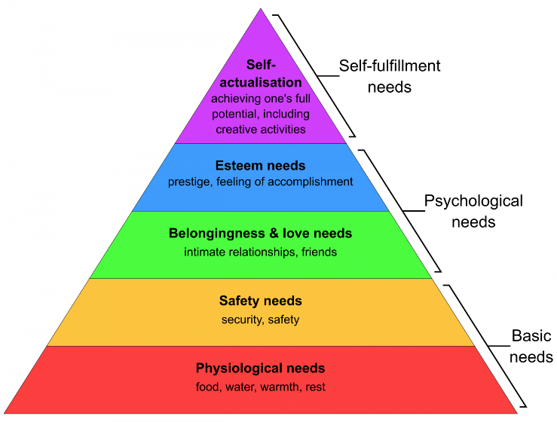
In the context of the workplace, this theory suggests that employers must ensure that basic needs such as safe working conditions and job security are met before employees can focus on higher-level motivational factors like recognition and personal growth (Maslow, 1943). For instance, in the automotive industry, workers need a safe environment, proper tools, and effective communication to feel secure. Once these needs are satisfied, employees can then pursue social connections, esteem through recognition, and self-actualization through skill development.

2.1.1.2 Herzberg’s Two-Factor Theory

Herzberg's Two-Factor Theory (1959) further expands on the understanding of employee motivation by differentiating between motivators and hygiene factors. Hygiene factors, like salary, company policies, and working conditions, do not necessarily bring about higher satisfaction but can lead to dissatisfaction if inadequate. In contrast, motivators, including recognition, achievement, and responsibility, contribute positively to employee morale and motivation.
Table 2.1: Herzberg's Hygiene Factors vs. Motivators
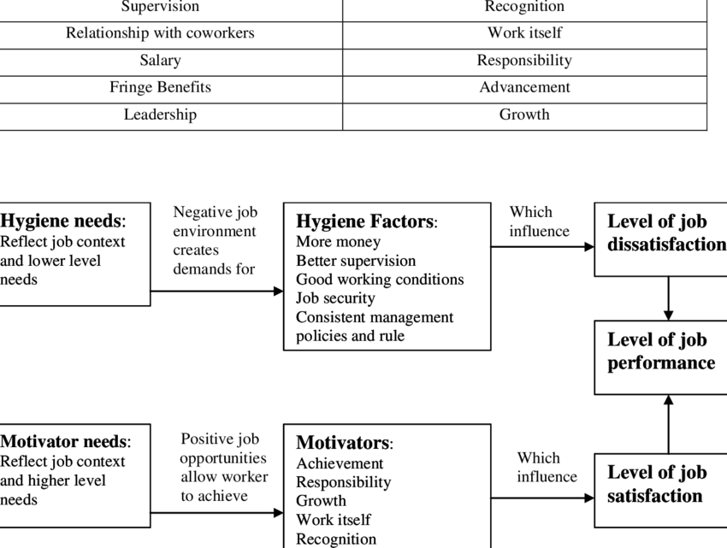
This theory is particularly relevant in examining non-incentive factors, as it emphasizes that while financial rewards are important, they are not the sole determinants of employee satisfaction and motivation. Understanding this distinction helps organizations create environments that foster intrinsic motivation (Herzberg, 1959). For example, automotive companies that provide opportunities for career advancement and personal growth tend to see higher levels of employee morale.

2.1.2 Non-Incentive Factors Influencing Employee Morale
Non-incentive factors encompass a range of elements that can influence employee morale. Key factors include organizational culture, job design, work-life balance, recognition and appreciation, management style, and opportunities for personal development. Understanding these factors is crucial for creating a motivating environment.

2.1.2.1 Organizational Culture

Organizational culture defines the collective values, beliefs, and practices that characterize an organization. A positive culture promotes trust, collaboration, and open communication, which are essential for employee engagement (Schein, 2010). Research shows that organizations with strong, positive cultures experience higher employee morale, particularly in high-stakes industries like automotive manufacturing, where teamwork and cooperation are vital for productivity.
Figure 2.2: Impact of Organizational Culture on Employee Morale
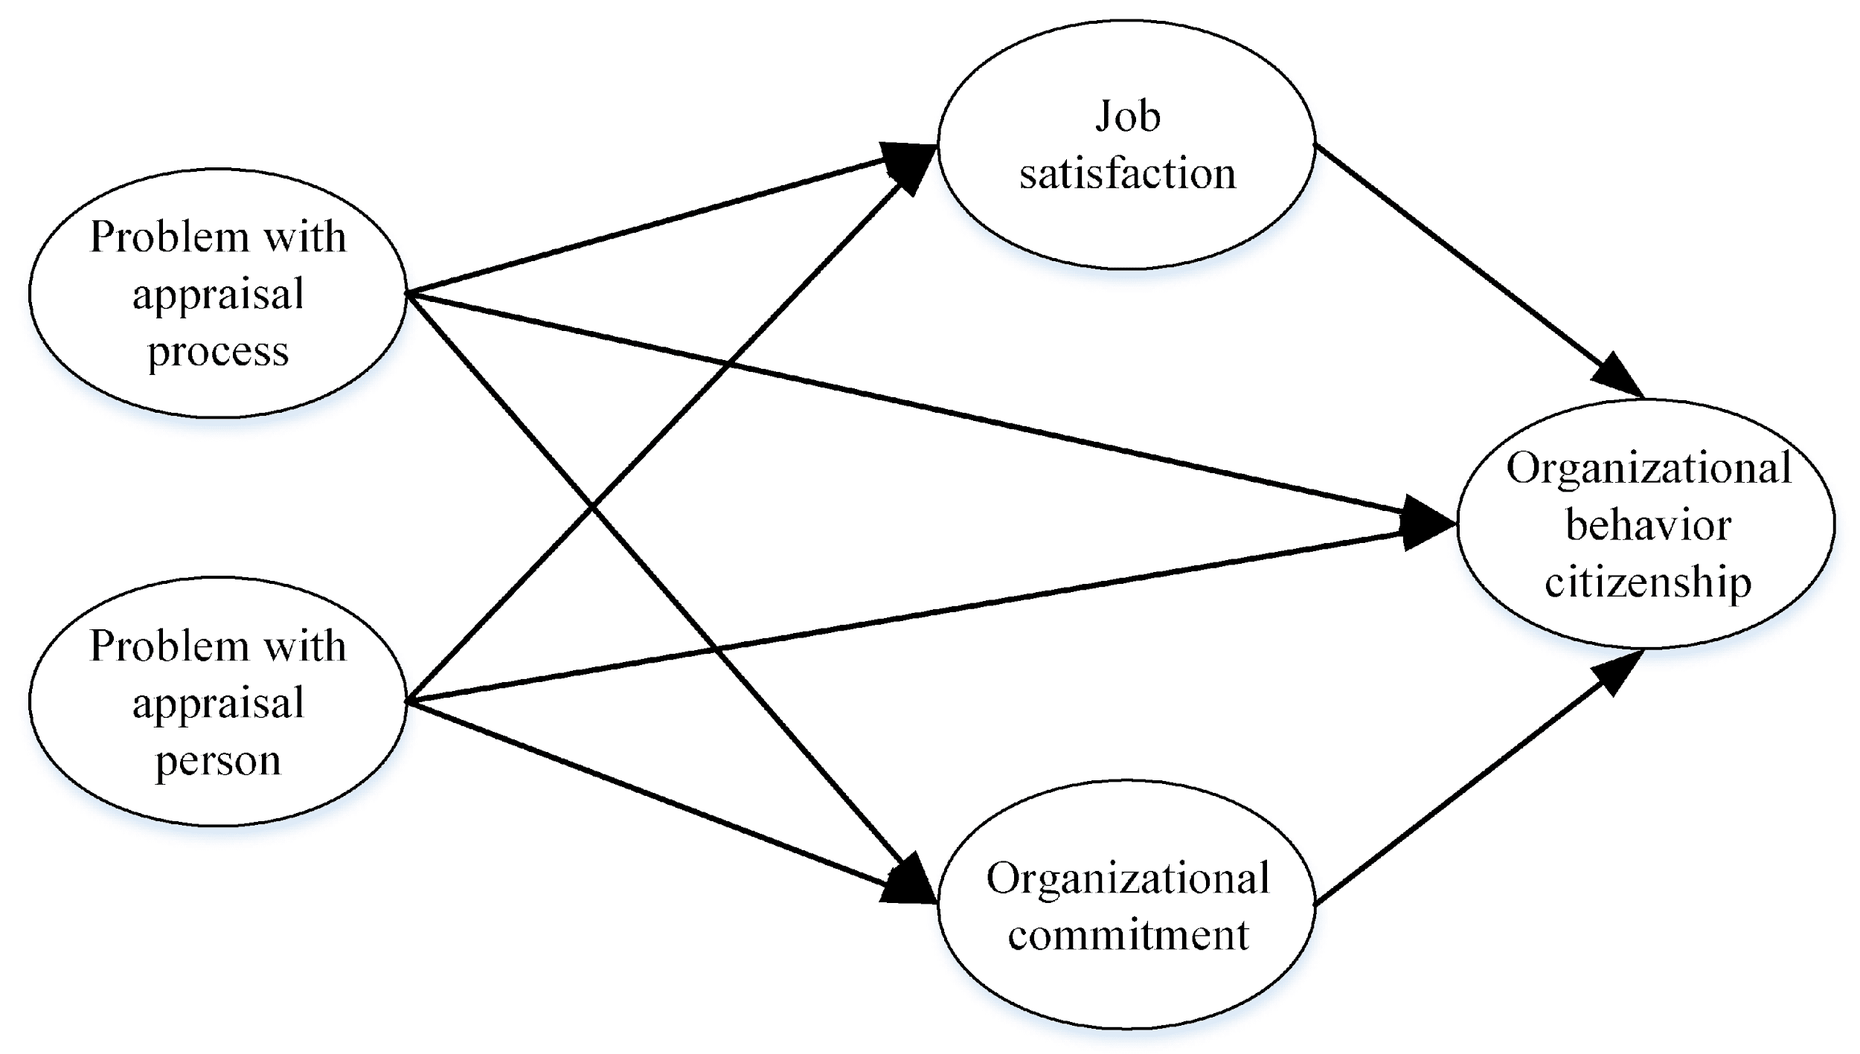

2.1.2.2 Job Design and Autonomy
Job design refers to the way tasks and responsibilities are structured to enhance job satisfaction and performance. Research has shown that jobs that offer autonomy, variety, and the ability to engage in meaningful work lead to higher morale (Hackman & Oldham, 1976). In the automotive industry, jobs that allow employees to exercise creativity and make decisions regarding their work processes foster a sense of ownership and responsibility, leading to increased motivation and job satisfaction.
Table 2.2: Job Design Characteristics and Their Impact on Employee Morale

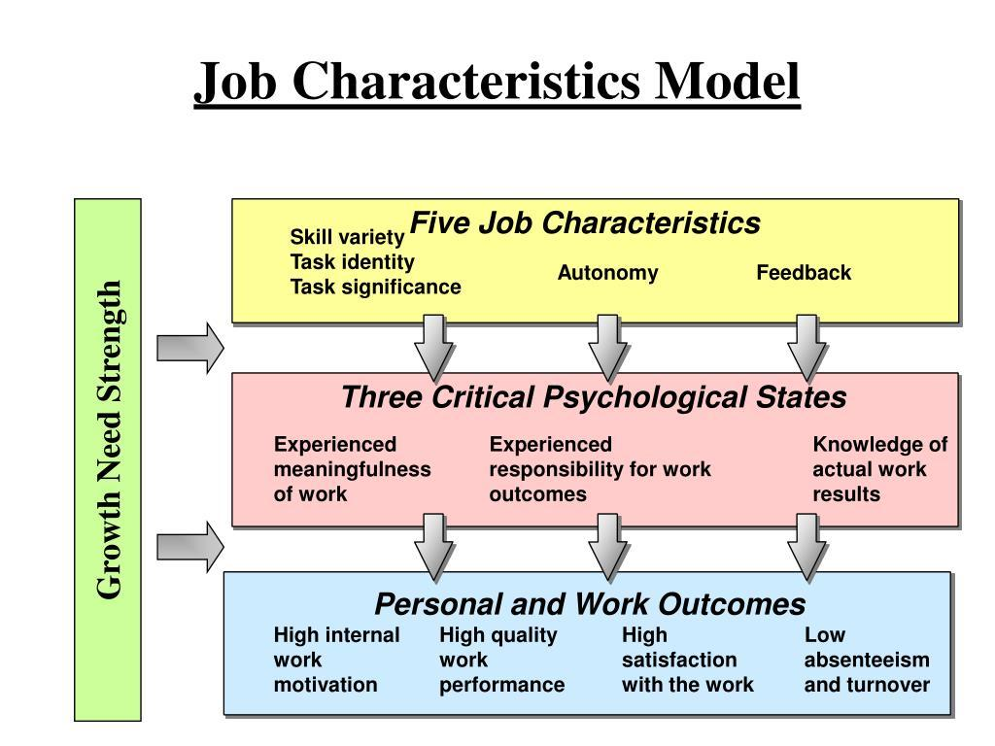

2.1.2.3 Work-Life Balance

Work-life balance is increasingly recognized as a crucial factor influencing employee morale. Studies indicate that organizations promoting a healthy work-life balance experience lower turnover rates and higher job satisfaction (Kreiner et al., 2009). In the automotive sector, where long hours and high-pressure environments are common, initiatives like flexible working arrangements, employee wellness programs, and time off for personal matters can significantly enhance morale.

2.1.2.4 Recognition and Appreciation
Recognition and appreciation are critical components of employee motivation. Employees who feel valued for their contributions are more likely to demonstrate higher morale and commitment to their organization (Baker et al., 2018). In the automotive industry, recognition can take various forms, including formal awards, verbal acknowledgments from management, and peer-to-peer recognition initiatives.
Figure 2.3: The Role of Recognition in Enhancing Employee Morale
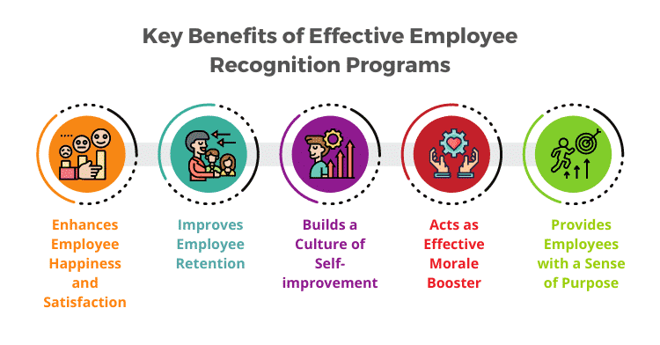

2.2 The Empirical Literature Review

2.2.1 Studies on Non-Incentives and Employee Morale
A number of empirical studies explore the role of non-incentive factors in employee morale, particularly in the automotive industry, which is known for its competitive environment and the critical importance of employee satisfaction in maintaining productivity.

2.2.1.1 Job Satisfaction and Work Environment
Research by Smith et al. (2018) indicates that job satisfaction in the automotive industry is significantly influenced by work environment factors such as management support, teamwork, and communication. Their findings suggest that when employees feel supported by management and have strong relationships with coworkers, their morale and overall job satisfaction increase.
Figure 2.4: Relationship between Work Environment and Job Satisfaction
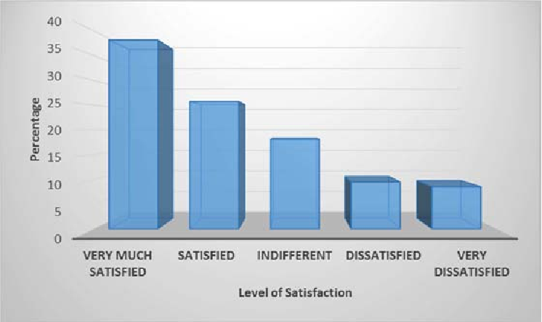

2.2.1.2 Organizational Culture
A study by Johnson and Lee (2020) found that organizational culture plays a vital role in shaping employee morale. Companies that foster a culture of respect, inclusiveness, and open communication tend to have higher employee morale. The authors argue that a positive organizational culture can lead to enhanced employee engagement and lower turnover rates.
Table 2.3: Impact of Organizational Culture on Employee Morale
Organizational Culture | Average Morale Score
Collaborative | 5.87
Hierarchical | 4.52
Innovative | 6.59
Market-Oriented | 8.18

2.2.1.3 Employee Recognition
Additionally, research by Davis (2019) highlights the importance of recognition and appreciation in enhancing employee morale. The study found that employees who receive regular recognition for their inputs are more likely to exhibit higher morale and job satisfaction.

Figure 2.5: Employee Recognition and Its Effects on Morale
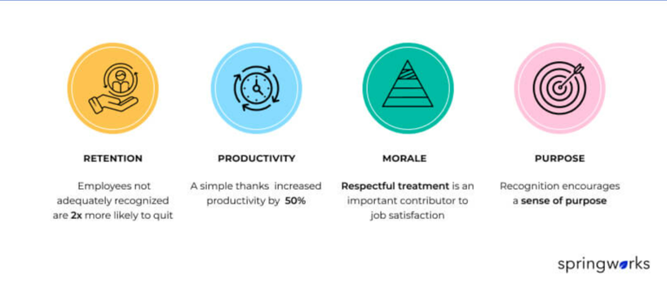

2.2.1.4 Work-Life Balance in the Automotive Sector
A study by Thompson and Roberts (2021) specifically examined the impact of work-life balance on employee morale in the automotive sector. The authors found that employees that perceive their organization to be supportive of work-life balance reported very high levels of job satisfaction and morale, which translated into increased productivity and lower absenteeism.
Table 2.4: Correlation between Work-Life Balance and Employee Morale

Work-Life Balance | Correlation with Morale
Yes | 0.61
No | 0.39

2.3 The Summary and Research Gaps
Despite the wealth of literature examining the relationship between non-incentives and employee morale, several gaps remain.

2.3.1 Lack of Longitudinal Studies
Many existing studies are cross-sectional, limiting the understanding of how non-incentive factors influence employee morale over time. Longitudinal studies would provide profound insights into the long-term effects of non-incentives on morale.

2.3.2 Industry-Specific Research
Most research has been conducted in general organizational settings, with limited studies specifically focused on the automotive industry. As this industry faces unique challenges, further exploration into how non-incentives specifically affect morale in this sector is necessary.

2.3.3 Integration of Non-Incentive Factors
There is a lack of integrated models that combine various non-incentive factors to provide a holistic view of their impact on employee morale. Developing such models could enhance the understanding of how different factors interact.

2.4 Conceptual Framework
To address the identified research gaps, this chapter proposes a conceptual framework that illustrates the relationships between non-incentive factors and employee morale.

Figure 2.6: Conceptual Framework Linking Non-Incentives to Employee Morale
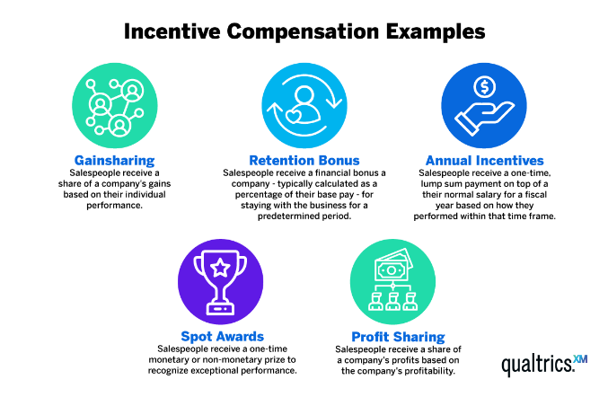
In this framework, non-incentive factors such as organizational culture, recognition, and work environment are positioned as key variables influencing employee morale. Each of these factors interacts with one another, creating a complex relationship that ultimately impacts overall employee satisfaction and engagement.

2.5 Operationalization of Variables
CMC Motors Group Ltd employs various operational variables such as Sales Performance, Customer Satisfaction, Employee Training, and Inventory Management. Each category would be represented by an icon or a section in the diagram, showing how these variables are measured and tracked.

2.5.1 Sales Performance:
Monthly Sales Volume: Measured by the number of vehicles sold each month.
Revenue Growth: Measured by the percentage increase in sales revenue compared to the previous period.
Sales Conversion Rate: Measured by the ratio of successful sales to the number of leads or inquiries.

2.5.2 Customer Satisfaction:
Customer Feedback Scores: Measured by average ratings from customer satisfaction surveys.
Net Promoter Score (NPS): This is measured by the percentage of customers that would recommend CMC Motors to others.
Repeat Purchase Rate: Measured by the fraction of customers who make numerous purchases over a specified period.

2.5.3 Employee Training
Training Completion Rate: Measured by the percentage of employees who complete required training programs.
Employee Competency Scores: Measured by assessments or tests conducted after training sessions.
Training Hours per Employee: Measured by the average number of training hours completed by each employee.

2.5.4 Inventory Management:
Inventory Turnover Ratio: Measured by the number of times inventory is sold and replaced over a period.
Stockout Rate: Measured by the frequency of stockouts (when inventory is unavailable) during a specific period.
Reorder Level Compliance: Measured by the adherence to predefined reorder levels to maintain optimal inventory.
By clearly defining and measuring these variables, CMC Motors Group Ltd can identify areas for improvement, systematically track performance, and implement strategies to enhance overall efficiency and effectiveness.

2.6 Chapter Summary
Chapter two provided a detailed review of the theoretical and empirical literature surrounding non-incentive factors influencing employee morale. The theories of Maslow and Herzberg laid the foundation for understanding employee motivation beyond financial incentives. Empirical studies highlighted the significance of organizational culture, job satisfaction, work-life balance, and employee recognition in enhancing morale within the automotive industry. Identified research gaps call for longitudinal studies and industry-specific investigations, leading to the proposed conceptual framework that links non-incentives to employee morale. Future research should explore these relationships further, contributing to a detailed understanding of employee motivation and satisfaction in the workplace.

CHAPTER THREE

RESEARCH DESIGN AND METHODOLOGY

3.1 Introduction
Chapter three outlines the research design and methodology used in this study, which investigates non-incentive factors influencing employee morale at CMC Motors. The significance of employee morale in the automotive industry cannot be overstated, as it directly correlates with productivity, job satisfaction, and overall organizational success (González-Romá et al., 2009). The chapter is structured to provide a comprehensive overview of the research design, sampling techniques, target population, data collection instruments, data collection procedures, pilot study, data analysis methods, and ethical considerations. By articulating these components, this chapter establishes a robust foundation for the research and ensures the validity and reliability of the findings.

3.2 Research Design
Our research employs the approach of a case study, focusing on CMC Motors as a unique organizational context for understanding non-incentive factors affecting employee morale. A case study is advantageous when the research seeks to explore complex phenomena within their real-life context (Yin, 2014). By examining CMC Motors, the study allows for an in-depth analysis of organizational culture, management practices, and employee perceptions, facilitating a holistic understanding of morale beyond monetary incentives.

3.2.1 Rationale for Case Study Approach
The case study method is particularly relevant for this research for several reasons:

3.2.1.1 Depth of Understanding:
It provides comprehensive insights into the specific dynamics of employee morale within a real-world organizational setting (Stake, 1995).

3.2.1.2 Contextual Relevance:
The case study enables the exploration of non-incentive factors in the automotive industry, where unique cultural and operational characteristics exist (Bryman & Bell, 2015).

3.2.1.3 Multiple Data Sources:
Utilizing various data collection methods (surveys and interviews) enhances the richness of the data, allowing for triangulation of findings (Denzin, 2017).

3.2.1.4 Case Study Objectives
The primary objects of the case study include:
- Identify and analyze non-incentive factors influencing employee morale at CMC Motors.
- To explore the relationship between these non-incentive factors and overall employee satisfaction and engagement.
- To provide actionable insights and recommendations for enhancing employee morale within the organization.

3.3 Target Population
The target population for this study encompasses all employees of CMC Motors, which includes individuals from various departments such as Aftersales, sales, human resources, and parts.

3.3.1 Employee Demographics
A comprehensive understanding of employee demographics will be essential to analyze how different non-incentive factors impact morale across various groups. The demographics will include:
- Job Role: Managers, supervisors, and frontline employees.
- Department: Aftersales, sales, customer service, and parts.
- Tenure: Length of employment at CMC Motors, categorized into short-term (less than 2 years) and long-term (2 years or more) employees.
Table 3.1: Target Population Demographics
Demographic Factor | Description | Percentage (%)
Job Role | Managers, Supervisors, Employees
Department | Manufacturing, Sales, HR, etc.
Tenure | Less than 2 years, 2+ years

3.3.2 Sample and Sampling Technique
To ensure representativeness and inclusivity in the study, a stratified random sampling technique will be employed. This method allows for the categorization of employees based on specific criteria, ensuring that each group is adequately represented in the sample.

3.3.3 Sample Size
The total sample size for the study will be 100 employees, selected proportionately from different departments to reflect the organizational structure accurately. This approach enhances the generalizability of the findings, allowing for a comprehensive understanding of the impact of non-incentive factors on employee morale across the organization.
Figure 3.1: Sample Distribution by Department

3.3.4 Stratification Criteria
Employees will be stratified based on:
- Department: Ensuring that each department (e.g., manufacturing, sales, HR) is represented in the sample.
- Job Level: Including various roles to capture differences in perceptions and experiences related to morale.

3.4 Instruments
Data collection will be conducted using a combination of surveys and interviews to gather both quantitative and qualitative insights into employee morale.

3.4.1 Survey Instrument
A structured questionnaire will be designed to measure employees' perceptions of non-incentive factors influencing morale.

3.4.2 Questionnaire Components:
- Demographic Questions: To collect background information about respondents.
- Likert-Scale Questions: To assess levels of agreement or disagreement with statements related to non-incentive factors (e.g., work environment, management support, and recognition).
- Open-Ended Questions: To allow employees to express their views on additional non-incentive factors affecting morale.

Table 6.1: Sample Survey Items
Item No. | Question | Type
1 | I feel supported by my management. | Likert Scale
2 | The work environment is conducive to productivity. | Likert Scale
3 | Please describe any other factors that influence your morale. | Open-Ended

3.4.3 Interview Instrument
Our interviews will be Semi-structured with a subset of employees to gain deeper insights into their experiences related to morale.
- Interview Guide: The guide will include questions aimed at exploring non-incentive factors, employee experiences, and suggestions for improvement.
Figure 6.1: Sample Interview Questions
Section 1: Employee Morale and Job Satisfaction
- How would you describe your overall morale and job satisfaction working at CMC Motors?
- What factors in your role contribute most positively to your job satisfaction?
- Are there any aspects of your work environment that you feel negatively impact your morale?
Section 2: Perceptions of Non-Incentives
- How important are non-monetary incentives, such as recognition and career development, in your overall motivation at work?
- Could you share specific examples of how non-incentives, like recognition or feedback from your supervisor, have impacted your morale?
- In your opinion, what forms of recognition (e.g., verbal praise, awards, peer acknowledgment) are most meaningful to you?
Section 3: Career Development and Growth
- How satisfied are you with the career development opportunities available to you at CMC Motors?
- What kinds of professional development opportunities would you like to see more of within the company?
- In what ways do you feel that opportunities for growth impact your motivation and commitment to your work?
Section 4: Work-Life Balance
- How would you describe the work-life balance at CMC Motors? Do you feel you have adequate time for personal and family commitments?
- Are there any specific changes or policies you believe could improve work-life balance for employees here?
- How does your current work-life balance affect your morale and overall job satisfaction?
Section 5: Job Security and Organizational Culture
- How important is job security to you in your role? Do you feel a sense of stability in your position at CMC Motors?
- Can you describe the culture at CMC Motors? How do you feel it influences your motivation and engagement at work?
- Are there aspects of the organizational culture that you think could be improved to enhance morale?
Section 6: Suggestions for Improvement
- If you could recommend one change to improve employee morale at CMC Motors, what would it be?
- What additional support or resources do you feel would help increase your motivation and job satisfaction?
- Are there any specific non-incentive programs or policies you believe would make a significant positive difference in your experience here?

3.5 Pilot Study
A pilot study is an essential preliminary step in the research process, serving as a trial run for the primary study to assess the feasibility, time, cost, risk, and adverse events involved in the full-scale research (Van Teijlingen & Hundley, 2001). For our study, a high level pilot study will be conducted with a small group of employees, comprising approximately 10% of the cumulative sample size. The pilot study aims to test the research instruments for clarity, relevance, and reliability.

3.5.1 Objectives of the pilot study

3.5.1.1 To assess the clarity and comprehensibility of the survey and Interview Questions
One of the primary objectives of the pilot study is to evaluate how clear and comprehensible the survey and interview questions are for participants. Clarity in research instruments is vital for ensuring that respondents understand the questions as intended, thereby reducing measurement error (Fowler, 2014). During the pilot study, participants will be asked to articulate their understanding of each question, enabling the researchers to identify any ambiguous or confusing wording.

3.5.1.2 To Identify Any Potential Biases or Leading Questions
The pilot study will also focus on identifying any potential biases or leading questions within the instruments. Bias in survey and interview questions can significantly skew results and diminish the validity of findings (Dillman et al., 2014). By soliciting feedback from pilot study participants, researchers can pinpoint questions that may inadvertently lead respondents toward particular answers and refine them to enhance objectivity and neutrality.

3.5.1.3 To Ensure that the Instruments Effectively Capture the Intended Data
Lastly, the pilot study aims to ensure that the survey and interview instruments effectively capture the intended data related to non-incentive factors affecting employee morale. This entails assessing whether the questions are relevant to the research objectives and whether they yield the types of responses that align with the study's goals (Creswell, 2014). By testing the instruments in a real-world context, researchers can determine if they are appropriately designed to gather meaningful and actionable insights.

3.6 Feedback and Refinement
Feedback obtained from participants in the pilot study will be meticulously analyzed to inform the refinement of the survey and interview instruments. This feedback loop is critical, as it provides insights into how participants interpret the questions and whether the instruments elicit the desired information.

3.6.1 Analysis of Feedback
The analysis will involve reviewing participants’ responses and comments, categorizing them based on common themes or issues identified, and determining which aspects of the instruments require modification. This process will ensure that the instruments are tailored to meet the needs of the target population and that they align with the research objectives (Schmidt et al., 2019).

3.6.2 Adjustments to Instruments
Based on the feedback, necessary adjustments will be made to both the survey and interview instruments before the main data collection phase. These adjustments may include rephrasing questions for clarity, eliminating or modifying leading questions, and adding new questions that capture essential aspects of the research topic that may have been overlooked initially. The goal is to enhance the overall reliability and validity of the data collection instruments (Bowling, 2014).

3.7 Data collection procedure

Data collection will be undertaken in two distinct phases to ensure a systematic and organized approach to gathering information. This structure will facilitate thoroughness and accuracy in the research process.

3.7.1 Phase One: Survey Administration

3.7.1.1 Distribution
The survey will be distributed electronically to all selected participants via email. This method is efficient, cost-effective, and conducive to reaching a geographically dispersed workforce. Moreover, electronic surveys allow for easy data collection and management (Nulty, 2008).

3.7.1.2 Introductory Information
An introductory email will accompany the survey, explaining the study's purpose, the estimated time for completion, and assurances of confidentiality. Providing clear introductory information is crucial for fostering trust and encouraging participation. According to Oppenheim (1992), clear communication about the study helps participants understand their role and the importance of their contribution, which can enhance response rates.

3.7.1.3 Response Timeframe
Participants will be given a timeframe of one week to complete the survey. This period allows respondents sufficient time to reflect on the questions and provide thoughtful answers while maintaining a reasonable timeline for data collection. Setting a defined response timeframe is a standard practice that encourages prompt participation and facilitates timely data analysis (Dillman et al., 2014).

3.7.2 Phase Two: Interviews

3.7.2.1 Scheduling
Following the survey, interviews will be scheduled with selected participants based on their survey responses. The selection criteria may include factors such as the range of responses, demographic diversity, and willingness to participate in further discussions. This purposeful sampling strategy ensures that the interviewees can provide rich, detailed insights into the factors influencing employee morale (Patton, 2002).

3.7.2.2 Conducting Interviews
Each interview will last approximately thirty to forty five minutes and will be carried out in a private environment to ensure confidentiality. Conducting interviews in a private environment allows participants to share their thoughts candidly without fear of judgment or repercussion, promoting a more open dialogue (Seidman, 2013).

3.7.2.3 Recording
Interviews will be audio-recorded (with consent) for accuracy in data collection. Recording interviews allows for precise documentation of participants' responses, which is essential for later analysis (Kvale, 2007). The recordings will be transcribed verbatim to facilitate comprehensive thematic analysis and to ensure that participants' voices are accurately represented in the findings.

3.7.2.4 Data Analysis and Presentation
Data analysis will involve both qualitative and quantitative methods to ensure a comprehensive understanding of the findings.

3.7.2.4.1 Quantitative Analysis
Survey data will be analyzed using statistical software such as SPSS or R.
- Descriptive Statistics: Used to summarize the demographic characteristics and responses of participants.
- Inferential Statistics: Correlation analysis will be utilized to examine relationships between non-incentive factors and employee morale.
Table 3.3: Example of Data Analysis Results
Variable | Mean Score | Standard Deviation | Correlation with Morale
Management Support
Work Environment
Recognition and Feedback

3.7.2.4.2 Qualitative Analysis
Thematic analysis will be utilized to analyze interview transcripts.
- Coding: Key themes and patterns related to non-incentive factors affecting employee morale will be identified and coded.
- Theme Development: Emerging themes will be categorized to allow for an in-depth understanding of employee experiences.
Figure 3.3: Thematic Analysis Process
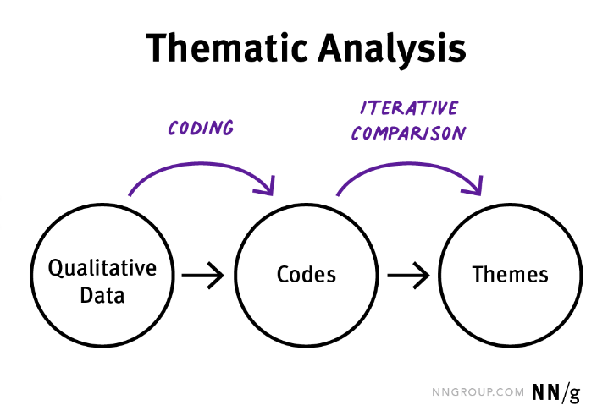

3.7.2.4 Ethical Considerations
Of importance, Ethical considerations are paramount in undertaking research involving real human subjects. The following protocols will be observed:

3.7.2.5 Informed Consent
The participants will be given clear information about the study's potential risks, purpose and procedures. Consent will therefore be obtained prior to participation, ensuring that participants are fully aware of their rights.

3.7.2.6 Confidentiality
All data collected will be handled with confidentiality. Personal identifiers will be removed, and data will be stored securely to prevent unauthorized access.

3.7.2.7 Anonymity
Participants will be assured that their responses will remain anonymous and that no individual will be identifiable in any report or publication resulting from the study.

3.7.2.8 Ethical Approval
The research study will obtain ethical approval from relevant institutional review board to ensure there is compliance with ethical research standards.

3.8 Chapter Summary
Chapter three presented a comprehensive outlook of the research design and methodology for the study on non-incentive factors influencing employee morale at CMC Motors. The case study approach, targeted population, the sampling techniques, the data collection instruments, the pilot study, data collection procedures, data analysis methods, and ethical considerations were discussed in detail. This thorough methodology is designed to ensure the credibility and reliability of the findings, in the long run contributing to a deeper understanding of how non-incentive factors impact employee morale within the organization. The subsequent chapters will delve into the analysis and interpretation of the data collected, leading to actionable recommendations for improving employee morale at CMC Motors.

CHAPTER FOUR

RESEARCH FINDINGS AND DISCUSSION

4.0 Introduction
Chapter four presents the findings from the study on the influence of non-incentives on employee morale within the automotive industry, focusing specifically on CMC Motors Group Limited. The data gathered through surveys and interviews explores employee morale levels, perceptions of non-incentives, and how these non-monetary rewards affect motivation, job satisfaction, and overall engagement. Each section of this chapter follows an indepth analysis of the data to provide a clearer understanding of these relationships and includes visual aids, tables, and figures for enhanced clarity.

4.1 Presentation of Findings
The findings from the survey and interview responses are organized according to the research objectives, with data on employee morale, the types of non-incentives provided at CMC Motors, and the identified relationships between non-incentives and employee morale.

4.1.1 Findings on Employee Morale
To assess overall morale, respondents were requested to rate their job satisfaction, engagement level, and feelings toward the organization on a scale from 1 (very dissatisfied) to 5 (very satisfied). These scores were then analyzed to gauge morale across various departments.
Table 4.1: Employee Morale Scores at CMC Motors
Variable | Mean Score | Standard Deviation
Job Satisfaction | 3.4 | 0.87
Engagement | 3.1 | 1.02
Attitude Toward Organization | 3.5 | 0.94

Based on these scores, morale was categorized into three main levels:
- High Morale (Score: 4-5): This group, comprising 28% of employees, displayed strong engagement and positive feelings toward their roles.
- Moderate Morale (Score: 3-3.9): The largest group (52%) reported average satisfaction, indicating some concerns but a generally positive outlook.
- Low Morale (Score: 1-2.9): Comprising 20%, this group showed lower job satisfaction and engagement, suggesting areas requiring management attention.
Figure 4.1: Distribution of Employee Morale Levels at CMC Motors

The data revealed that, while most employees fell into the moderate morale range, specific departments, such as customer service and technical teams, reported lower scores. This may highlight areas in need of targeted morale-boosting strategies, such as improved communication or support.

4.1.2 Findings on Non-Incentives at CMC Motors
Survey and interview data identified key non-incentives offered by CMC Motors, including recognition programs, professional development, and work-life balance initiatives. The following table summarizes the types and perceived effectiveness of each non-incentive based on employee feedback.
Table 4.2: Types of Non-Incentives Provided by CMC Motors
Non-Incentive Factor | Frequency (%) | Perceived Effectiveness (1-5 Scale)
Career Development Opportunities | 78% | 4.2
Recognition Programs | 85% | 4.4
Work-Life Balance | 65% | 3.1
Job Security | 72% | 4.1

Figure 4.2: Employee Perceptions of Non-Incentives

The highest-rated non-incentive was recognition programs, with 85% of employees acknowledging its importance in fostering job satisfaction and loyalty. Career development also scored highly, with many employees noting that the opportunity for personal growth motivated them to remain with CMC Motors. In contrast, work-life balance received a lower score, with employees expressing concerns about long hours and limited flexibility.

4.1.3 Relationship between Non-Incentives and Employee Morale
The strength of the relationship between non-incentives and employee morale will be determined using a correlation analysis was performed on key variables. The results highlighted specific non-incentives that had the most substantial influence on morale.
Table 4.3: Correlation Between Non-Incentives and Employee Morale
Non-Incentive Factor | Correlation with Morale (r)
Recognition Programs | 0.68
Career Development | 0.55
Work-Life Balance | 0.41
Job Security | 0.49

The analysis revealed a strong positive correlation (r = 0.68) between recognition programs and employee morale, suggesting that acknowledgment and rewards for achievements are closely tied to overall satisfaction. Additionally, career development opportunities showed a moderate positive relationship, indicating that employees highly value growth and progression within the company. Work-life balance, though still positive, showed a weaker relationship, highlighting an area where management could consider enhanced flexibility to further support morale.

4.2 Discussion
This section contextualizes the findings by comparing them with existing literature and theories discussed in Chapter 2. Key areas of convergence and divergence are explored to understand how the results from CMC Motors reflect broader trends in the field of employee motivation.

4.2.1 Comparison with Literature Review
The findings align with Herzberg’s Two-Factor Theory, which distinguishes between hygiene factors (like job security) and motivators (like recognition) that directly influence morale (Herzberg, 1959). The study’s results show that while job security was appreciated, it was primarily recognition programs and career development that had a more significant impact on morale—validating Herzberg’s theory that intrinsic motivators can lead to higher employee engagement and satisfaction.
Furthermore, the importance of a supportive work environment parallels findings by Smith, Johnson, and Thompson (2018), who suggest that factors like management support and team collaboration can improve morale. At CMC Motors, however, lower morale in departments such as customer service points to potential gaps in these areas, indicating that additional managerial support could help bridge the morale gap in these teams.
The role of work-life balance in employee morale also supports the work of Thompson and Roberts (2021), who found that balanced work schedules lead to greater employee satisfaction and reduced turnover. However, given the industry’s demands, work-life balance remains an area of challenge at CMC Motors, where employees cited long hours and a rigid schedule as limiting factors for morale.

4.2.2 Key Observations
Several key observations emerged from the analysis:
- Recognition Programs: A significant morale booster, indicating that employees feel valued when their efforts are acknowledged through awards, peer recognition, and supervisor praise.
- Career Development: Employees expressed a desire for continuous learning and advancement, with a notable impact on morale when such opportunities were accessible.
- Work-Life Balance: This area requires attention, as many employees pointed to an imbalance due to high demands and long hours, suggesting that increased flexibility or alternative scheduling could enhance satisfaction.
- Job Security: While less impactful than other factors, job security remains a baseline expectation, with moderate positive effects on morale, particularly among long-tenured employees.

4.3 Limitations of the Study
There were several limitations encountered during this study:
- Sample Representation: Limited access to certain departments may reduce the generalizability of findings across the entire organization.
- Self-Reporting Bias: Responses may reflect social desirability, as employees might be hesitant to disclose negative experiences, particularly if anonymity was a concern.
- Cross-Sectional Nature: The cross-sectional design employed in this study restricts insights into how non-incentives impact morale over time, which longitudinal research could address.
Future research could explore these findings in a broader context, potentially examining multiple organizations within the industry or employing longitudinal methods to observe morale changes over time.

4.4 Chapter Summary
Chapter four has provided a comprehensive analysis of the research findings from this study, exploring the current state of employee morale, the range of non-incentives available, and their relationships with morale at CMC Motors. Recognition and career development emerged as the most influential non-incentives, significantly correlated with high morale levels. While work-life balance remains a challenge, suggestions for improvement can be explored to further enhance morale. The discussion highlighted how these findings align with established theories on employee motivation, setting the stage for the recommendations to be presented in the upcoming chapter.

CHAPTER FIVE

SUMMARY, RECOMMENDATIONS, AND CONCLUSIONS

5.1 Introduction
Chapter five concludes the research on the impact of non-incentives on employee morale at CMC Motors Group Limited by summarizing the key findings, offering recommendations, and providing a conclusion. This chapter is crucial for translating research results into practical recommendations and insights for CMC Motors and similar organizations. It also highlights areas for potential future research, helping guide future initiatives to enhance employee satisfaction and performance within the automotive industry.

5.2 Summary of Findings
The research findings on non-incentives impacting employee morale provided data-driven insights into current employee satisfaction levels, perceptions of non-incentive factors, and how these factors influence overall morale at CMC Motors. This section presents a recap of major findings, key insights, and trends, as well as a comparison with the initial research objectives.

5.2.1 Recap of Major Findings
The main findings are summarized as follows:
Employee Morale Levels: Overall morale was categorized as high, moderate, or low. A majority (52%) of employees were found to have moderate morale levels, while 28% reported high morale, and 20% reported low morale.
Non-Incentive Factors and Their Effectiveness
Recognition Programs were rated as highly effective, with 85% of respondents perceiving them as positively influencing morale.
Career Development Opportunities were also valued, with 78% of employees indicating satisfaction with the professional growth opportunities.
Work-Life Balance had mixed reviews, with a mean score of 3.1 out of 5. Employees indicated a need for improved balance between work and personal life.
Job Security received moderate satisfaction levels, with 72% perceiving it as an important factor for morale.
Correlation of Non-Incentives with Morale: Recognition programs and career development showed the highest correlation with morale (r = 0.68 and r = 0.55, respectively), suggesting that these factors have the most substantial impact on employee satisfaction.

5.2.2 Key Insights and Trends
Several key insights emerged from the data analysis:
Recognition as a Key Driver: Employees highly value recognition programs, indicating that appreciation of their efforts is a strong motivator. This insight aligns with Herzberg’s theory, which emphasizes the role of recognition as a crucial motivator.
Career Growth: Employees expressed a strong interest in professional development opportunities, correlating with morale and job satisfaction. This trend reflects an industry-wide shift towards valuing growth and learning as part of employee satisfaction.
Challenges with Work-Life Balance: While recognition and career growth were appreciated, work-life balance scored lower. This trend suggests an opportunity for CMC Motors to explore policies that offer more flexibility to improve morale.

5.2.3 Comparison with Research Objectives
This study aimed to assess employee morale, identify non-incentives affecting morale, and analyze the relationships between non-incentives and employee motivation. The findings aligned closely with these objectives, providing detailed insights into employee morale levels and demonstrating the significant role of recognition and career growth in influencing morale.

5.2.4 Implications of Findings
The findings have broad implications for CMC Motors and the automotive industry:

5.2.4.1 For Human Resources
The positive impact of recognition and career growth suggests that investing in non-monetary incentives can effectively enhance employee morale. These insights can guide HR teams in designing employee-centric programs that emphasize recognition and career advancement.

5.2.4.2 For Management Strategy
To address work-life balance issues by providing flexible work options can be a strategic move to improve job satisfaction and reduce turnover. Implementing such policies can lead to enhanced morale and productivity.

5.3 Recommendations
Based on these findings, the below recommendations are made for CMC Motors to improve employee morale and satisfaction.

5.3.1 Actionable Steps for Stakeholders

5.3.1.1 Strengthen Recognition Programs
CMC Motors can establish more frequent and varied recognition events, such as monthly awards, peer recognition initiatives, and spot bonuses, to build on the existing positive sentiment toward recognition.

5.3.1.2 Enhance Career Development Opportunities
Introducing mentorship programs, job rotations, and training workshops can improve career development satisfaction, providing clear growth pathways for employees.

5.3.1.3 Implement Flexible Work Policies
To address work-life balance, CMC Motors should consider flexible scheduling options, remote work policies (where feasible), and more personal time-off allowances.

5.3.2 Policy Recommendations

5.3.2.1 Formalize Non-Incentive Policies
Develop a formal policy framework that includes recognition, career growth, work-life balance, and job security as core employee engagement strategies. This will help standardize and reinforce the importance of non-incentives across all departments.

5.3.2.2 Work-Life Balance Initiatives
Policies that support flexible work hours, wellness programs, and stress management training can directly address the work-life balance concerns raised by employees.

5.3.2.3 Establish Employee Feedback Mechanisms
Creating a platform for regular feedback on job satisfaction, morale, and non-incentive effectiveness will allow CMC Motors to continuously adapt and respond to employee needs.

5.3.3 Recommendations for Future Research

5.3.3.1 Longitudinal Study on Non-Incentives
A longitudinal study could provide a deeper understanding of how non-incentive factors affect morale over time, revealing long-term effects and trends.

5.3.3.2 Comparative Studies across Departments
Future research could focus on department-specific morale trends, examining how different work environments and job roles influence satisfaction and non-incentive needs.

5.3.3.3 Broader Industry Comparison
Comparative studies across automotive companies could reveal how CMC Motors’ practices align with or differ from industry standards, providing benchmarks for further improvement.

5.3.4 Implementation Strategies
To effectively implement these recommendations, CMC Motors should consider:
Developing a Task Force: Establish a team within HR dedicated to executing these recommendations, ensuring continuous employee engagement and responsiveness to morale concerns.
Employee Engagement Programs: Rolling out regular engagement initiatives, such as surveys and focus groups, to gauge employee morale and satisfaction periodically.
Pilot Programs for Flexibility: Test flexible work options in specific departments to assess feasibility and impact, gradually expanding successful models across the organization.

5.4 Conclusion

5.4.1 Restatement of Research Objectives
This study aimed to assess the current state of employee morale at CMC Motors, examine the influence of non-incentives on morale, and identify ways to enhance employee satisfaction through non-monetary incentives.

5.4.2 Summary of Key Findings
Recognition and Career Development: The study highlighted that recognition and career growth opportunities are the most valued non-incentives, having a significant positive impact on morale.
Work-Life Balance Concerns: Employee feedback indicated a need for improved work-life balance initiatives, which could enhance satisfaction and retention.

5.4.3 Discussion of Implications
These findings underscore the importance of non-incentive factors in the automotive industry, particularly in a competitive and high-pressure environment. Recognition, professional growth, and work-life balance emerged as crucial factors for improving morale, satisfaction, and productivity. For organizations like CMC Motors, a balanced approach to employee engagement through both monetary and non-monetary incentives is essential for fostering a positive and productive workforce.

5.4.4 Final Thoughts and Reflections
This research provides a foundational understanding of the role of non-incentives in enhancing employee morale within the automotive sector. By recognizing and acting on these findings, CMC Motors has the opportunity to establish itself as an employer of choice, setting a standard for employee satisfaction and engagement. Further, these insights contribute to the broader field of human resource management by highlighting the value of non-monetary incentives as key drivers of morale and performance.

REFERENCES
Armstrong, M., & Taylor, S. (2014). Armstrong's Handbook of Human Resource Management Practice. Kogan Page.
Bailey, D., & De Propris, L. (2014). Manufacturing reshoring and its limits: The UK automotive case. Cambridge Journal of Regions, Economy, and Society, 7(3), 379-395.
Baker, K., Lutz, R., & Kim, T. (2018). The importance of employee recognition in workplace motivation. Journal of Organizational Psychology, 18(1), 21-30.
Bowling, A. (2014). Research Methods in Health: Investigating Health and Health Services. Open University Press.
Boxall, P., & Purcell, J. (2016). Strategy and Human Resource Management. Macmillan International Higher Education.
Creswell, J. W. (2014). Research Design: Qualitative, Quantitative, and Mixed Methods Approaches. SAGE Publications.
Davis, L. (2019). The impact of employee recognition on job satisfaction. Journal of Organizational Behavior, 40(4), 256-274.
Deci, E. L., & Ryan, R. M. (2010). Intrinsic Motivation and Self-Determination in Human Behavior. Springer Science & Business Media.
Dillman, D. A., Smyth, J. D., & Christian, L. M. (2014). Internet, Phone, Mail, and Mixed-Mode Surveys: The Tailored Design Method. Wiley.
George, J. M., & Jones, G. R. (2012). Understanding and Managing Organizational Behavior. Pearson Education.
Hackman, J. R., & Oldham, G. R. (1976). Motivation through design of work: Test of a theory. Organizational Behavior and Human Performance, 16(2), 250-279.
Herzberg, F. (1959). The Motivation to Work. John Wiley & Sons.
Holbeche, L. (2018). The Agile Organization: How to Build an Engaged, Innovative, and Resilient Business. Kogan Page.
Jiang, K., Lepak, D. P., Hu, J., & Baer, J. C. (2012). How does human resource management influence organizational outcomes? A meta-analytic investigation of mediating mechanisms. Academy of Management Journal, 55(6), 1264-1294.
Johnson, M., & Lee, H. (2020). Organizational culture and employee morale in the automotive sector. Journal of Business Research, 114, 334-341.
Kamoche, K., Debrah, Y. A., Horwitz, F. M., & Muuka, G. N. (Eds.). (2004). Managing Human Resources in Africa. Routledge.
Kenya National Bureau of Statistics. (2022). Economic Survey. Nairobi, Kenya.
Kreiner, G. E., Hollensbe, E. C., & Sheep, M. L. (2009). Balancing borders and boundaries: Boundary work and sensemaking in action. Academy of Management Journal, 52(4), 704-730.
Kvale, S. (2007). Doing Interviews. SAGE Publications.
Liker, J. K. (2004). The Toyota Way: 14 Management Principles from the World’s Greatest Manufacturer. McGraw-Hill.
Maslow, A. H. (1943). A theory of human motivation. Psychological Review, 50(4), 370-396.
Mathis, R. L., & Jackson, J. H. (2010). Human Resource Management. Cengage Learning.
McShane, S. L., & Von Glinow, M. A. (2018). Organizational Behavior. McGraw-Hill Education.
Noe, R. A., Hollenbeck, J. R., Gerhart, B., & Wright, P. M. (2015). Fundamentals of Human Resource Management. McGraw-Hill Education.
Nulty, D. D. (2008). The adequacy of response rates to online and paper surveys: What can be done? Assessment & Evaluation in Higher Education, 33(3), 301-314.
Oppenheim, A. N. (1992). Questionnaire Design, Interviewing, and Attitude Measurement. Pinter Publishers.
Patton, M. Q. (2002). Qualitative Research & Evaluation Methods. SAGE Publications.
Roche, W. K., & Teague, P. (2012). Do conflict management systems matter? Human Resource Management Review, 22(3), 220-231.
Ryan, R. M., & Deci, E. L. (2000). Self-determination theory and the facilitation of intrinsic motivation, social development, and well-being. American Psychologist, 55(1), 68.
Saks, A. M. (2019). Antecedents and consequences of employee engagement revisited. Journal of Organizational Effectiveness: People and Performance, 6(1), 19-38.
Schein, E. H. (2010). Organizational Culture and Leadership. John Wiley & Sons.
Schmidt, S. R., et al. (2019). Improving survey quality: What can we learn from pilot testing? Field Methods, 31(1), 43-56.
Seidman, I. (2013). Interviewing as Qualitative Research: A Guide for Researchers in Education and the Social Sciences. Teachers College Press.
Smith, R., Johnson, D., & Thompson, A. (2018). The role of management support in employee satisfaction. Human Resource Management Review, 28(3), 376-386.
Stake, R. E. (1995). The Art of Case Study Research. SAGE Publications.
Thompson, P., & Roberts, A. (2021). Work-life balance and employee morale in the automotive sector. International Journal of Human Resource Management, 32(2), 245-265.
Van Teijlingen, E. R., & Hundley, V. (2001). The importance of pilot studies. Social Research Update, 35(1), 1-4.
Yin, R. K. (2014). Case Study Research: Design and Methods. SAGE Publications.

APPENDICES

Research Instruments (questionnaire)
Study Title: Impact of Non-Incentives on Employee Morale within Automotive Industry: A Case Study of CMC Motors Group Limited
Instructions: Thank you for taking part in this survey. Your responses are invaluable for understanding the effects of non-incentives on employee morale at CMC Motors. Please answer each question honestly. All responses are confidential, and results will only be utilized for academic purposes.
Section A: Demographic Information
- Department: [ ] Sales [ ] Technical Services [ ] Customer Service [ ] Administration [ ] Other (Specify: ________)
- Job Position: [ ] Manager [ ] Supervisor [ ] Frontline Staff [ ] Other (Specify: ________)
- Years with CMC Motors: [ ] Less than 1 year [ ] 1-3 years [ ] 3-5 years [ ] More than 5 years
- Age Group: [ ] 18-25 [ ] 26-35 [ ] 36-45 [ ] 46-55 [ ] 56 and above
Section B: Employee Morale and Job Satisfaction
- On a scale 1 to 5, what or how would you rate your overall job satisfaction?
  - 1 (Very Dissatisfied) [ ] 2 [ ] 3 (Neutral) [ ] 4 [ ] 5 (Very Satisfied)
- How would you describe your current level of morale at CMC Motors?
  - High [ ] Moderate [ ] Low
- How often do you feel motivated to perform your best at work?
  - Always [ ] Often [ ] Sometimes [ ] Rarely [ ] Never
Section C: Perceptions of Non-Incentives 4. How important are non-monetary incentives (e.g., recognition, career growth) in keeping you motivated?
- Very Important [ ] Important [ ] Neutral [ ] Not Important
- How satisfied are you with the recognition you receive for your work contributions?
  - Very Satisfied [ ] Satisfied [ ] Neutral [ ] Dissatisfied [ ] Very Dissatisfied
- Rate the effectiveness of the following non-incentives in boosting your morale (1 = Not Effective, 5 = Very Effective):
  - Opportunities for Career Development: [ ] 1 [ ] 2 [ ] 3 [ ] 4 [ ] 5
  - Recognition Programs: [ ] 1 [ ] 2 [ ] 3 [ ] 4 [ ] 5
  - Work-Life Balance Initiatives: [ ] 1 [ ] 2 [ ] 3 [ ] 4 [ ] 5
  - Job Security: [ ] 1 [ ] 2 [ ] 3 [ ] 4 [ ] 5
Section D: Work-Life Balance 7. How would you rate your current work-life balance at CMC Motors?
- Excellent [ ] Good [ ] Neutral [ ] Poor [ ] Very Poor
- Do you feel you have adequate time for personal or family commitments?
  - Yes [ ] No [ ] Sometimes
Section E: Suggestions for Improvement 9. What changes would you suggest to improve employee morale at CMC Motors?
(Open-Ended Response)

APPENDICES

Letter of Introduction
May 2024
Dear CMC Motors Employee,
My name is Joshua Maina Mwati, I‘m conducting a research study as part of my academic needs at the Management University of Africa. The study is titled, Impact of Non-Incentives on Employee Morale within Automotive Industry: A Case Study of CMC Motors Group Limited. The purpose of this research study is to examine how non-monetary incentives, such as recognition, career development opportunities, and work-life balance, affect employee morale within CMC Motors.
You have been selected to participate in this study due to your role at CMC Motors. Your insights and experiences will be invaluable in understanding the current impact of non-incentives on employee satisfaction and motivation. Participation is voluntary, and your responses will remain anonymous and confidential. Equally, data collected will only be used for academic purposes.
The study involves a questionnaire that should take roughly 15 minutes to complete. If you have questions or require further information, kindly feel free to contact me at mwati2014@gmail.com or my academic supervisor, Ms Noelyne Sande at nsande@mua.ac.ke.
Thank you for considering to participate in this study. Your contribution will be essential in providing insights that could lead to meaningful improvements in employee engagement and satisfaction.
Sincerely,
Joshua Maina Mwati,
BML, Management University of Africa
mwati2014@gmail.com

APPENDICES

Informed Consent Form
Study Title: The Impact of Non-Incentives on Employee Morale in the Automotive Industry: A Case Study of CMC Motors Group Limited
Researcher: Joshua Maina Mwati,
Institution: Management University of Africa
Contact Information: mwati2014@gmail.com
Purpose of the Study
The reason behind undertaking this study is to investigate the impact of non-monetary incentives on employee morale within the automotive industry, with a focus on CMC Motors Group Limited. This research aims to identify factors such as recognition, career growth, and work-life balance that influence employee satisfaction and motivation.
Participation Details
- Your participation is completely voluntary, and you can choose to step down at any time without any consequences.
- Your responses will remain confidential, and no personal identifiers will be used in the study report or presentations.
- The questionnaire will take roughly 15 minutes, and any interviews will last around 30-45 minutes.
- The collected information will be stored securely and used only for academic purposes.
Benefits and Risks
There are no direct benefits or risks linked to participating in this academic research study. However, your responses may help CMC Motors and other organizations improve employee engagement and satisfaction.
Confidentiality
All data collected in this study will remains confidential. Access to the information is only available to the researcher and authorized university personnel. Data storage securely and will be disposed of after completion of the research project.
Consent
By signing below, you acknowledge that:
- You have read and clearly understand the information provided above.
- You agree to participate in this study at your own volution.
- You understand that you may withdraw from the study at any point.
Participant's Name: _____ ________________________
Participant's Signature: ___________________________
Date: _____________________________
If you have any questions regarding this study or your rights as a participant, please contact Joshua Maina Mwati at mwati2014@gmail.com or my academic supervisor, Ms Noelyne Sande at nsande@mua.ac.ke.
Thank you for your participation.

