EFFECTS ON TOURISM INFORMATION AND MANAGEMENT SYSTEM, TO HELP HOSPITALITY INDUSTRY AND TRAVELLING AGENCY.

MBAABU ONESMUS MICHUBU.

SUBMITTED RESEARCH PROJECT IN PARTIAL COMPLETION OF THE REQUIREMENTS FOR THE AWARD OF A DIPLOMA IN INFORMATION COMMUNICATION TECHNOLOGY FROM THE MANAGEMENT UNIVERSITY OF AFRICA, DEPARTMENT OF INFORMATION COMPUTER AND TECHNOLOGY.

SEPTEMBER 2022.

DECLARATION.
Declaration by the student.
I declare that this work is my original work and has not previously been accepted in substance for any degree or diploma and is not being concurrently submitted in candidature for any diploma.
Name: Mbaabu Onesmus Michubu.
Admission: Dict/10/00039/2/21.
Email: onesmusmbaabum@gmail.com
Signed ………………………………
Date …………………………………

Declaration by supervisor.
I hereby certify that the candidate under my supervision completed the work reported in this research project, under
my supervision as The Management University of Africa Supervisor.
Supervisor Name: Noelyen Sande.
Signed ………………………………
Date ………………………………
Supervising Lecturer.

ABSTRACT.

Tourism Information and Management system is a web application that works through centralized network. Tourism Information and Management system is a facility that will enable customers to book for accommodation and make quick securing reservations. By identifying the shortcomings of the current system, a computerized system that is more user-friendly and compatible with the current system can be designed. Accurate information data can easily be backed up and accesses them. The core of tourism, especially in this day of information overload, has become an important phenomena and a significant problem for individuals looking for accurate information. The effectiveness of travel websites has increased, and they now attempt to close the information gap by documenting what they believe to be essential facts. The main emphasis of this study is content because it is thought to be a factor connected the effective websites. Hence the aim of the research entails the design and implementation of tourist information which gain access in various destinations in Kenya. In light of the aforementioned, the system was developed utilizing the Rational Unified Process as the software development process, and MySQL, HTML, and PHP as the implementation technologies. Upon completion, the system was able to deliver information by pulling data relevant to the topic of interest from the web to aid visitors in making decisions. By adopting a hybrid recommendation technique to suggest tourist attractions depending on their preferences, it was also capable of acting intelligently.

ACKNOWLDGEMENT.
I give thanks to the All-Powerful God for giving me the sustenance, knowledge, and fortitude necessary to carry out this research effort.
Second ,For their love and encouragement, I want to thank my family and friends during the time I was studying. Without her leadership and insightful criticism, my supervisor NOELYNE SANDE, as well as the entire fraternity of the MANAGEMENT UNIVERSITY OF AFRICA ,Without their help, I could not have finished this project successfully. I genuinely appreciate their efforts. Thank you and God bless you.

Contents
DECLARATION. ii
ABSTRACT. iii
CHAPTER ONE: INTORDUCTION. 1
1.0 Introduction. 1
1.1 Background to the study. 2
1.2 Statement of the problem. 2
1.3 Objectives of the study. 2
1.4 Research questions. 2
1.5 Justification of the study. 3
1.6 Significance of the study. 3
1.7 Scope of the study. 3
CHAPTER TWO: LITERATURE REVIEW. 5
2.1 Summary. 5
CHAPTER THREE: RESEARCH METHODOLOGY. 6
3.1 Introduction: SDLC (System Development Life Cycle) methodology. 6
3.2 Samples and sampling procedure. 9
3.3 Instrumentation. 10
3.4 Data collection. 10
3.5 Data analysis technique. 10
CHAPTER FOUR: REQUIREMENTS SPECIFICATION AND SYSTEM DESIGN. 11
4.0 System flow chart. 11
4.1 Data flow diagram. 13
Use of case diagram. 20
4.3 System requirement. 24
4.4Hardware requirements or specifications. 24
4.5 Software requirements. 24
4.6 Functional requirement. 24
CHAPTER FIVE: DATABASE DESIGN. 27
5.0 Database Layout or Database design. 27
5.1 The Interface Design for Users. 30
SYSTEM IMPLEMENTATION. 39
Check to see if the entries are formatted correctly. 42
There shouldn't be any room for repeat entries. 42
The user should be directed to the correct page by each link. 42
Integration Testing: 42
CHAPTER SEVEN: ACHIEVEMENTS AND LESSON LEARNT. 54
7.0 Achievements. 54
7.1 Conclusions. 55
APPENDIX. 56
REFERENCES. 57

CHAPTER ONE: INTORDUCTION.

Introduction.
This chapter incorporates the study's background and a summary of the problem to give readers an idea of what will be covered in the entire study, be indicated and what makes the researcher carry out of the study. On the other hand, the chapter gives the objectives of the study, significance, limitations and the study's range. This results in an understanding of the study which is expected to attaining the long run.
The process of Kenya's economic growth has been boosted by tourism, which has proven to be a powerful economic driver and globally over the last few decades. People see as holiday necessity and not as luxury in current situation Tourism necessitates collaboration and planning between travelers, tour guides, and tourists. The main components of tourism include destinations, attractions, sites, lodgings, and all supporting services. To offer clients and travel agencies the greatest travel services, I have created an application or rather a website that has all this on board.
The tourism information and management system provide a search platform where Visitors can select the locations for their tours based on their preferences. Additionally, this strategy aids in promoting fascinating and responsible travel so that people enjoy their vacations at their favorable places and develop tourism with different cultures so that they enrich the experience and build pride. This project's goal is to create a system that streamlines the operations and procedures of a travel business agency and hospitality industry likes hotels and etc. It is tedious for customers to plan particular journey and have it done properly. The project is designed to replace the current system, which aids in keeping track of consumer information regarding destinations and payments received. The proposed system is highly automated and makes the travelling activities much easier and flexible. The users can get exact right information at the right time. This will increase confidence and trust of the customer into Tourism Company as well.
This project is design with SQL server as back end. All the data will be stored in the server and incase of any data losing situation, a backup will be available by this server.

1.1 Background to the study.
Tourism industry has great significance in every area of the human activities. It affects economically, physically, emotionality, politically, and socially. Being number one country’s source revenue, it is really important.

1.2 Statement of the problem.
Currently most people around the globe find it difficult managing their records, missing records due to human errors. Currently the user needs to travel to an agency office to plan for his tour. This is time wasting and a lot funds may be used moving to and from offices which may sometimes have long queues that can lower your morale. With current situation it involves a lot of paper works which can easily be misplaced and forgotten. Sometimes poor customer satisfaction-with lack of information and telling the customer about the recognized area can be misleading.
Therefore, this study seeks to find a system that connects customers and agents directly, providing feedback to tourists, maintaining and controlling database of tourists and providing a variety of travel services.

1.3 Objectives of the study.
This project's goal is to create a system which can carry out any travel and sightseeing-related tasks.
The goal is to create a system that automates the operations and procedures of activities of travel and tourism agency.

1.4 Research questions.
What solution will the system have among its users?
What is the response after interacting with the new system?
What are the differences between the proposed computerized system and the manual system?
Have you been mistreated at any tourism agency?
What help will the system offer to tourism industry and how?
Does government policy influence service delivery in Tourism sector in Kenya?

1.5 Justification of the study.
The major purpose of conducting this research is to enable the tourists visiting Kenya get quality tourism services and care. Most tourists complain of poor services offered at the tourist’s agency they visit to plan for tour. This includes a lot of paper works that might even get lost on the way, there is also long queues making a lot of tourists to wait for long hours before they get served.
On the other hand, the system will help people find and plan for their tour at ease. This saves time and also one is assured of quality places, accommodation just after making bookings.
This research will be very useful to several parties in future the hospitality industry, Tourism sector on both national level and also the local tourism and hospitality sector.
This research project will be of importance to tourism industry with a view to adopt the current kind of technology, better exploring places of visits by tourists and good tourism and hospitality management style in order to have an effective and competitive Tourism sector hence improving the tourist’s services delivered to them on visits.
This study and the system will be of benefit to the government in coming up with good policies that encourage a conducive environment for both local and international tourists. These system policies will help in ensuring effectiveness, efficiency, growth in tourism and hospitality industry.

1.6 Significance of the study.
This system connects customers (tourist) and agents directly. Provides feedback system for visitors and tourists, controlling and maintaining the database of visitor and the tourist’s data, and providing a range of travel services to the customers or rather the website users.

1.7 Scope of the study.
The tourism information management system is all about travel, and tourism planning for tours of the tourist interest. It provides accommodation, transportation and sight viewing, food etc.

  - Preliminary data processing and analysis.

The main methods which were used during the research to collect information and coming up with the idea of developing a Tourism management website include the following as mentioned below:
Interviews.
An interview is a planned dialogue in which one party asks questions and the other replies. Understand the problem. During the investigation, tourists and the identified potential like travel and tourist’s companies were involved in different locations.
Observation.
Observation is an act of viewing or noting a fact or occurrence for some scientific or other particular purposes; this will provide first-hand information on which processes the user of the website undergo before using it for example I did an observation with other Do I have to think of sites so as to be vivid clear on which kind of a unique website , a web application which will cater for the tourism industry at large, a website to create solutions in the tourism industry.
Questionnaire.
A questionnaire is a research tool made up of a series of inquiries to gather data from respondents in this case I had to look for most likely potential users and clients for example tourism management companies like hotels and travelling agencies. They can be carried by telephone, face to face, computer, or post and provide a relatively quick, cheap, and replies to both open-ended and closed-ended questionnaires are a quick and effective technique to get a lot of information from a big sample of people. To the clients and admin who are respondents while researching the system. Close-ended requires the respondent to choose from the available.

CHAPTER TWO:

LITERATURE REVIEW.
In Literature Review the reader is given an explanation of the theoretical underpinnings of the problem being examined, as well as information about prior research and how the results relate to the current issue. This is done through a literature review. The literature review's primary goal is to prevent needless repetition of previously covered content. Working papers, journals, books, reports, periodicals, and online sources all contributed to the review of the literature. The tourism and hospitality industries in Kenya were discussed, along with previous studies, theoretical reviews, critical analyses, and research gaps.
In this chapter,i will give an analysis of the literature on crucial issues dealing with the provision of quality tourism services and how it will affect the lives of people who will seek tourism assistance both for foreign and local tourists. The review will also present a review of how both the local and foreign tourists can book for tour places in various sightseeing places in Kenya.
Difference between the proposed system and manual booking system.
My proposed system will enable tourists to book all services online whenever they are, the customers can rate and review the tours they make to various places and how they were served in relevant places they visited as compared to manual system which does not provide the tourists privileges.

2.1 Summary.
There is need to have a rating, consulting, reviewing and booking system to solve our major problem in tourism sector. There have been other systems before but the aspect of quality has not yet been achieved in the tourism sector especially in Africa, there is a need of good working and convenient tourism management system which can be used at one’s comfort to explore places to visit, for holiday and also staycations, both for family and groups.

CHAPTER THREE:

RESEARCH METHODOLOGY.
3.0 Research Methodology Overview.
The research approach utilized in the study is covered in this chapter. It analyzes and defends the research methodology used in the study. Additionally, it specifies the sample that will be employed as well as the study's target demographic. The techniques for gathering the data are described. In my website development I will use the SDLC (System Development Life Cycle) methodology.

3.1 Introduction: SDLC (System Development Life Cycle) methodology.
This document is essential to the software development life cycle (SDLC) since it outlines all of the system's requirements. It means that it will serve as the fundamental tool for developers during the testing phase. Future modifications to the standards will need to go through a formal change approval process.
In his 1988 article, "A spiral Model of Software Development and Enhancement," Barry Boehm defined SPIRAL MODEL. Although this model wasn't the first to talk about iterative development, it was the first to provide a justification for it.
Each step begins with a design objective and concludes with a client evaluation of the work done thus far.
Efforts in engineering and analysis are used throughout the project's various phases with an eye toward the end goal of the project.
The Following are some generalized spiral model steps:
The updated system specifications are laid out as precisely as feasible. This typically entails
Conducting interviews with a variety of users who represent all the internal and external users as well as other areas of

The current setup.
The new system has a draft design made for it.
The initial design of the new system is used to build a first prototype. It is typically a
Scaled-down system that represents a rough approximation of the final product's qualities.
A second prototype is developed using the following four steps:
Assessing the initial prototype's advantages, disadvantages, and hazards.
Identifying the second prototype's requirements.
Preparing and creating a second prototype.
Building and evaluating a second prototype.
If the risk is thought to be too high, the customer has the option to cancel the entire project. Risk considerations could include operating cost underestimations, development cost overruns, or any other
A component that, in the opinion of the client, could lead to an unsatisfactory final product.
The current prototype is assessed similarly to how the prior prototype was examined, and if
When another prototype is required, the four-step process is followed to create it.
Above.
The previous processes are repeated until the client is happy with the improved prototype.
Indicates the desired outcome. On the basis of the improved prototype, the finished system is built.
The finished system undergoes extensive testing and evaluation. To avoid major failures and save downtime, routine maintenance is performed continuously.

Advantages.
As work develops, estimates (such as budget, timeline, etc.) become more realistic due to significant difficulties being uncovered earlier.
It is better equipped to handle the changes that software development often involves.
The heart of a project might get underway earlier with the help of software engineers.
Target population and sample frame.
Foreign tourists are the one identified to be the primary target group that will be able to get the information from the system, find the interesting places before booking. They will be able to understand the history of each site they will be interested to tour or relax. Local tourists are also the target group but most of them are familiarized with the places here in Kenya and it would be difficult for them to choose the system.

3.2 Samples and sampling procedure.
I was able to identify the population of interest it was both local and foreign tourists across various sight viewing sites e.g., National parks and hotels.
Sample frame was all both local and foreign tourists in Maasai Mara National Park. The population was sampled randomly so as to get views from various people. The sample size was from 10-100 surveys so that I get the relevant result.
Advantage of sampling.
Less time consuming in sampling than census technique.
Accuracy of data is always high.
Suitable in limited resources.
Disadvantages.
Difficult in selecting truly a representative sample.

3.3 Instrumentation.
This includes; Tests, Questionares and Surveys.

3.4 Data collection.
The main methods were used during the research to collect information include;
Interviews.
A planned interaction in which one party asks questions and the other responds is referred to as an interview and understand the problem thus coming up with one on one solution. During the investigation, agents and tourist were involved in different locations.
Observation.
This is an act of viewing or noting a fact or occurrence for some scientific or other particular purposes; this will provide first-hand information on which processes customers undergo before being approved by the admin.
Questionnaire.
This is a research instrument consisting of a sequence question to collect information from respondents. They can carry by telephone, face to face, computer or post and provide a relatively quick, cheap and efficient way of obtaining large amounts of data from sample of people. The agents and customers were provided with the questions to provide first-hand information.

3.5 Data analysis technique.
The data analysis is a technique that involves typically multiple activities such as gathering and organizing data. Finding these insights in data using tools and approaches, such as metrics, figures etc.

Data Analysis Methods.
The data collected and the research was conducted by use of various instruments, first I edited and come up with a tourism system or sector to get relevant data for the topic. In order to make the research tabulation easier, the altered data was coded for quick categorization and the research tabulation. The tabulated and scripted data was the n analyzed quantitatively by calculating various dos and don’ts on the topic of research. The presentation of the research was in form of tables, a coded tourism management system website to provide a very successful interpretation of the project research. Both quantitative and qualitative analysis was done on descriptive data, and the results were presented as explanatory notes.
The two data analysis methods used are;
Qualitative data analysis- this describes data information that typically non-numerical.
Quantitative data analysis- this method involves working with numerical values e.g. Statistics, calculations.

CHAPTER FOUR:

REQUIREMENTS SPECIFICATION AND SYSTEM DESIGN.

4.0 System flow chart.
System flowchart symbolically shows how the data flows throughout the system and how events controlling decisions are made;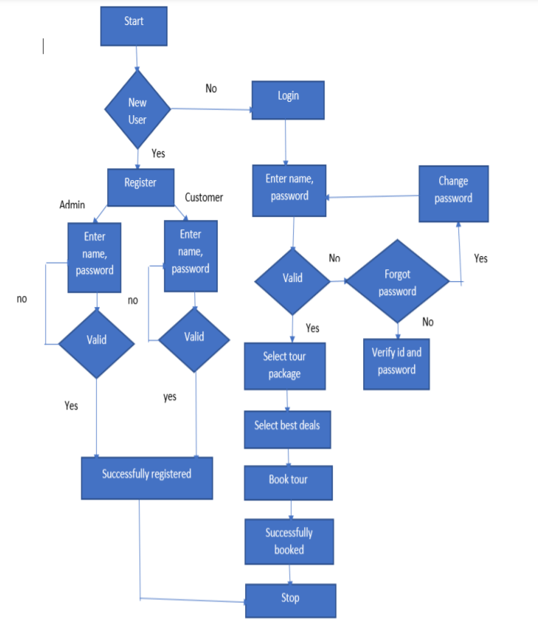

4.1 Data flow diagram.

TABLE 2.
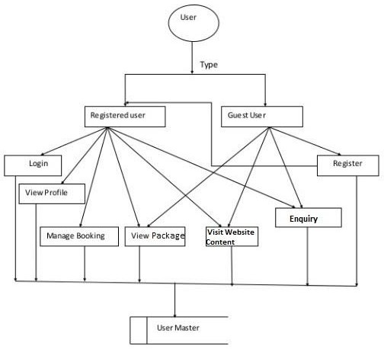

TABLE 3.
Users.
Database.
Admin.
Guest User.
User.
TOURISM MANAGEMENT SYSTEM (TMS).

TABLE 4.
Admin.
Admin

Login.
Manage user.
Manage profile.
Manage pages.
Package.
Booking.
Manage issues
Manage enquiry.
Admin Dashboard

Admin master.
Add Information

TABLE 5.
D Packages.
Packages Master.
BOOKING.

Package Module.

Enquiry.
View.

UML (Unified Modeling Language) Design.
Unified Modeling Language is a Language for Specifying, visualizing, and communicating models using the Unified Modeling Language (UML).
The software system and its components are built and documented. A graphic is used.
Language offers a vocabulary as well as a set of rules and semantics. The UML emphasizes
The system's conceptual and physical representation. It records the choices and
Understandings of the systems that need to be built. It is employed to comprehend, design,
Configure, keep up with, and manage system information.

The UML is a language for: Visualizing, Specifying, Constructing and Documenting.
Visualizing.
Through the use of UML, we can view or visualize an existing system and ultimately, we can see how the system will look once it has been put into use. Without thinking, we are unable to act.
UML aids in the visualization of how system components interact and communicate with one another.

Specifying.

UML addresses the specification of all the significant, Making decisions on analysis, design, and implementation that must be made in creating and deploying a software system. Specifying entails creating models that are exact, unambiguous, and comprehensive.

Constructing.

Various programming languages can be directly coupled to UML models by
Converting a UML model into a programming language, such as Java, C++, or VB.
Through UM, forward and reverse engineering are both achievable.

Documenting.

In addition to the code, a project's deliverables include some artifacts that are vital for monitoring, managing, and conveying information about a system as it develops, including its requirements, architecture, desire, source code, project plans, tests, prototypes, and releasers.

UML Methodology and Unified Model Language Chart.

UML Approach and the UML Diagram.
A diagram is a visual representation of a collection of elements; it is most frequently a connected network of vertices and arcs. Drawing a diagram is a projection into a system that allows you to see it from numerous angles. A diagram depicts an obfuscated perspective of the components of a system for all save the simplest systems. The same element could be represented by several different diagrams, just a few diagrams, or none at all. Theoretically, a diagram might include any assortment of elements and connections. The five most practical viewpoints that make up the architecture of a software-intensive system, however, are only partially compatible with the tiny number of typical combinations that actually occur. Because of this, the UML has nine such diagrams: The following Diagrams of a class, an object, a use case, a sequence, a collaboration, a state chart, an activity, a component diagram, and the deployment diagram.

4.2 USE CASE DIAGRAM:
A use case diagram is a particular kind of behavioral diagram in the Unified Modeling Language (UML).

Derived from a use-case analysis and defined by it. Its objective is to provide a pictorial summary of

The functionality a system offers in terms of its actors and their objectives (represented as use cases),

As well as any connections between those uses cases.

Two modeling languages established by the unified modeling language standards formally include use case diagrams.

Systems modeling language (SML) and the modeling language (UML) (sysML).

UML design.
UML design is a shortlisted of unified modified language. This modeling language's goal is to make the system's design visible.

UML diagram.
TABLE 6.
ADMIN.
Manage package
Manager User
Tours &Travel management system.
Registration

Login
Admin.

Manage booking

Manage issues
View cancellation

Manage Enquiries

Use of case diagram.
It provides a visual overview of the key players in a system. The interaction between the actors' various functions is demonstrated.
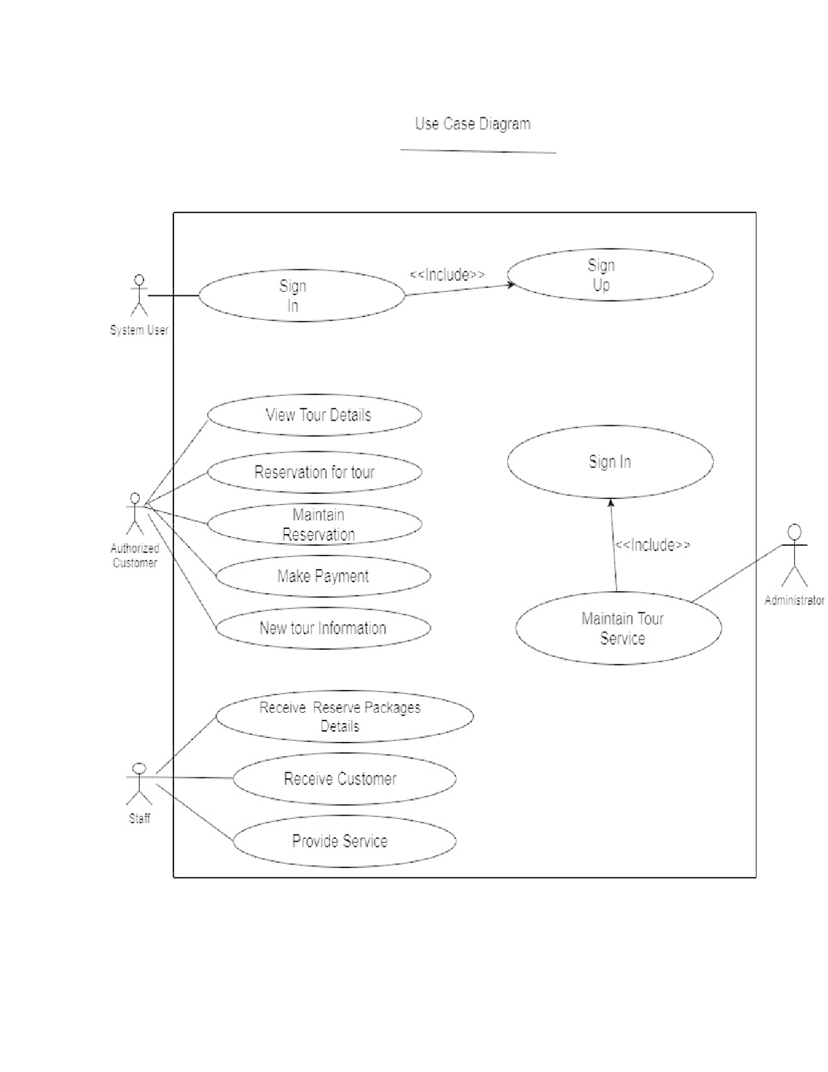
TABLE 7.

Sign in/sign up, Reservation for tour, View tour details,Mantain reservation, Database, New tour information, Receive,reserve packages, Receive customer, Provide services and Maintain tour service.
The actors in the systems are;
Administrator.
Staff.
Authorized customers.
Use case: sign in.
The admin enters a password and a username. And details are displayed on the screen if the entered information is accurate; if not, an appropriate notification is shown.
Use case: sign up.
New users provide their full name, address, email address, and their phone number for registration.
Use case: view tour details.
The authorized customer is able to view the details after registering in the system. The customer after providing with information details after reviewing can decide to cancel after booking.
Use case: reservation for tour.
Authorized customer has the tour reservation form which accepts online reservation system which likely used to minimize the paperwork process. This form gathers personal contact information; provide tour packages for the customers. If working with original reservation details in computerized system, we will be recorded and printed form of reservation done.
Use case: maintain reservation.
The records are maintained as documentation of original reservation in the computerized system.
Use case: database.
It stores all the data that are related to this tourism information and management system.

Use case: new tour information.
The new tour has to go through the information according and understand the activities, destination; sites etc. in the areas of tour and make payment if possible.
Use case: provide service.
The staff has to provide services to the authorized customer in the areas of tours. Also, the staff will be able make the customers fill satisfied which make them encouraged in the area.
Use case: receive the reserve packages.
The reserved entry fees and park rules are done by the staff and well respective accommodation and activities accordingly to make sure effective and acceptance by the customers.
Use case: maintain services.
The administrator completes the updating databases, scheduling appointments, providing services which ensure tasks performed in daily a basic that’s keeps running smoothly and efficiently.

Actors: Authorized customers.
The end users who use the system for booking tourism accommodation.
Actors: staff.
The staff is the one who provide services to the customers, ensure customers are safe in the areas of the tourism.
Actors: administrators.
The overall administrator of the system, who does all the maintenance of the booking system.

4.3 System requirement.
The system requirements for the tourism information and management system are described in this section. We will now list the essential hardware and software requirements.

4.4Hardware requirements or specifications.
Any software must have hardware in order for it to exist and function properly.
The size and capacity requirements are also crucial when choosing hardware.
A Pentium computer with a minimum of 128 MB of RAM and a 20 GB hard drive can run the Web Based Manufacturing System well. The operation of the information system is best suited by a 1.44 MB floppy disk drive and a 14-inch Samsung color monitor. (Hard copy production requires a printer.)
The minimum hardware requirements for the tourism information and management system are:
The Computer, a 1GB RAM or higher capacity, a 100GB Hard Disk Space, 1 MHZ Processor or higher, A floppy disk (1.44 MB), CD-ROM device (32 HZ) and a KEYBOARD (108 Standard) (108 Standard).

4.5 Software requirements.
Determining whether a certain software package satisfies the criteria is one of the most challenging tasks after system requirements are understood. After initial selection, more security is required to assess particular software's desirability in comparison to other options. This section offers more thorough comparisons after first summarizing the application requirement question.
The minimum software requirements for the tourism information system are the following:
Windows 7 or above operating system, Microsoft Word, Text Editor (Notepad) ,A Browser (Google Chrome),Operating System (Windows 95/98/NT/2000),A Web/Application Server (Xampp server),Database Server (MySQL),Database Connectivity (JDBC) and Other Tools & Technologies (PHP, HTML) .

4.6 Functional requirement.
2. Modules for administrators.
This module offers features for administrators. The administrator is in charge of all data and has access permissions to add, remove, edit, and see information about locations, trips, routes, reservations, inquiries, etc.
Packages— the administrator will make and maintain the packages (Create, Update, delete)
Users: The administrator can access all user information.
Booking: Admin is in charge of managing reservations. A traveler's booking may be confirmed or canceled by the administrator.
Admin can respond to any concern or complaint brought up by a user (a traveler) and posts a comment.
Admin can control any inquiries sent by users (traveler). All pages that are displayed on the website are Manage pages, and the Admin can alter their information.
Dashboard: From here, the admin may see the total number of bookings, problems, inquiries, and users.
Change password--- Admin can change own password.
2. Authorized users.
Signup- User can register you for booking.
Sign in- Here the user can login with valid username and password to view the packages.
Forgot Password— The User can recover his/her own password through the registered email address or mobile phone.
My Profile- The website or the system user can update his or her own profile.
Tour history-. The user can book any tour that appears in the tour history after logging in. The user has 24 hours to cancel their reservation.
Change password- The use can change his or her own the password incase needs be.

Write-use — here the user can raise any issue related to booking. Cancelation any enquiry etc.
3. Guest MODULE:
A guest user may access and view the entire website's content. Visitors can also do inquires on the website during the time of booking and requesting reservations.

Nonfunctional requirements of the tourism information and management system.

The nonfunctional requirements of the tourism information and management include the system's security, dependability, portability, scalability, and maintainability. Following is an introduction to each individual function:
The system's security: Customers can use the system by enrolling and confirming in it; otherwise, they will not be able to obtain any service information from the tourism information service system.
The System's Reliability: For customers to accurately access the mechanism's travel information, a reliable login system is required.
The system's portability and scalability allow it to expand its functionality while maintaining compatibility with new customers without impairing its current functionality.
The System's Maintainability: Make sure that it fixes system errors within 24 hours.
The performance requirements of the tourism information and management system.
The tourism information and management system's performance requirements are that
At least 500 visitors can be accommodated at a time by the tourism information and management system, and normal system operation is guaranteed. The electronic map's reaction time under a typical network is 3 seconds or less, and the text information's response time is 2 seconds or less. It requires a database table with a minimum of 10,000 lines, a 40 GB or larger disk, and 512 MB of memory.

CHAPTER FIVE:

DATABASE DESIGN.

5.0 Database Layout or Database design.
To hold information and relevant data, the database's contents must be logically arranged. The MYSQL database management system was chosen to be the database development tool for this project. After deciding on the relational database to be utilized and receiving information on the data that has to be maintained for the project, a design for the database that shows the entity relationship diagram was produced as shown below.
TABLE 1.
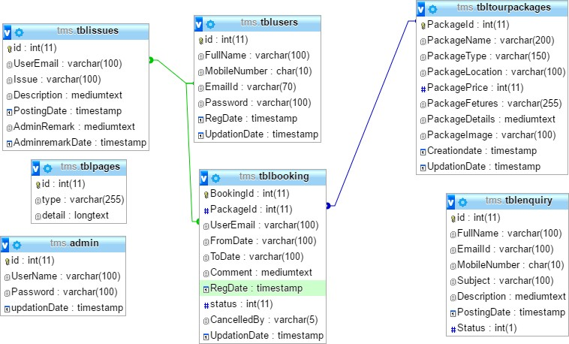

TABLE 2.
Tblpages
Column. | Type. | Null | Default
Id(primary) | Int(11) | No
Type | Varchar(255) | No
Detail | Long text | No

TABLE 3.
Indexes
Key name | type | unique | packed | column | cardinality | collation | Null | comment
Primary | BTREE | yes | No | Id | 4 | A | No

TABLE 4.
Tblissues
Column | Type | Null | Default | Links to
Id(primary) | Int(11) | No
userEmail | Varcher(100) | No |  | Tblusers>emailid
Issue | Varcher(100) | No
Description | Mediumtext | No
Posting date | Timestamp | No | CURRENT_TIME STAMP
AdminRemark | Mediumtext | Yes | NULL
AdminRemarkDate | Timestamp | Yes | 0000-00-00:00:00

TABLE 5.
Indexes.
Keyname | type | unique | packed | column | cardinality | collation | Null | comment
Primary | BTREE | yes | No | Id | 4 | A | No

5.1 The Interface Design for Users.
For one to create a system that is user-friendly for all the users, it is crucial to take the interface design into account. As previously said ,Designing a system is one of the objectives of this project that is useable by visually impaired users. The system may be used by a variety of users, and those users may range from novice users to expert users; the system needs to be able to handle both. As a result, the system adopts a fundamental approach to interface design and will only require a limited number of interfaces.

How to host the website on the XAMP control panel?
On my Tourism Management System Website, I will have to host it on xamp, the below picture is a screenshot to show how the XAMP control panel looks like before hosting.
On this case I will have to host my project on xamp control panel version (v3.3.0). First one has to down the version of the xamp in his or her laptop or desktop, Download and install XAMPP or WAMP, or any other local web server.

XAMP CONTROL PANEL.
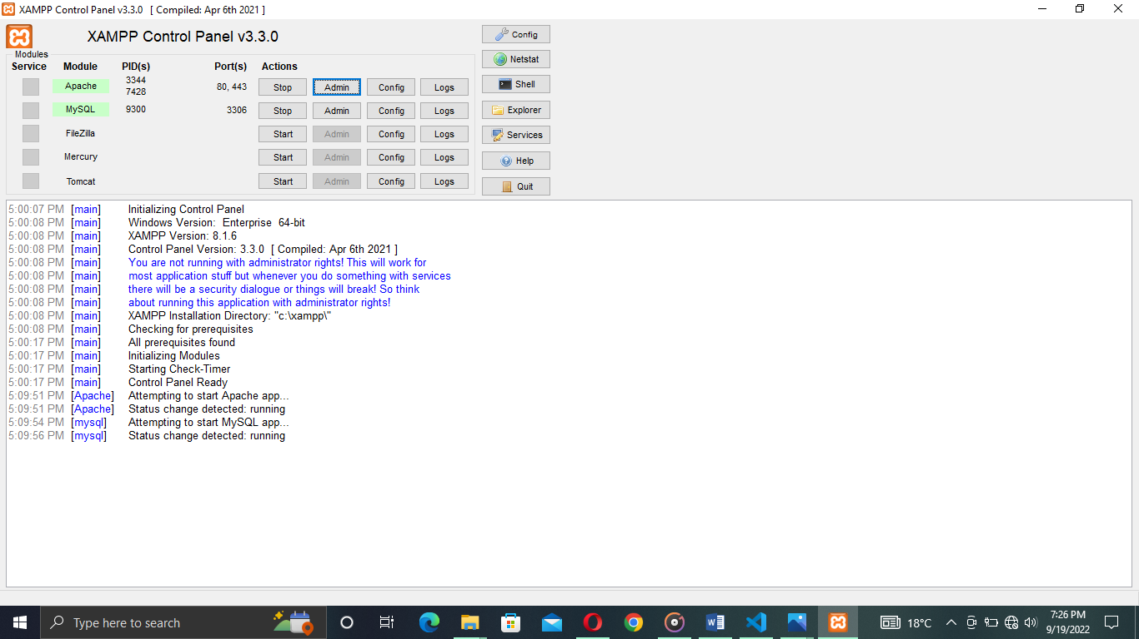

HOW TO LOG IN FROM THE WEBSITE HOST (XAMP).
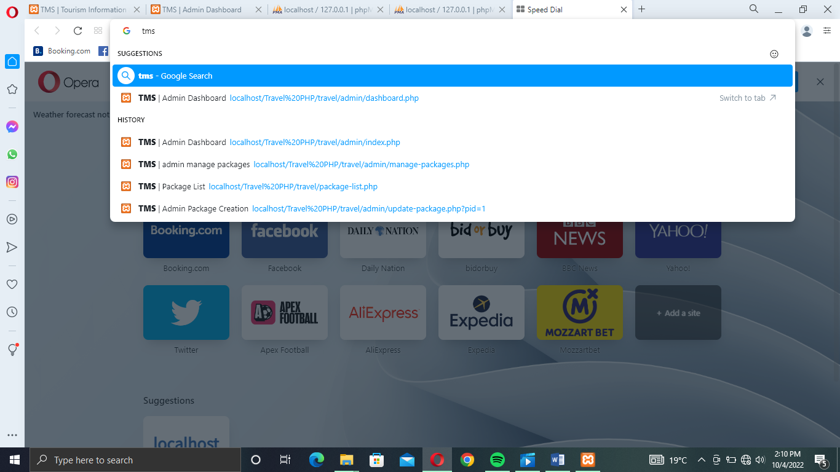

1 TMS ADMIN LOG IN ACCESS.
The Tourism Management System has an Admin Log in Access, the log in access has a sign in access for the administrator, and it has two very important requirements, the username for the administrator and the valid password.
Below is a screenshot for the admin log in or sign in page, in my case the log in credentials for the administrator are (Admin as the username and Test@123 as the password.
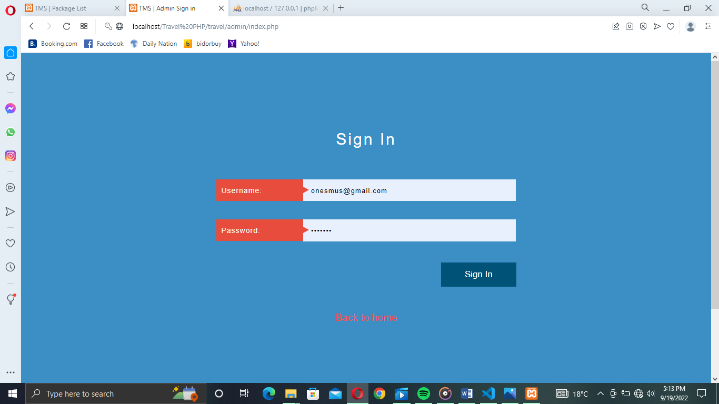
Admin can confirm/reject the booking.
- TMS CREATING PACKAGE TAB.
The Tourism Management System on its dashboard it has an option for crating travelling or dinner packages, it may be either in a hotel or a game reserve package, in the case the administrator is the one authorized to create a package so as to reflect on the user website.
Below is a screenshot on how the package tab looks like. Where by it have features like Package name, package type, package location, package price in Ksh and package features.
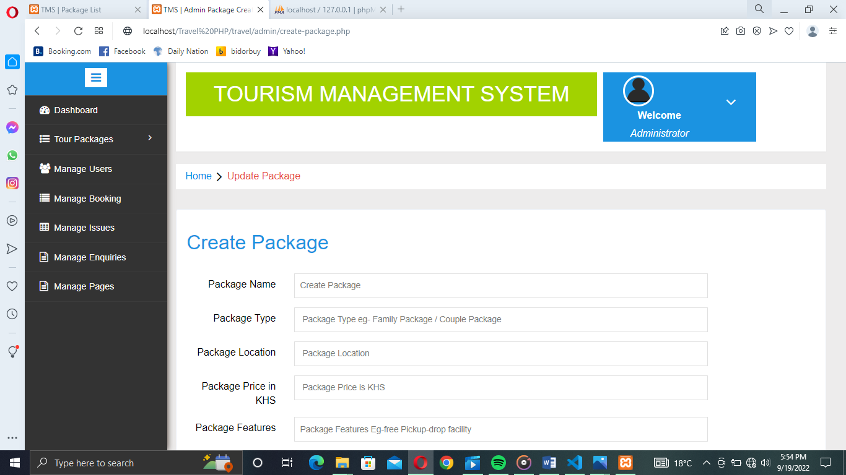
- TOURISM MANAGEMENT DASHBOARDS.
Tourism Management system has a designed dashboard which shows what the website contains on the Administrator side, for example my website has six characters or login pages which offer different roles. For example Tour packages to show the created package and to create new packages for the views to view and book for a trip or tour.
It also contains the following. Manage users, Manage bookings, Manage issues, Manage enquiries and Manage pages.

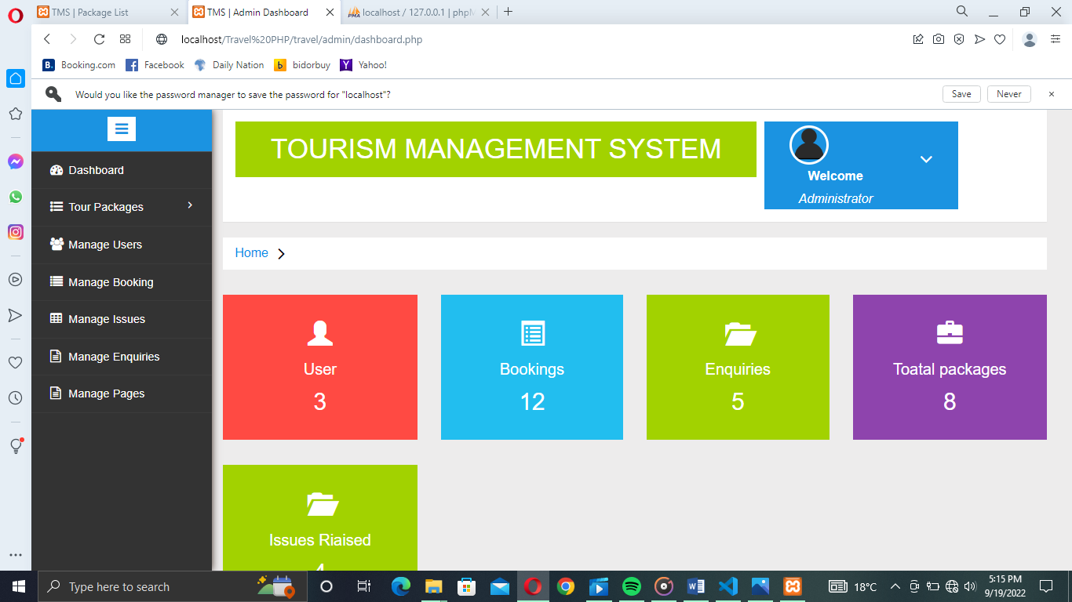

4 TMS MANAGE USERS DASHBOARD.
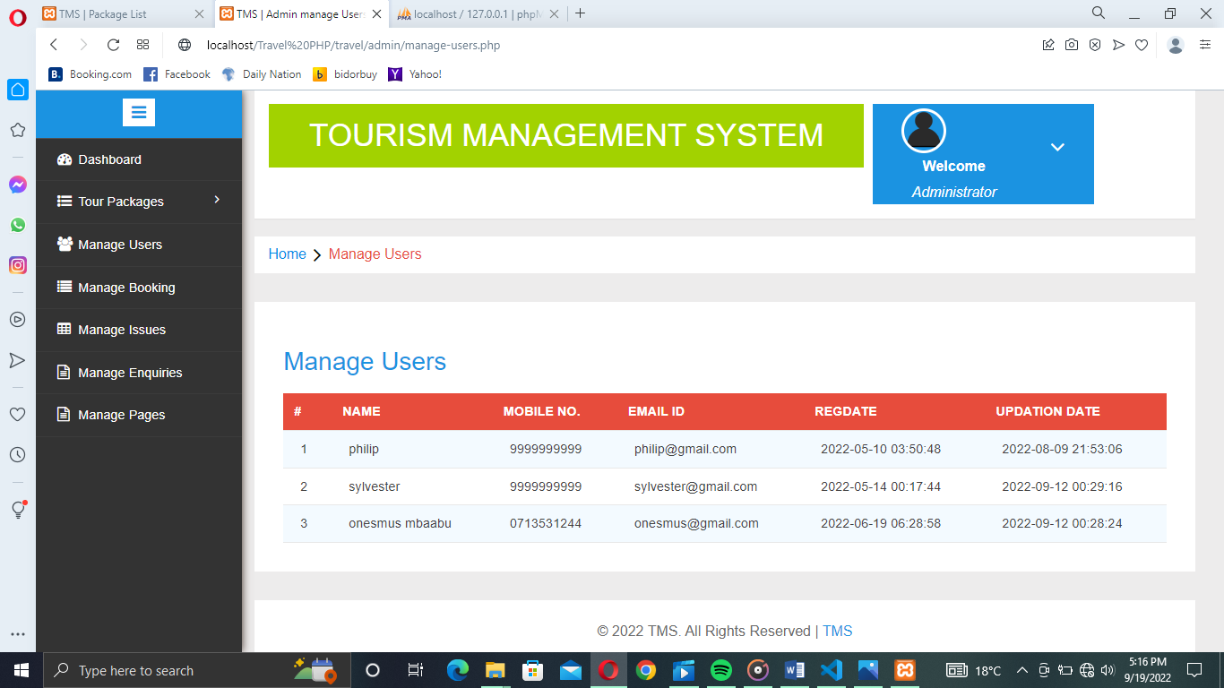
5 TMS MANAGE BOOKINGS TEST DASHBOARD.
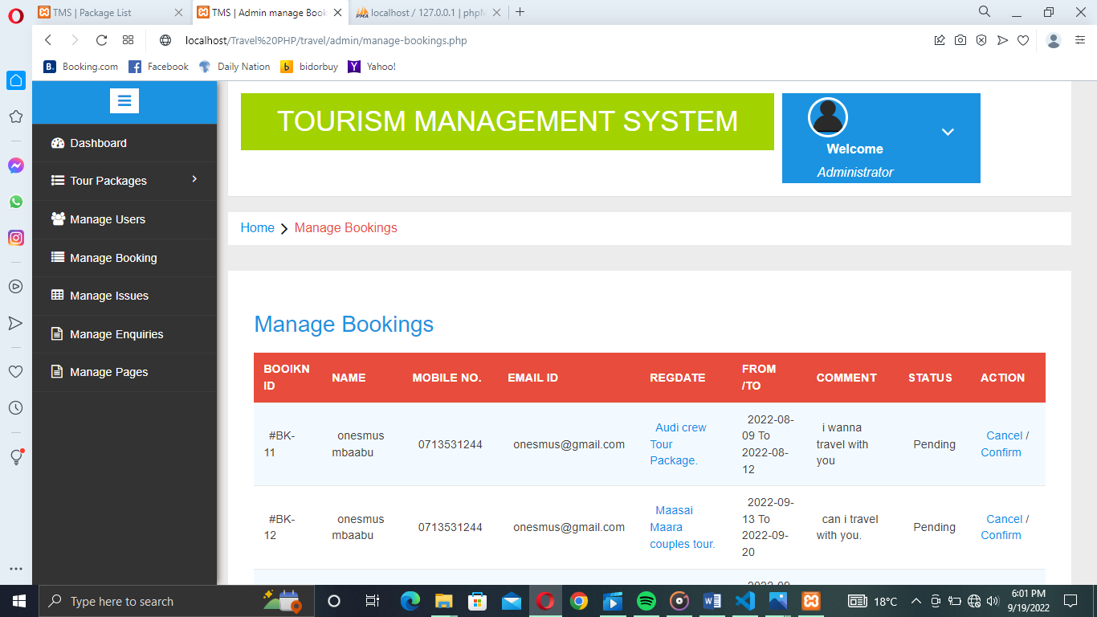

6 TMS MANAGE ISSUES DASHBOARD.
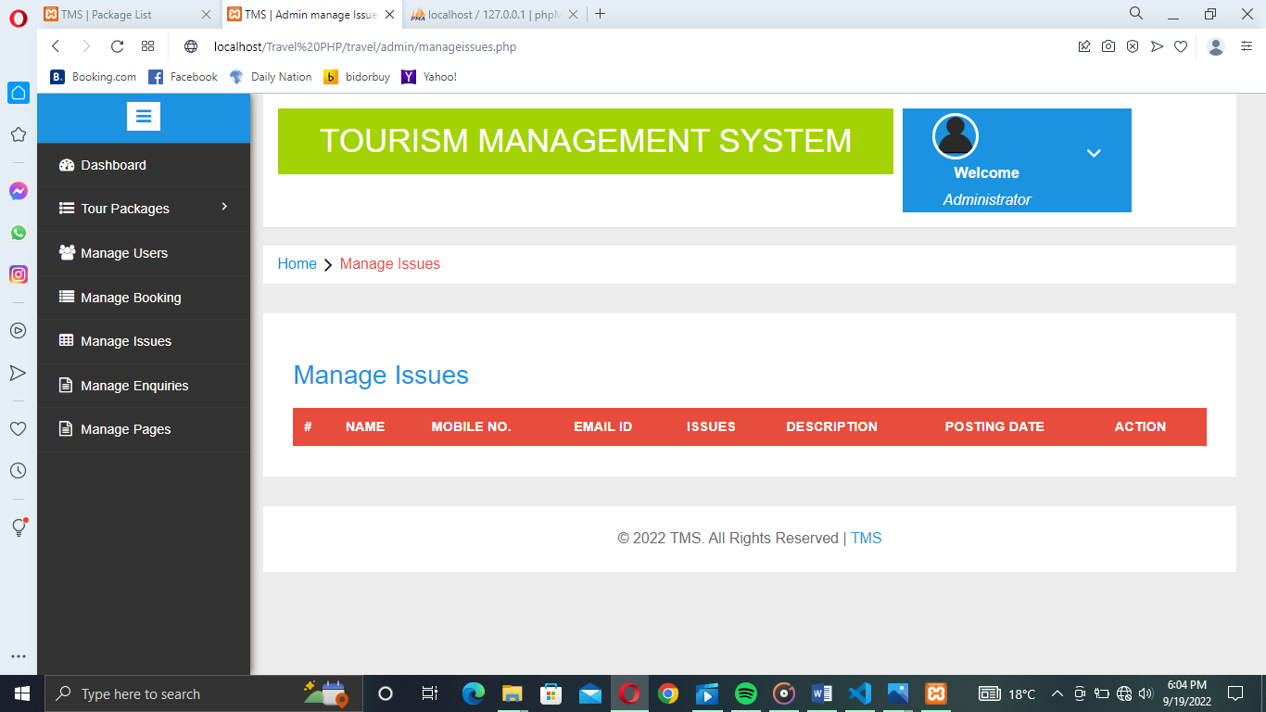

7 TMS UPDATE PAGE DATA DASHBOARD.
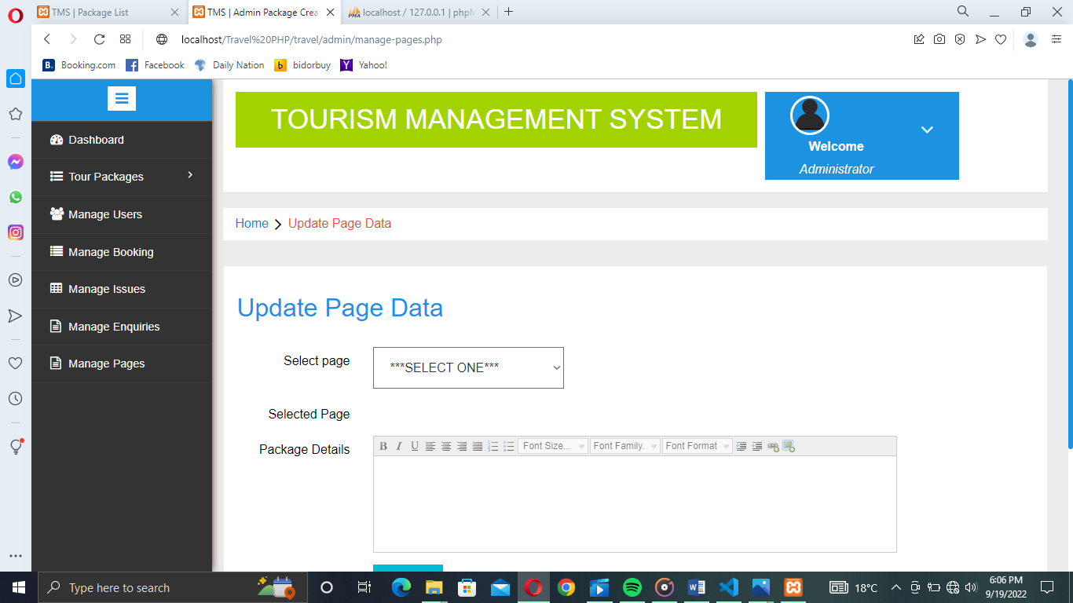
8 TMS USER PACKAGE LISTS EXAMPLE.
This is a sample of package created by the administrator on the Tourism Management Website, it was a general test on the website done to check whether the clients or the users could do some bookings, the general test package was named Mbaabu Onesmus Friends Package, the package location was stated as Mount Kenya Tour and the package price was KS 2000 each per individual.
The screenshot shows how it appeared on the website user side or the client side.
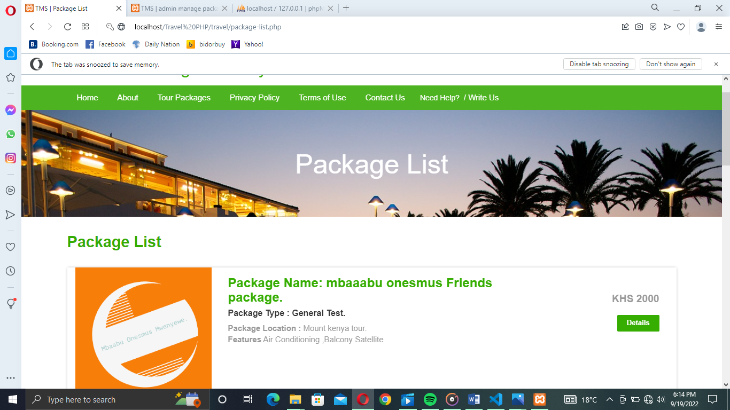

CHAPTER SIX:
SYSTEM IMPLEMENTATION AND SYSTEM TESTING.
6.0 Introduction to system implementation and testing.

SYSTEM IMPLEMENTATION.
It is the process of making sure an information system is functional and enables people to take control of it so as they may utilize and evaluate Implementations such as:
Training of end users how the whole system operates and the functionalities of the system
Completion of the user manual.
System upgrade or changeover.
System evaluation at regular periods.
The project's implementation phase is when the conceptual design is transformed into a functional system. As a result, it can be said to be the stage that will determine whether a new system is a success and whether its users have faith in its ability to function well.
The implementation step entails meticulous planning, research into the current system and its implementation limitations, design of transitional methods, and evaluation of transitional methods.
At this point, the programming code is generated in accordance with DDS (Design Development Service). Code generation can be completed quickly if the design is done in a precise and systematic manner.
Testing is done to look for mistakes. To test anything is to put it to the test ensuring that the
Software system does not fail in an unacceptable way and satisfies user expectations and criteria. Different test types exist. Each test type focuses on a certain testing issue.
TYPES OF TESTING:

Unit testing:
Types of testing include unit testing, which entails creating test cases to verify that the internal computer logic is operating correctly and that program inputs result in legitimate outputs. It is important to verify the internal code flow and all decision branches. It is the testing of the several software parts of an application. It happens after each individual unit is finished, not before integration. This is an intrusive structural test that relies on knowing how it was constructed. Unit tests evaluate a specific configuration of a system, application, or business process while performing fundamental tests at the component level. Unit tests provide assurance that each unique business process path complies perfectly with the stated standards and has well-defined inputs and outputs.
Integration testing:

Integration tests are made to test integrated software components to see if they work together properly and ran as a single program. Event-driven testing is more focused on the fundamental consequence of screens or fields. Integration tests prove that the combination of the components is correct and consistent, despite the fact that the unit testing of the separate components was successful .The purpose of integration testing is to identify issues that can occur when combining components.

Functional test:
Functional tests provide methodical evidence that the functionalities under test are available and meet all technical and business requirements as well as those specified in the system documentation and user guides.

The Focus of functional testing is on the following areas:

Valid Input: The Recognized valid input classes must be accepted.

Unacceptable Input: Recognized categories of unacceptable input must be discarded.

Functions: It is necessary to use the listed functions.

Output: The identified application output classes must be put to use.

Systems/Procedures: It is necessary to call interacting systems or processes.
With a focus on requirements, crucial functions, or special test cases, functional tests are planned and produced. The systematic coverage of data fields, established practices, following processes, and business process flows must all be taken into account during testing. Before functional testing is complete, further tests are discovered, and the effective value .

System Test:

System testing guarantees that the integrated software system as a whole complies with requirements. To assure known and predictable results, it checks a configuration. An illustration of a system test is the system integration test that is configuration-oriented. Process descriptions provide the basis of system testing thus highlighting integration points and links between pre-driven process operations.

White Box Testing:

A White box testing is a type of testing where the software tester is familiar with the inner workings, structure, and language of the software, or at the at least, knows what it is intended to do. It has a goal. It is employed to test regions that are inaccessible from a black box level.

Black Box Testing:
The term "black box testing" refers to software testing done without any prior knowledge of the inner workings, architecture, or language of the module being tested. A Black box tests, like the majority of other types of tests, must be created from an authoritative source document, such as a specification or requirements document. This type of testing treats the software being tested as a black box. You can't look inside of it. Without taking the software's operation into an account, the test generates some inputs and reacts to outputs.
Unit Testing:
Although it is not unusual for coding and unit testing to be carried out as two separate processes, unit testing is typically done as part of a phase of the software lifecycle that combines the two.

Test strategy and approach.
Analyze your approach and strategy.
In-depth functional tests will be written, and field testing will be done manually by the researcher or the person conducting the research.

Test objectives.
Each field entry must function correctly.
To activate pages, click the specified link.
There should be no delay in the entry screen, messages, or responses.
The Features to be tested are.

Check to see if the entries are formatted correctly.

There shouldn't be any room for repeat entries.

The user should be directed to the correct page by each link.

Integration Testing:
Software integration testing involves incrementally integrating two or more software components that have been integrated on a single platform in order to induce failures brought on by interface flaws.
The goal of an integration test is to make sure that software applications or their components, such as those found in a software system or, in a higher level, those found at the corporate level, work together without error.
Test Results:
The Results of the tests showed that each of the aforementioned test scenarios was successful. Nothing wrong was found.

Testing acceptance:
Acceptance by users, any project's testing phase is crucial and necessitates the end user's active involvement. Additionally, it makes sure the system satisfies the functional specifications of the project proposed.

Test Results:
Each of the aforementioned test cases ended in a successful way. Nothing wrong was found.

TOURISM MANAGEMENT SYSTEM CODE ON VISUAL STUDIO, SAMPLES OF SCREENSHOTS.
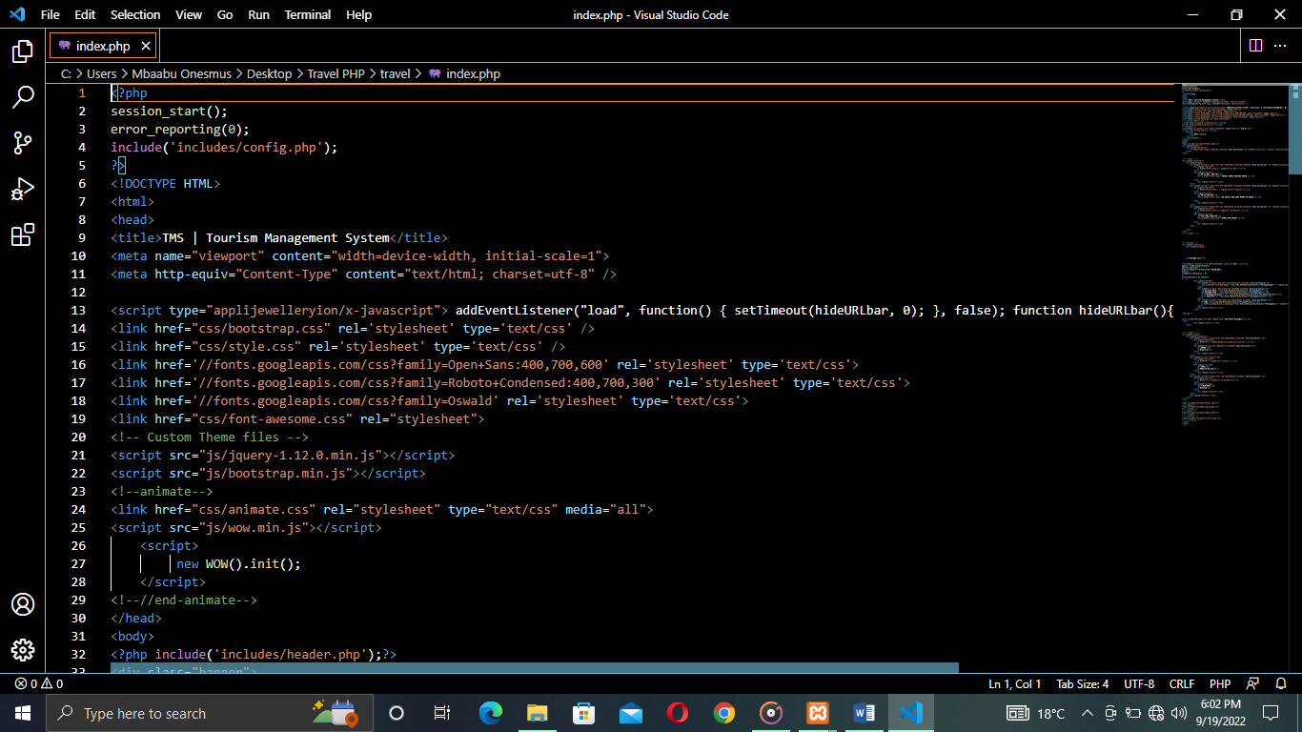
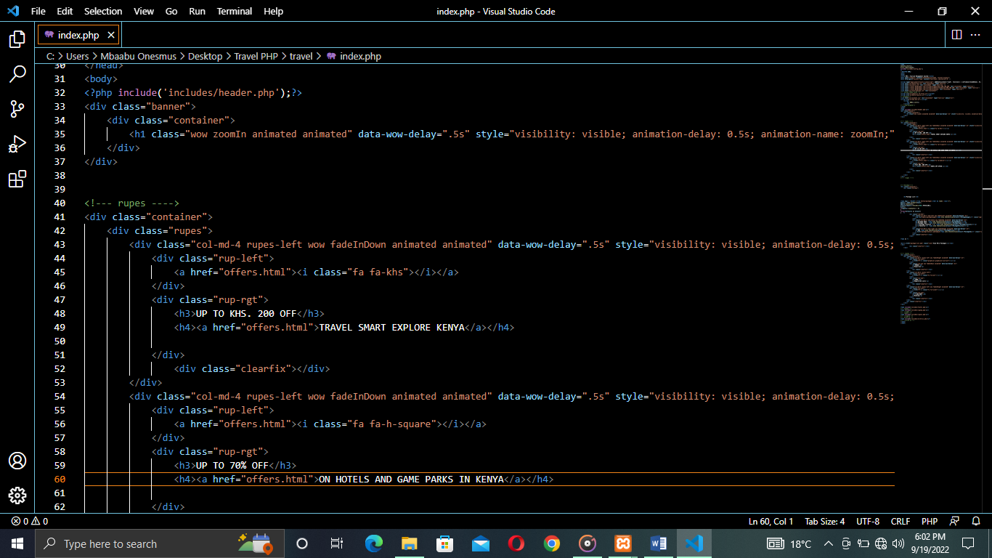
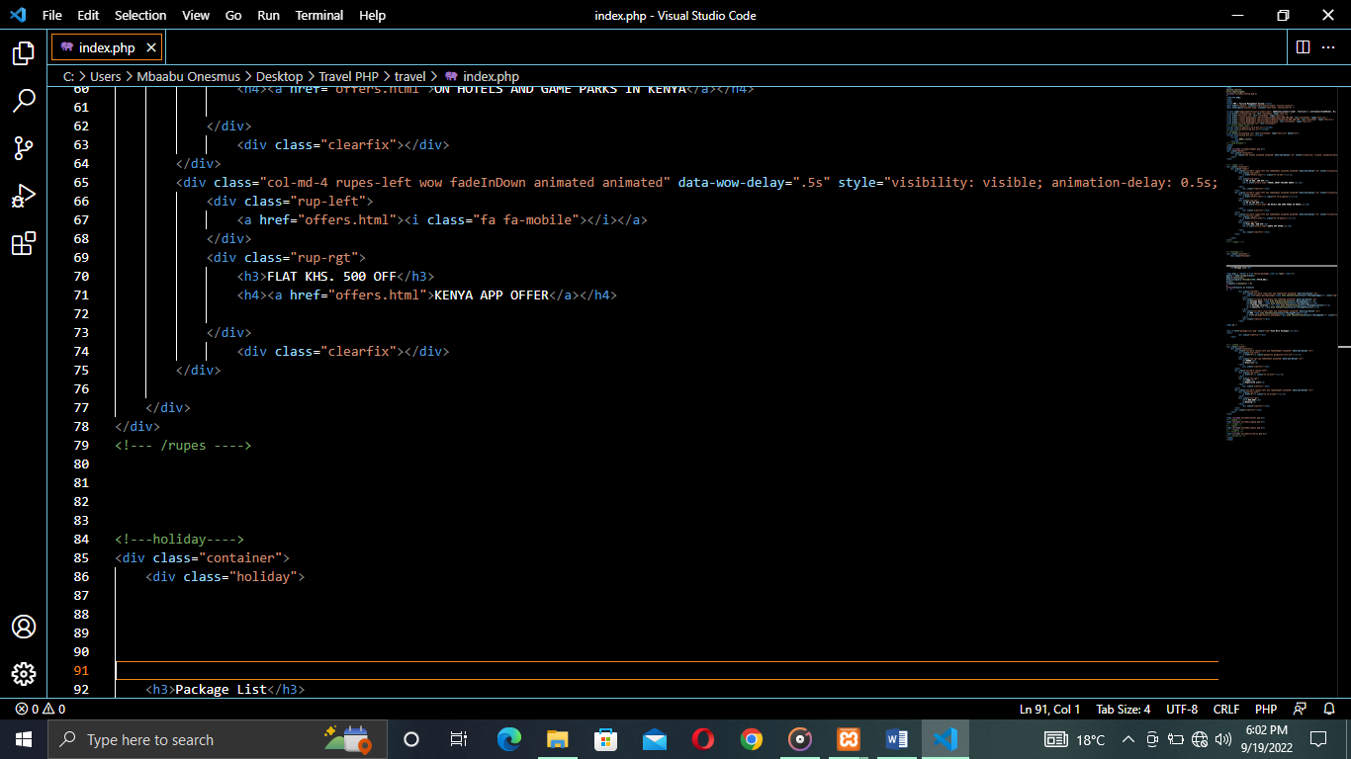
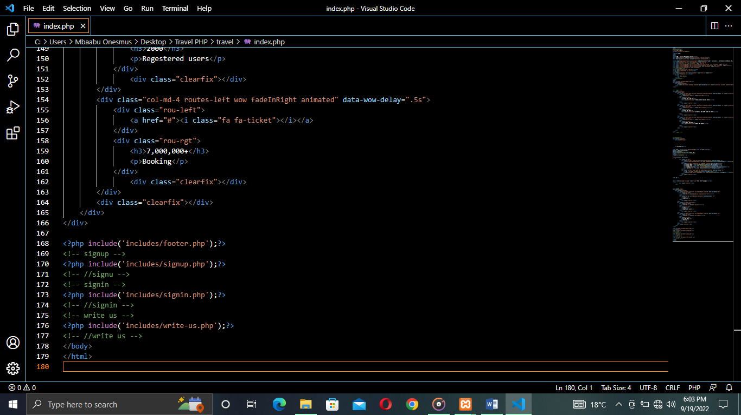

Sample code: html.
<! DOCTYPE HTML>
<html>
<head>
<title>TMS | Tourism Management System</title>
<meta name="viewport" content="width=device-width, initial-scale=1">
<meta http-equiv="Content-Type" content="text/html; charset=utf-8" />

<script type="applijewelleryion/x-javascript"> addEventListener("load", function() { setTimeout(hideURLbar, 0); }, false); function hideURLbar(){ window.scrollTo(0,1); } </script>
<link href="css/bootstrap.css" rel='stylesheet' type='text/css' />
<link href="css/style.css" rel='stylesheet' type='text/css' />
<link href='//fonts.googleapis.com/css?family=Open+Sans:400,700,600' rel='stylesheet' type='text/css'>
<link href='//fonts.googleapis.com/css?family=Roboto+Condensed:400,700,300' rel='stylesheet' type='text/css'>
<link href='//fonts.googleapis.com/css?family=Oswald' rel='stylesheet' type='text/css'>
<link href="css/font-awesome.css" rel="stylesheet">
<!-- Custom Theme files -->
<script src="js/jquery-1.12.0.min.js"></script>
<script src="js/bootstrap.min.js"></script>
<!--animate-->
<link href="css/animate.css" rel="stylesheet" type="text/css" media="all">
<script src="js/wow.min.js"></script>
<script>
new WOW().init();
</script>
<!--//end-animate-->
</head>
<body>
<?php include('includes/header.php');?>
<div class="banner">
<div class="container">
<h1 class="wow zoomIn animated animated" data-wow-delay=".5s" style="visibility: visible; animation-delay: 0.5s; animation-name: zoomIn;"> Tourism Management System</h1>
</div>
</div>

<!--- rupes ---->
<div class="container">
<div class="rupes">
<div class="col-md-4 rupes-left wow fadeInDown animated animated" data-wow-delay=".5s" style="visibility: visible; animation-delay: 0.5s; animation-name: fadeInDown;">
<div class="rup-left">
<a href="offers.html"><i class="fa fa-khs"></i></a>
</div>
<div class="rup-rgt">
<h3>UP TO KHS. 200 OFF</h3>
<h4><a href="offers.html">TRAVEL SMART EXPLORE KENYA</a></h4>

</div>
<div class="clearfix"></div>
</div>
<div class="col-md-4 rupes-left wow fadeInDown animated animated" data-wow-delay=".5s" style="visibility: visible; animation-delay: 0.5s; animation-name: fadeInDown;">
<div class="rup-left">
<a href="offers.html"><i class="fa fa-h-square"></i></a>
</div>
<div class="rup-rgt">
<h3>UP TO 70% OFF</h3>
<h4><a href="offers.html">ON HOTELS AND GAME PARKS IN KENYA</a></h4>

</div>
<div class="clearfix"></div>
</div>
<div class="col-md-4 rupes-left wow fadeInDown animated animated" data-wow-delay=".5s" style="visibility: visible; animation-delay: 0.5s; animation-name: fadeInDown;">
<div class="rup-left">
<a href="offers.html"><i class="fa fa-mobile"></i></a>
</div>
<div class="rup-rgt">
<h3>FLAT KHS. 500 OFF</h3>
<h4><a href="offers.html">KENYA APP OFFER</a></h4>

</div>
<div class="clearfix"></div>
</div>

</div>
</div>
<!--- /rupes ---->

<!---holiday---->
<div class="container">
<div class="holiday">

<h3>Package List</h3>

<?php $sql = "SELECT * from tbltourpackages order by rand() limit 4";
$query = $dbh->prepare($sql);
$query->execute();
$results=$query->fetchAll(PDO::FETCH_OBJ);
$cnt=1;
if($query->rowCount() > 0)
{
foreach($results as $result)
{ ?>
<div class="rom-btm">
<div class="col-md-3 room-left wow fadeInLeft animated" data-wow-delay=".5s">
<img src="admin/pacakgeimages/<?php echo htmlentities($result->PackageImage);?>" class="img-responsive" alt="">
</div>
<div class="col-md-6 room-midle wow fadeInUp animated" data-wow-delay=".5s">
<h4>Package Name: <?php echo htmlentities($result->PackageName);?></h4>
<h6>Package Type : <?php echo htmlentities($result->PackageType);?></h6>
<p><b>Package Location :</b> <?php echo htmlentities($result->PackageLocation);?></p>
<p><b>Features</b> <?php echo htmlentities($result->PackageFetures);?></p>
</div>
<div class="col-md-3 room-right wow fadeInRight animated" data-wow-delay=".5s">
<h5>KHS <?php echo htmlentities($result->PackagePrice);?></h5>
<a href="package-details.php?pkgid=<?php echo htmlentities($result->PackageId);?>" class="view">Details</a>
</div>
<div class="clearfix"></div>
</div>

<?php }} ?>

<div><a href="package-list.php" class="view">View More Packages</a></div>
</div>
<div class="clearfix"></div>
</div>

<!--- routes ---->
<div class="routes">
<div class="container">
<div class="col-md-4 routes-left wow fadeInRight animated" data-wow-delay=".5s">
<div class="rou-left">
<a href="#"><i class="glyphicon glyphicon-list-alt"></i></a>
</div>
<div class="rou-rgt wow fadeInDown animated" data-wow-delay=".5s">
<h3>90000</h3>
<p>Enquiries</p>
</div>
<div class="clearfix"></div>
</div>
<div class="col-md-4 routes-left">
<div class="rou-left">
<a href="#"><i class="fa fa-user"></i></a>
</div>
<div class="rou-rgt">
<h3>2000</h3>
<p>Regestered users</p>
</div>
<div class="clearfix"></div>
</div>
<div class="col-md-4 routes-left wow fadeInRight animated" data-wow-delay=".5s">
<div class="rou-left">
<a href="#"><i class="fa fa-ticket"></i></a>
</div>
<div class="rou-rgt">
<h3>7,000,000+</h3>
<p>Booking</p>
</div>
<div class="clearfix"></div>
</div>
<div class="clearfix"></div>
</div>
</div>

<?php include('includes/footer.php');?>
<!-- signup -->
<?php include('includes/signup.php');?>
<!-- //signu -->
<!-- signin -->
<?php include('includes/signin.php');?>
<!-- //signin -->
<!-- write us -->
<?php include('includes/write-us.php');?>
<!-- //write us -->
</body>
</html>

TMS ADMIN DASHBORD CODE SAMPLE.
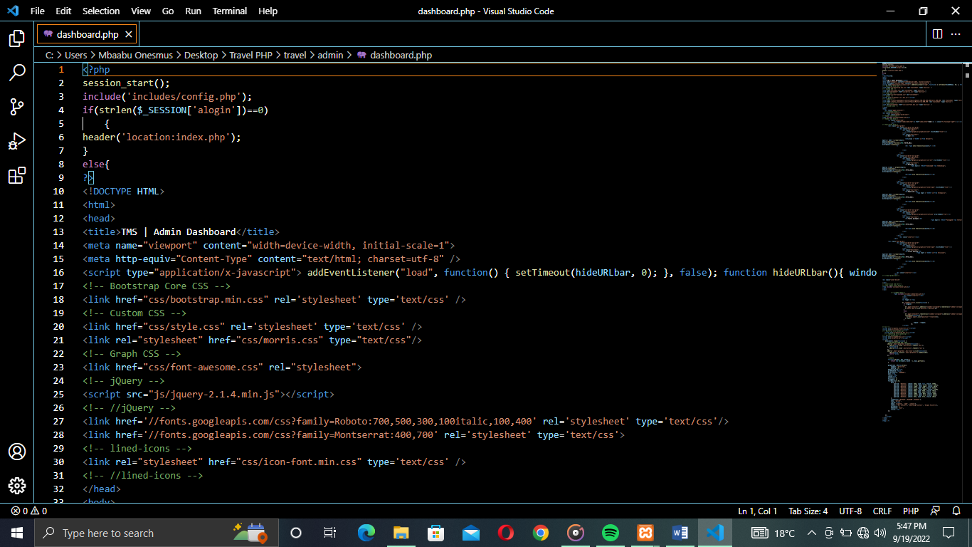

TMS ADMIN MANAGE PACKAGES CODE SAMPLE.
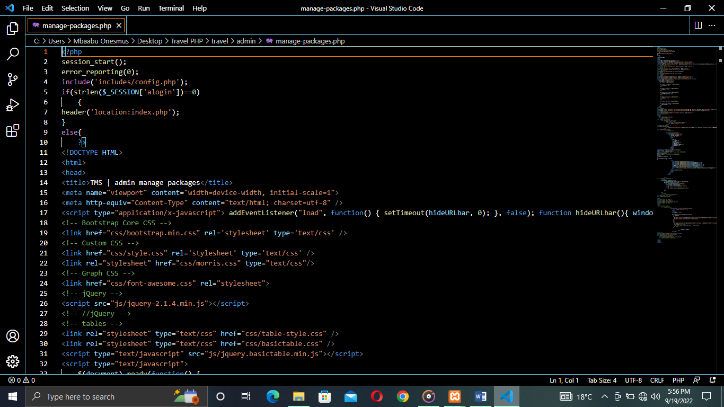
TMS ADMIN PAGE CODE SCREENSHOT 1.

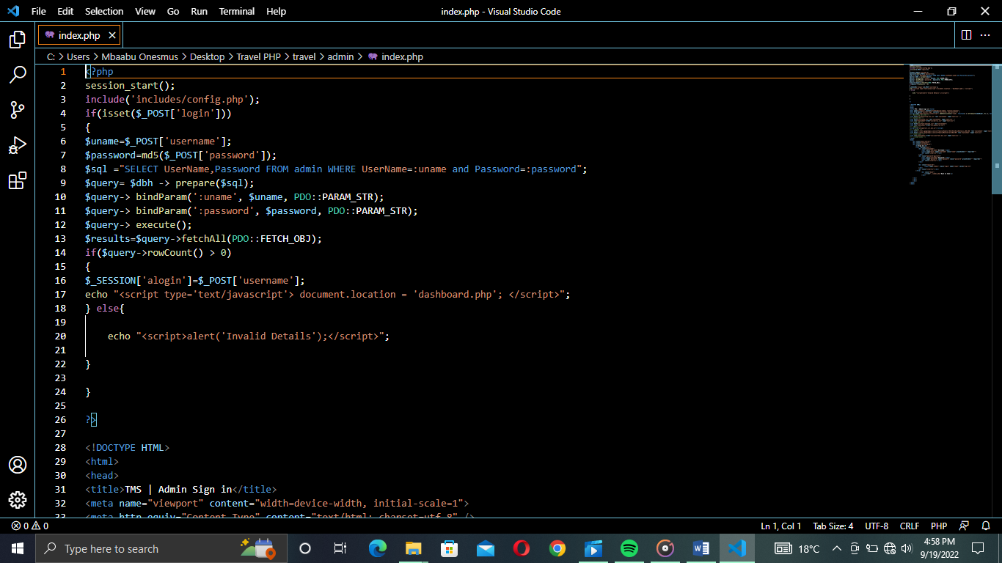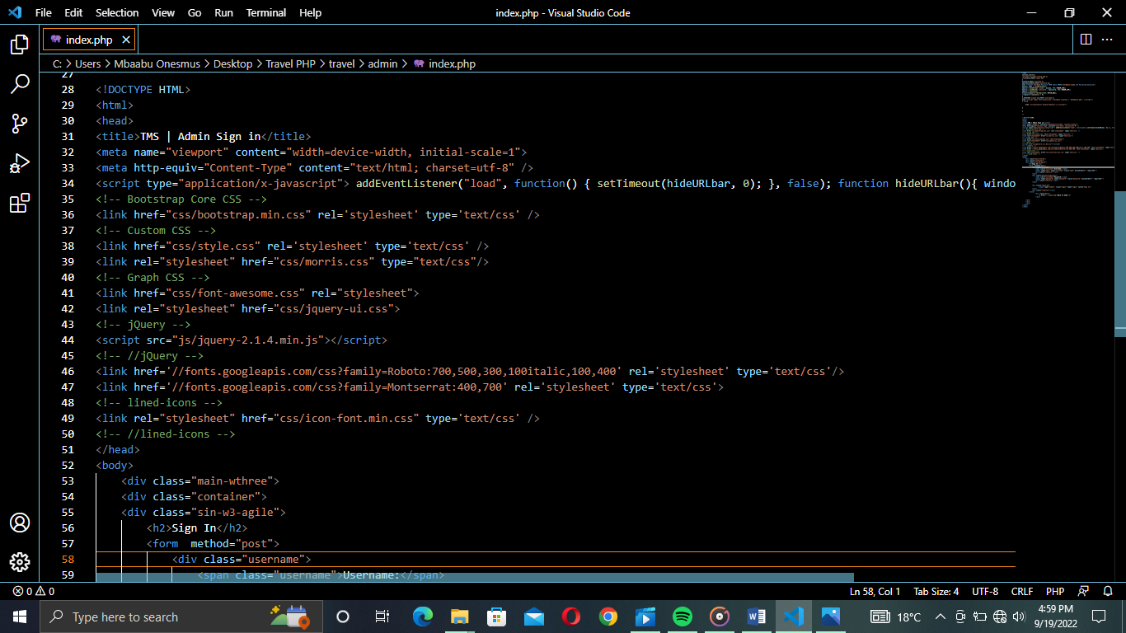

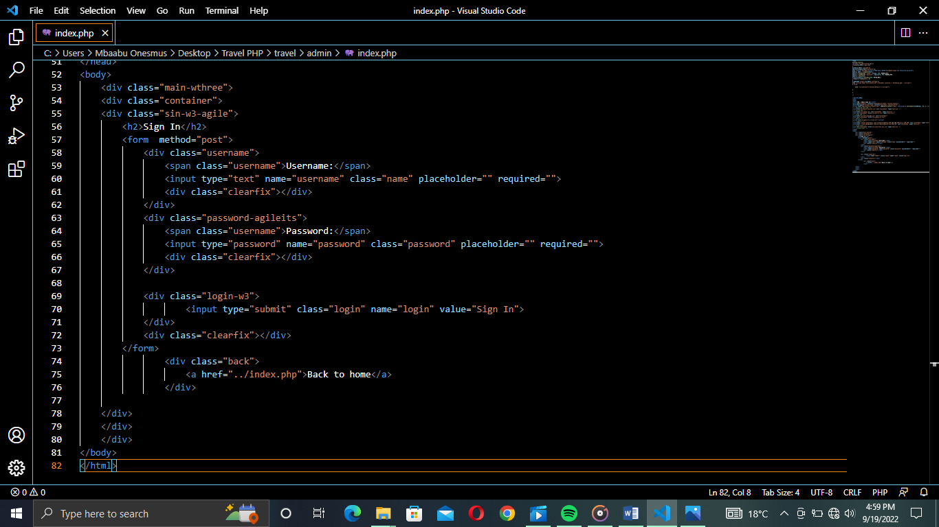

CHAPTER SEVEN:

ACHIEVEMENTS AND LESSON LEARNT.

7.0 Achievements.
I have managed to develop a well-functioning web-based Online Tourism Management Booking System
I have developed a system whereby the error rates are low enough and the system is fit to function.
The user interface is easy and quick to understand.
As compared to the project plan, the final output of the system was far more advanced

7.1 Conclusions.
Despite the fact that the system as a whole will offer some benefits for The Kenya Tourism Board, some of the facts needed to be considered. If the internet connection become down, then the system will halt and no offline data can be accessed through it. Changing customers mind wont effect, the system as there will be no refund after booking.
The pros of the system we can consider here is like Kenya tourism board can run the business smoothly as there will be no hustle regarding managing customer’s details, booking details, payments and so on. This system will increase the productivity of their business as well.
The project developed using PHP and MySQL is based on the requirement specification of the user and the analysis of the existing system, with flexibility for future enhancement.
The expanded functionality of today’s software requires an appropriate approach towards software development. This tourist management software is designed for people who want to manage various activities in the tourism sector.
Identification of the drawbacks of the existing system leads to the designing of computerized system that will be compatible to the existing system with the system which is more users friendly and more GUI oriented.
Besides, there is also need to provide hands on training to the staffs so that they will become more familiar to the system and also make it easy for them to book accommodation and viewing sites on behalf of customers. Auto backup will be implemented in future as currently we designed the backup system manually. If the system crash, then all the data will be erased so staff should take care for keeping the data safe by saving it every day after office hours.
From the above discussion we can say that although the system will have some cons, somehow it will have some positive impact to Kenya tourism board and tourism sector at large. Comparing to current system which is just a manual book keeping, this online web system will automate their day-to-day business process.

APPENDIX.
How to Run or Ways to Run.
Requirements to host the website.
Download and install XAMPP or WAMP, or any other local web server.
Download the source code zip file that is provided. (The download button is below there.)
Installation/Setup.
Start "Apache" and "MySQL" from the Control Panel of your XAMPP/WAMP installation.
Extract the source code file that you downloaded.
Copy the extracted source code folder and paste it into the XAMPP directory if you're using that.

the "htdocs" directory of XAMPP. Add it to the "www" directory if you're using WAMP.

Use a browser to browse PhpMyAdmin. Specifically, http://localhost/phpmyadmin
Make a new database with the name "travel-php."
Import the SQL file that has been given. The "tms db.sql" file is found inside the "travel" directory.
Browse the Modern Tourism Management System in a browser. i.e., http://localhost/Ticket_Reservation_system
Admin Access
Username: admin
Password: Test@123

REFERENCES.
Affolter Daniel (1998). The Electronic Tourism Market Place challenges. The 5th International Conference on Information and Communication Technologies in Tourism, Istanbul, Turkey, page 4-5, retrieved from https://www.mngt.waikaito.ac.nz.pdf
Agnihotri, R., Dingus, R., Hu, M.Y. and Krus, M.T., (2016). Social media: Influencing customer satisfaction in B2B sales. Industrial Marketing Management. Page 3 retrieved from https://www.reseachgate .net pdf
Ahmad, N.S., Musa, R. and Harun, M.H.M., (2016). The impact of social media content marketing (SMCM) towards brand health. Procedia Economics and Finance page 4 retrieved from. https://www.reseachgate .net pdf
Alves, H., Fernandes, C. and Rapson, M., (2016). Social media marketing: a literature review and implications. Psychology & Marketing. Page 4 retrieved from https://www.reseachgate .net pdf.
Badri, A. (2002): Shaping Web Usability. Boston: Pearson Education, Inc.
Eastman Group, March, www.eastmangroup.com page 4 retrieved from https://www.mngt.waikaito.ac.nz.pdf
Eastman, Richard (1998). Essays on Factors that Influence Travel Product Distribution,
In.php.net ,www.w3schools.com
Jung, Hyung-Soo and Baker, Michael (1998). Assessing the Market effectiveness of the
Madden A.D., (2000): "A definition of information", Alsip Proceedings, Vol. 52 ISSP: 9, pp.343 – 349
Operator Web Sites, The Journal of Tourism Studies, page 4 retrieved from https://www.mngt.waikaito.ac.nz.pdf
Ranchman, Zulfikar M. and Richens, Harrold (1997). The Status of New Zealand Tour
The Service Sector, University of Surrey page 4 retrieved from https://www.mngt.waikaito.ac.nz.pdf
Travel and Tourism Council, www.wttc.org ,page 4 retrieved from https://www.mngt.waikaito.ac.nz.pdf
World Wide Web in National Tourism Offices, School of Management Studies for
WTTC (1998). The Travel and Tourism Satellite Account, World Economic Impact, World
www.apache.org/ en.wikipedia.org/wiki/PHP www.mysql.com/click php =35050

