

THE MANAGEMENT UNIVERSITY OF AFRICA

ADMISSION NUMBER : DIR/12/00080/3/21

NAME : LEILA ADHAN ABDI

COURSE TITLE : INDUSTRIAL ATTACHMENT

COURSE CODE : DCU 110

SUPERVISOR :

ORGANIZATION : STATE DEPARTMENT FOR EAST AFRICAN COMMUNITY

TABLE OF CONTENTS

TABLE OF CONTENTS 2
INTRODUCTION 3
Background of the company 3
The Mission, Vision and core Values 3
Functions 4
Organizational structure 5
Department Attached 5
Purpose of the Attachment 5
My expectations 6
General activities undertaken 6
KEY ACHIEVEMENT AND BENEFITS OF THE PROGRAM 7
My achievements 7
Lessons learnt 7
Own skills applied during attachment 7
Key observation made 8
CHALLENGES 9
SOLUTIONS 9
RECOMMENDATIONS 10
CONCLUSION 10

INTRODUCTION

Background of the company
State Department for East African Community
The task of coordinating and carrying out policies, initiatives, and programs intended to strengthen regional integration falls within the purview of the State Department for East African Community Integration. It develops EAC policy, organizes public and private sector involvement in EAC affairs, manages the execution of EAC regional programs, manages the execution of the EAC Treaty, and promotes and expedites the EAC integration process.
The Customs Union, Common Market, and Monetary Union procedures are being implemented in accordance with schedules, and the State Department wants to increase Kenya's involvement in these processes. It also serves as a coordinating tool in the process of establishing the EAC Political Federation.
The foregoing methods are implemented within the five directorates that make up the State Department of East African Community Integration. These are a few of them: -
- Directorate of Administration and Planning.
- Directorate of Economic Affairs.
- Directorate of Political Affairs.
- Directorate of Productive and Services.
- Directorate of Social Affairs.

The Mission, Vision and core Values
Vision
A champion on Regional Integration and sustainable ASALs and basin-based development.
Mission
To deepen and widen East African Integration, coordinate ASALs and integrated basin based development for improved livelihoods.
Our Core Values
- Integrity and transparency;
- Teamwork and productive partnerships
- Innovativeness and creativity;
- Professionalism, Commitment and Customer focus;
- Equity, Fairness and Inclusion;
- Sustainability

Functions
The Executive Order No. 1 of January 2023 sets down the duties and responsibilities of the Ministry of East African Community (EAC), the ASALs, and Regional Development. When the Ministry was founded, it had the following responsibilities:
- Co-ordination of Government’s Participation in East African Community Affairs
- Co-ordination of Implementation of EAC Regional Programmes and Projects
- Develop and Implement policies and programmes to fast-track regional integration
- Domestication of regional agreements in all areas
- East African Community Organs and Institutions
- Implementation of the Treaty for the Establishment of the East African Community
- Monitor Implementation of Summit and Council Directives/Decisions
- Negotiation and Implementation of EAC protocols
- Policy on East African Community.
- Sustainable development of Lake Victoria Basin and other shared resources

Organizational structure
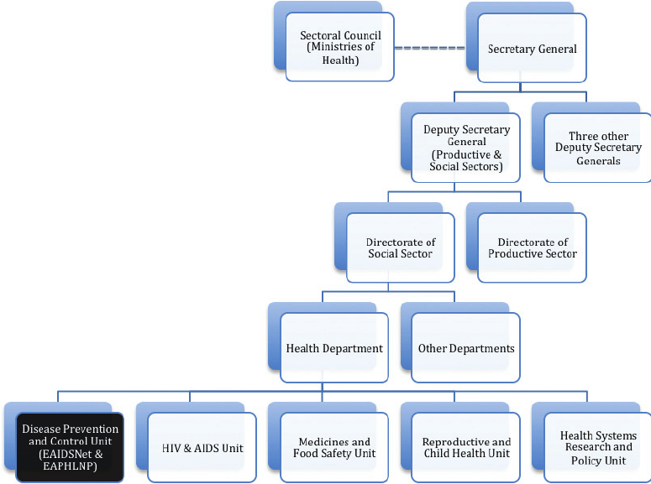

Department Attached
I was attached to department of productive and services – environmental and natural resources sector.

Purpose of the Attachment
- To provide students the opportunity to evaluate their interest in a certain field before making long-term commitments.
- To improve abilities in applying theory to realistic work circumstances.
- To learn skills and practices that will be immediately useful to their careers.
- Internships help students develop a feeling of responsibility and solid work habits.
- To expose students to real-world work environments and to teach them how to write reports for technical works/projects.
- Internship programs will boost students' earning potential when they graduate.
- To instill strength, collaboration, and self-confidence in students.
- To develop students' creative abilities and capacity to share ideas.
- To develop effective communication skills with a group of workers and to understand suitable corporate conduct in the industrial sector.

My expectations
- Introducing me to the demands and problems of the workplace.
- Getting hands-on experience.
- Developing own work ethics.
- Assisting me in developing self-reliance abilities.
- Help me develop job-related skills.
- Create industry networks and relationships.
- Improve my ability to communicate across cultures.
- Provide me a competitive advantage over other graduates who have no job experience.
- I will encounter a variety of important individuals.

General activities undertaken
- examining and interpreting international legal systems.
- giving companies specialized guidance on foreign policy.
- recognizing and evaluating important trends, regulations, and tactics in light of the global situation.
- collaborating with foreign colleagues and international institutions/organizations.
- cooperating with public media, international organizations, and government representatives.

KEY ACHIEVEMENT AND BENEFITS OF THE PROGRAM

My achievements
- strong writing and verbal communication, particularly the capacity to convey complicated concepts to a large audience.
- collecting, structuring, and displaying data and information from many sources
- evaluating material attentively to develop a case and identify potential challenges or problems to solve
- gaining knowledge of other cultures and the world, which is important in a global work market.
- collaborating with others to complete group tasks, projects, and presentations in order to attain joint objectives
- the capacity to reflect on your learning and take into account ethical aspects when utilizing and presenting knowledge, as well as time management and independent study abilities.
- utilizing technology to gather and convey facts and information

Lessons learnt
Successful writing and verbal communication skills - including the ability to translate multifaceted concepts to a wide audience gathering, organizing, and presenting facts and information from a variety of places critically analysing information to form a compelling case and find possible solutions to problems or issues developing intercultural and global awareness, which is valuable in a global job market working with others to achieve common goals through group work, group projects
Effective organization of time and independent study abilities, as well as the capacity to reflect on your learning and weigh ethical implications while utilizing and presenting knowledge, are required.

Own skills applied during attachment
Social abilities: I was able to collaborate with others, speak clearly, and show the dedication and work ethic needed to get the best outcomes. I showed the following qualities: self-assurance, work ethics, relationship management skills, listening intently, teamwork, appropriate body language, expressing gratitude, optimistic attitude, and workplace etiquette.

Key observation made
Throughout my attachment period, I carefully examined the organization's complete system for keeping track of personnel information, the procedure for filling up those records, and the Internal Control over those records. These systems, which are used to guide strategic choices, are designed to ensure the veracity, reliability, confidentiality, and accountability of such records. The method worked well overall, and I gained a lot of knowledge from it.

CHALLENGES
Too Much Work
I was given so much work that I felt incompetent and untrained to complete it.
Adapting New Lifestyle
I had a terrible time adjusting to a new lifestyle, which was pretty stressful.
For a while, I tried to fit in with the corporate culture. Learned to follow the office's rules and regulations.
Receiving No Feedback from the Supervisor
With little to no work experience working in a single job sector, I needed more supervision from my superiors, which was tough.
Insufficient Workspace
Inadequate workspaces make it difficult for a company to provide services in an effective manner.

SOLUTIONS
Too Much Work
To make it all feel worthwhile, I kept my long-term job ambitions in mind.
Adapting New Lifestyle
For a while, I tried to fit in with the corporate culture. Learned to follow the office's rules and regulations.
Receiving No Feedback from the Supervisor
After completing each project, I contacted my supervisors. Determine whether there were any flaws or mistakes made while working on the project, making it easier to work with them while learning and refining my talents.
Insufficient Workspace
Due to a lack of workspace, I encourage the company's management to construct additional, extra places that will make it simpler to deliver great service to clients.

RECOMMENDATIONS
I suggest using this resource for students who wish to complete an attachment within their course of study. because you will like the program and learn new topics in an appropriate way. This training program should be continued since it has been a wonderful and fulfilling experience that will allow students to learn more practically. I wish other attaches were as productive as I was.
I was able to gain knowledge on a variety of topics since I interacted with all firm stakeholders in a considerate and courteous manner. The company was able to innovate and be creative thanks to this. Customer focus, openness, gender adaptability, competence, collaboration, and innovation are the company's key principles that must be upheld if it is to accomplish its goals and implement out its statements of purpose and vision.

CONCLUSION
All students benefit from industrial attachment as part of their education and learning process. The government as well as universities should work together with industry and workplaces to ensure that students have chances to use their knowledge and skills. This is a useful tool for bridging the gap between technical knowledge. The necessary abilities to flourish in any industry that a student desires to work in after graduation.
Students that participate in industrial attachment and job placement should create a portfolio of their work and projects. That they contributed to during the attachment, as well as a summary of the program's major accomplishments. Students must also maintain touch with the individuals they meet during their industrial attachment and job placement, as well as strive to enhance their work-related abilities.

Name of University Supervisor:
Signature of University Supervisor:
Date:

