EMPLOYEE MANAGEMENT SYSTEM AND ITS IMPACT ON WORKERS SATISFACTION AND MANAGEMENT IN AN ORGANIZATION
A CASE STUDY OF TAVIC NETWORKS LIMITED

AHMED ABDIRAHMAN MAALIM

A RESEARCH PROJECT SUBMITTED TO THE SCHOOL OF MANAGEMENT AND LEADERSHIP IN PARTIAL FULFILLMENT OF THE REQUIREMENTS FOR DIPLOMA IN BUSINESS INFORMATION TECHNOLOGY

APRIL 2024

DECLARATION
I hereby declare that the project entitled Advanced Employee management System submitted for the Diploma in Information Communication Technology is my original work and has not formed the basis for an award of any degree, diploma or any other similar titles.
Name: AHMED ABDIRAHMAN MAALIM
DBIT/13/00056/1/23
Signature: …………………
Date: ………………………
This project has been submitted for examination with my approval as a university supervisor
Name: ALPHONCE KILONZO
Signature: ………………………...
Date: …………………………….

DEDICATION
I would like to dedicate this project to my parents for always being my source of support, inspiration, guidance and motivation. I am thankful for planting the seed of knowledge, nurturing the gifts of dreams and the ability to realize them. I am honored to have you as my parents.

ACKNOWLEDGEMENT
First, I want to thank the almighty God for bringing me this far during the entire field of research. I am grateful to my supervisor Mr. Alphonce, for His guidance throughout. I also thank my parents for the moral and financial support that kept me moving. Lastly, would like to appreciate the Management University of Africa for the knowledge they instilled in me during t my study.

ABSTRACT.
The Employee Management System (EMS) is an innovative information technology (IT) project designed to optimize and automate various aspects of employee administration within an organization. This system leverages advanced technologies to streamline the management of human resources, resulting in improved operational efficiency and enhanced productivity. The EMS encompasses a wide range of features and functionalities tailored to address the specific needs of modern workforce management. The system helps upgrade the current inefficiency and lack of automation resulting to challenges. Thus with fully automated systems employee satisfaction is guaranteed and also accurate record keeping and also reporting. The employee management system is set to benefit all employees in an organization regardless of the ranks. Data is collected through employee surveys and interviews with the employees and also the HR managers. The employee management system employs robust security measures, including role-based access control and data encryption, to safeguard sensitive information and comply with data protection regulations. In summary, the Employee Management System revolutionizes traditional HR practices, replacing manual processes with a comprehensive IT solution. By streamlining workforce administration, the EMS empowers organizations to optimize employee management, boost productivity, and create a more efficient and engaged workforce. Through the thorough data collected I would highly recommend the use of the system to help upgrade the HR software and provide training for employees and staff to fully utilize the system

Table of Contents
DECLARATION 2
DEDICATION 3
ACKNOWLEDGEMENT 4
ABSTRACT. 5
Table of Contents 6
CHAPTER 1; INTRODUCTION 10
1.1 Background 10
1.2 Statement of the problem 11
1.3 Objectives 12
General objective. 12
Specific objectives. 12
1.4 Research questions 12
1.5 Justification. 12
1.6 Scope. 13
1.7 Limitation 14
CHAPTER 2; LITERATURE REVIEW. 15
1.1 Introduction 15
1.2 Case studies similar to this system. 16
2.2.1 Case study 1: Siemens HR Hub. 16
2.2.2 Case study 2: XYZ HR management system. 16
2.2.3 Case study 3: Safaricom my HR. 16
2.3 Summary (SWOT analysis). 17
Strengths: 17
Weaknesses: 18
Opportunities: 18
Threats: 18
2.4 Research gap. 19
2.5 Proposed methodology. 19
CHAPTER 3: METHODOLOGY. 20
3.1Introduction. 20
3.2 System Development Method. 20
Waterfall model 20
Reasons for using waterfall 21
3.3 Location of Study. 21
3.4 Target population. 22
3.5 Sampling size and sampling procedure. 22
3.6 Data collection. 22
Google forms. 23
3.7 Data analysis and presentation. 23
3.8 Sample interview Questions that were used. 24
3.9 Ethical consideration. 25
CHAPTER 4: SYSTEM ANALYSIS AND DESIGN. 27
4.1 Introduction. 27
4.2 Requirements Analysis. 27
4.2.1 Functional Requirements. 27
4.2.2 Non-functional requirements. 27
4.3 System Analysis. 28
Use case Diagram. 29
Sequence Diagram. 31
E-R Diagram. 32
System activity diagram 33
Class Diagram 33
CHAPTER 5: TESTING AND RESULTS. 34
5.1 INTRODUCTION 34
5.2. TEST CASE. 34
5.2.1; Test case 1 34
5.2.2 Test case 2. 36
5.2.3 Test case 3. 38
5.2.4Test case 4 38
5.3 Sample Results. 39
5.3.1 Sample result 1: Successful admin login. 39
5.3.2 Sample result for successful leave application. 40
CHAPTER 6: IMPLEMENTATION AND DEPLOYMENT. 41
6.1 DATA CONVERSION 41
6.3 SYSTEM SPECIFICATION. 44
6.3.1 Hardware requirements. 44
6.3.2 Software requirements. 45
6.4 SUPPORT AND TRAINING. 48
6.5 SYSTEMS DEPLOYMENT. 50
CHAPTER 7: CONCLUSION AND DEPLOYMENT. 53
7.1 DISCUSSION. 53
7.2 RECOMMENDATIONS. 54
7.3 LIMITATIONS. 56
7.4 CONCLUSION. 57
REFERENCES. 59
APPENDICES 62
Hardware and software requirements 62

List of figures
Figure 1: Waterfall model 20
Figure 2:chart highlighting employees view on employee management being done by a software 24
Figure 3: chart highlighting how many people have interacted with an employee management system 25
Figure 4: usecase diagram 29
Figure 5: sequence diagram 31
Figure: 6E-R diagram 32
Figure 7: activity diagram 33
Figure 8: class diagram 33
Figure 9: successful admin log in 35
Figure 10: unsuccessful admin login 36
Figure 11: logout 36
Figure 13: screenshot indicating hoe admin can allocate projects 38
Figure 14: screenshot to indicate employee page with navigate buttons 39
Figure 15: screenshot for admin successful login 39
Figure 16: successful leave application 40

CHAPTER 1; INTRODUCTION

1.1 Background
This project majorly focuses on the workforce also known as human resource in various large organizations, industries or companies. Due to the size of this organizations, they have very many employees working in them. The employees could include the Chief Executive Officer, Chief Financial Officer, Chief Technical Officer, Chief Operating Officer, managers, supervisors and the regular employees (Men, 2015).
This system aims to build an employee database that brings together all relevant information of the employees or human resource. The system will have two major components that is the admin and employee. To access the system, they will require a special employee I.D and an admin I.D. In this case the admin is majorly in charge of the system and information regarding the human resource. They admin will have the ability to edit various employee details at any given time they want to make changes (Simaanya, 2015).
The employees on the other hand, will have access to the system to enable them check various subjects such as their payment details, promotions, new changes in the company. At any given time should the employees have issues that they would like to raise to the organization’s management, the system will allow them to do so. The system will also display various awards such as employee of the month or employee of the year. The major objective of this system is bringing the entire workforce under one management system, organizing the employee’s details into an orderly manner (Singh, et al 2019).
The system is very crucial in tracking employee performance, aligning the workforce to achieve the goals set by the organization. It also creates an open work environment where employees can make suggestions and voice their complaints. The system will have some added functionalities, such as notifying the employees if their approval for advance payment before their monthly salary, has been approved by the finance department. The management system will help solve mix up of employee details, lack of an easy notification channel and ease up their access to information (Alagaraja, & Shuck, 2015).

1.2 Statement of the problem
In today's dynamic business environment, organizations face significant challenges in effectively managing their employees. Traditional manual methods of employee management are time-consuming, error-prone, and lack the necessary scalability to handle large workforces. These inefficiencies result in decreased productivity, increased administrative burden, and hindered decision-making processes. Hence, there is a critical need for a modern Employee Management System (EMS) that can address these challenges and streamline HR operations (Cletus, et al 2018).
The primary problem to be addressed by the EMS is the lack of a centralized and automated system for managing employee data, attendance, leave, performance, and communication. Existing systems often suffer from data redundancy, inconsistency, and security vulnerabilities. Additionally, manual attendance tracking and leave management processes are prone to errors, leading to inaccuracies in payroll calculations and resource planning (Tursunbayeva, 2019).
Furthermore, organizations struggle to evaluate employee performance objectively, relying on subjective assessments that can be biased and unfair. The absence of a robust performance evaluation system hinders career growth opportunities and employee motivation, this will be measured by whether employees complete assigned projects in time (Cletus, et al 2018).
Therefore, the goal is to design and implement an Employee Management System that provides comprehensive features for employee data management like leave management and performance evaluation through assigned projects. The system should be user-friendly, scalable, adaptable, and ensure data security and privacy. By addressing these challenges, the EMS will enhance productivity, simplify HR processes, and foster a positive work environment conducive to employee growth and organizational success (Cletus, et al 2018).

1.3 Objectives

General objective.
To develop a system that simplifies management of employees at various institutions and organizations.

Specific objectives.
- To display employee records within the database at any given time.
- To prevent unauthorized access to the system.
- To enable employees, apply for leaves.
- Enable admin to assign projects and assess them.
- Enable admin to register new employees.

1.4 Research questions
- What are the key pain points and challenges faced by organizations in managing their employees effectively using existing systems or manual methods?
- What are the essential features and functionalities required in an Employee Management System to address the identified challenges and improve HR operations?
- How can an Employee Management System streamline and automate employee data management, including personal information and skills?
- What are the most efficient and accurate methods for tracking employee leave management, and how can they be integrated into the Employee Management System?
- What are the best practices and techniques for evaluating employee performance objectively and fairly, and how can they be incorporated into the Employee Management System?

1.5 Justification.
- Addressing organizational challenges: Research helps identify the specific pain points and challenges faced by organizations in managing their employees effectively. By understanding these challenges, the research can inform the development of a system that directly addresses the identified issues and provides practical solutions.
- Customization and tailored solutions: Every organization has unique requirements and workflows when it comes to employee management. Research allows for a deep exploration of these specific needs, enabling the development of a system that can be customized and tailored to fit the organization's specific requirements. This ensures that the system aligns closely with the organization's processes and maximizes its effectiveness.
- Industry best practices: Research provides an opportunity to study and analyze industry best practices in employee management. By exploring successful case studies and benchmarking against leading organizations, the research can identify proven strategies, methodologies, and features that can be incorporated into the Employee Management System. This ensures that the system incorporates the latest and most effective practices for managing employees.
In summary, research is essential for creating an Employee Management System as it ensures that the system is tailored to organizational needs, incorporates best practices, prioritizes user experience, and is based on evidence and data. It increases the likelihood of developing a system that effectively addresses organizational challenges, enhances HR operations, and delivers tangible benefits to the organization and its employees.

1.6 Scope.
The scope of the project is to develop an Employee Management System that provides comprehensive functionalities to effectively manage employee data, attendance tracking, leave management, performance evaluation, and employee communication. The system will include features for creating and maintaining employee profiles with relevant personal information, employment history, and document management capabilities. It will enable real-time attendance tracking, capturing clock-in/out times, breaks, and overtime, with integration options for time-tracking devices or software.
The system will facilitate efficient leave management processes, including leave request workflows, approval processes, and automatic leave balance calculations based on company policies and local labor laws. Additionally, it will incorporate a performance evaluation module, allowing for goal setting, performance tracking, feedback exchange, and generating performance reports. The system will also provide a platform for internal communication, enabling announcements, collaboration, feedback, and recognition channels to promote employee engagement and facilitate knowledge sharing. The project will prioritize scalability, system administration, and data security, ensuring the system can be adapted to organizational growth and integrated with existing HR or payroll systems, if applicable.

1.7 Limitation
- Technical Constraints: Depending on the project's resources and technological capabilities, there may be limitations in terms of the system's scalability, performance, and integration capabilities. Technical constraints could impact the system's ability to handle a large number of employees, process real-time data efficiently, or integrate seamlessly with existing HR or payroll systems.
- Data Accuracy and Reliability: The accuracy and reliability of data depend on various factors, such as manual data entry, employee compliance, and system reliability. Human errors during data entry can lead to inaccurate information, affecting attendance records, leave balances, and performance evaluations. System reliability and uptime are crucial to ensure consistent data recording and availability.
- Organizational Resistance and User Adoption: Introducing a new system can face resistance from employees and stakeholders who may be accustomed to existing processes or skeptical about the benefits of change. User adoption can be a challenge, requiring effective change management strategies, training programs, and user-friendly interfaces to encourage widespread acceptance and usage of the Employee Management System.
- Privacy and Data Security: With sensitive employee information stored within the system, ensuring data privacy and security is of utmost importance. Limitations may arise in implementing robust security measures, including encryption, access controls, and compliance with data protection regulations. Any security vulnerabilities could compromise employee data, leading to potential legal and reputational risks for the organization.

CHAPTER 2; LITERATURE REVIEW.

1.1 Introduction
An The literature review for a project in employee management system aims to provide a comprehensive overview and analysis of existing research, studies, and scholarly articles related to employee management systems. It serves as a foundation for understanding the current state of knowledge, identifying gaps, and informing the development of an effective system.
The literature review begins by exploring the key concepts and theories relevant to employee management systems, such as employee data management, attendance tracking, leave management, performance evaluation, and employee communication. It delves into the challenges faced by organizations in managing their employees and highlights the potential benefits of implementing an advanced system (Jamali, El Dirani, & Harwood, 2015).
The review critically evaluates existing employee management systems, examining their functionalities, features, and limitations. It identifies best practices, industry standards, and emerging trends in employee management technology. By analyzing the literature, the review seeks to identify the factors that contribute to the success or failure of implementing an employee management system and the factors that influence user adoption (Jamali, El Dirani, & Harwood, 2015).
Furthermore, the literature review examines the impact of employee management systems on organizational performance, productivity, employee satisfaction, and overall employee engagement. It explores studies that demonstrate the effectiveness of various system components, such as attendance tracking, performance evaluation, and employee communication, in achieving positive outcomes (Pang, & Lu, 2018).
Overall, the literature review provides a comprehensive understanding of the current research landscape in employee management systems, identifies gaps and areas for further exploration, and helps establish a solid theoretical foundation for the project. It informs the development and design of the proposed employee management system by incorporating best practices, insights from previous studies, and addressing the limitations identified in the existing literature (Pang, & Lu, 2018).

advanced employee management system can be implemented in various settings including international, African and local organizations. This literature review presents case studies that demonstrate the implementation of the system in different contexts and the challenges and benefits associated with each implementation.

1.2 Case studies similar to this system.

2.2.1 Case study 1: Siemens HR Hub.
In 2019, Siemens, a German conglomerate, implemented and employee management system across its global operations. The system called “Siemens HR Hub “was developed in partnership with workday, a cloud-based HR software provider. The system aimed to streamline HR processes and provide consistent experience for Siemens employees across the world (Cozmiuc, & Petrisor, 2021).
Siemens HR hub included features such as employee data management, payroll processing, performance management and learning and development. The system was integrated with other Siemen’s systems such as the company’s financial system to reduce manual data entry and increase data accuracy (Varma, Budhwar, & DeNisi, 2023).
The implementation of Siemens HUB HR was a success, with the system being rolled out to over 300,000 employees across 120 countries

2.2.2 Case study 2: XYZ HR management system.
In 2021, XYZ Inc a software company in West Africa, implemented and employee management system called XYZ HR management system. The system had features such as employee data management, time and attendance management and payroll processing. The implementation was a success, with the system being rolled out to over to their branch companies across the continent. The system reduced the time and cost of HR processes and improved the accuracy and consistency of employee data. The system also provided managers with easy access to employee data, thus aiding them in making informed decisions (Gobachew, et al 2021).

2.2.3 Case study 3: Safaricom my HR.
In 2020, Safaricom a Kenyan telecommunication company implemented an employee management system called “Safaricom my HR’’ The systems aimed at improving HR processes and provide a seamless experience for Safaricom employees in Kenya (Fardowsa, 2022).
The implementation of Safaricom My HR was a success with the system being rolled out to over 6,000 employees across Kenya. The system reduced the time and cost of HR processes and improved the accuracy and consistency of employee data. The system also provided employees with easy access to their personal information, performance data and training opportunities, which increased their management and satisfaction (Fardowsa, 2022).

2.3 Summary (SWOT analysis).

Strengths:
- Comprehensive understanding: The literature review provides a thorough understanding of the current state of knowledge in the field of employee management systems, including concepts, theories, and best practices.
- Identification of gaps: The review identifies gaps in the existing research, highlighting areas where further exploration and investigation are needed.
- Informing system design: The review informs the development and design of the employee management system by incorporating insights and lessons learned from previous studies and successful implementations.
- Evidence-based decision-making: The literature review provides a foundation of evidence and data to support decision-making throughout the project, ensuring that the system is built on proven principles and practices (Gurl, 2017).

Weaknesses:
- Limited research availability: Depending on the scope and specific focus of the project, there may be limitations in the availability of relevant literature, particularly in emerging areas or niche topics within employee management systems.
- Quality and reliability of sources: Evaluating the quality and reliability of the literature can be a challenge, as not all sources may meet rigorous academic standards. Careful selection and critical assessment of sources are essential to ensure the validity of the literature review (Teoli, Sanvictores, & An, 2019).

Opportunities:
- Bridging research gaps: The identified gaps in the literature provide opportunities for further research and exploration, allowing the project to contribute to the existing knowledge base by addressing these gaps.
- Integration of emerging technologies: The literature review may highlight emerging trends and technologies in employee management systems, presenting opportunities to incorporate innovative features and functionalities into the proposed system (Gurl, 2017).

Threats:
- Rapidly evolving field: The field of employee management systems is continuously evolving, and new research is constantly being published. Keeping up with the latest developments and ensuring the relevance and timeliness of the literature review may be challenging.
- Lack of consensus: There may be conflicting viewpoints or varying approaches in the literature, making it challenging to form definitive conclusions. Navigating these differing perspectives requires careful analysis and interpretation.
Overall, the literature review for the project on employee management systems provides a strong foundation of knowledge, identifies areas for further research, and informs the design of the proposed system. However, it is essential to be aware of the limitations in research availability and source quality while taking advantage of the opportunities to contribute to the field and integrate emerging technologies (Teoli, Sanvictores, & An, 2019).

2.4 Research gap.
Research Gap: One research gap in the field of employee management systems could be the limited exploration of the impact of artificial intelligence (AI) and machine learning (ML) techniques in improving performance evaluation and employee feedback processes. While there is existing literature on performance evaluation methods, there is a lack of research that specifically investigates how AI and ML technologies can enhance the accuracy, objectivity, and fairness of performance evaluations (Younis, Sundarakani, & Alsharairi, 2022).

2.5 Proposed methodology.
Defining the research problem; involves identifying the specific problem that the system aims to solve and why it’s important.
Identifying research objectives; the research objectives should be specific, measurable, achievable, relevant and time-bound. They should clearly state what the research aims to achieve, and how it will contribute to solving the research problem.
Design the system; this involves creating system architecture, defining the database schema and creating user interface prototypes

CHAPTER 3: METHODOLOGY.

3.1Introduction.
This phase involves choosing and declaring the system development method I am going to apply in order to come up with a functioning system, one that is free of errors and is running without any glitches.

3.2 System Development Method.

Waterfall model
The requirements definition stage involves confirmation that the problem really exists, studying the context of the problem as a part of the bigger system and carrying out feasibility studies. The analysis level breaks down requirements to remove any ambiguity and include more emitted requirements. Design stage represents diagrammatically including user interface design together with the process design (Alshamrani, & Bahattab, 2015).

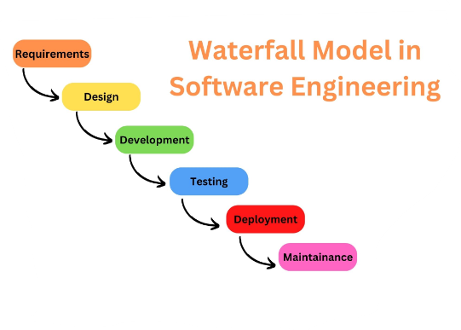
Figure 1: Waterfall model
Coding is done by integration and correctness are tested. This ensures that components of the system work well when integrated to make up the system. Raw data will also be used to check whether the system gives the expected system (Shihab, 2015).
Deployment involves installing the completed system and working the system to perform operation. Maintenance will involve employing preventive measures to secure the website from any possible attack to the system. For instance, perfective measures (Alshamrani, & Bahattab, 2015).

Reasons for using waterfall
The Waterfall model boasts simplicity and user-friendliness, making it accessible to teams of varying experience levels. Its manageable nature is attributed to the model's structured rigidity, which helps streamline project management. The sequential processing of phases, tackled one at a time, adds to its straightforward approach, ensuring focused and systematic development. This model particularly shines in smaller projects with crystal-clear requirements, where its well-defined stages and milestones provide a clear roadmap. Task organization is made seamless, as the linear progression naturally aligns tasks within each phase. In essence, the Waterfall model's simplicity, phased approach, and clear delineation of tasks render it especially suitable for projects with straightforward needs and well-understood prerequisites (Andrei, 2019).

3.3 Location of Study.
The specific area of study for an employee management system includes topics such as personnel administration, employee data management, performance management, time and attendance tracking, leave management, training and development, employee engagement, payroll processing, and compliance with labor laws and regulations. The study of employee management systems also involves exploring best practices in HRM, organizational behavior, data analysis, and user experience design to create systems that enhance employee productivity, satisfaction, and overall organizational performance.

3.4 Target population.
The target population for an advanced employee management system would be all the employees in the organization or company where the system will be implemented. This includes all full-time, part-time, and contract employees, as well as employees who work in different departments or locations.
It is important to consider the needs and characteristics of the target population when designing the advanced employee management system. For example, if the organization has a large number of remote workers, the system should include features that allow for remote access and communication. Similarly, if the organization has a diverse workforce, the system should be designed to accommodate different languages, cultures, and backgrounds (Mugenda & Mugenda 2019).

In addition to the employees themselves, the target population may also include other stakeholders such as managers, HR personnel, and IT staff who will be involved in the implementation and maintenance of the advanced employee management system.

3.5 Sampling size and sampling procedure.
The research aimed to understand the overall experiences of all employees in the organization, a probability sampling approach was more appropriate. This approach involved randomly selecting participants from the entire population of employees, ensuring that each employee has an equal chance of being selected. The sample size also depended on the research design, the desired level of precision, and the available resources. In general, larger sample sizes can led to more accurate estimates and greater statistical power (Otzen, & Manterola, 2017).

3.6 Data collection.
In order to develop system software that fitted the requirements, the clients’ views were collected. This was a very important stage in the system development cycle. Fact finding technique is important as it ensures that data gathered is both precise and correct. It also improves on the quality of decisions made. In this case interviews were used (Feng, et al 2021).

Google forms.
Google forms can be used to gather qualitative data from a dependable size of employees about their experiences and perspectives related to various aspects of the workplace. Google forms were also issued managers to gather information about the specific challenges they face in managing employees or with employees to gather information about their experiences with the current management system (Sileyew, 2019).

3.7 Data analysis and presentation.
The project development process used interviews to collect primary data from a sample size of employees in the organization, in regards to the Employee Management System (Weissgerber, et al 2015).

3.8 Sample interview Questions that were used.
- What are the key challenges you face in managing employee information and data?
- How do you currently track and manage employee performance? Are there any limitations or areas where you feel the existing system could be improved?
- What types of employee data do you find most crucial for effective management and decision-making?
- How do you handle employee leave management, including requests, approvals, and tracking balances? Are there any pain points or areas that could be improved?
- What features or functionalities would you like to see in an advanced employee management system that would make your job easier or more efficient?
These questions helped me gather valuable insights from employees and guide the development of an employee management system that addresses their needs and suggestions effectively.
The pie chart below indicates that in most organizations, the use of software to manage employees would be of greater importance.
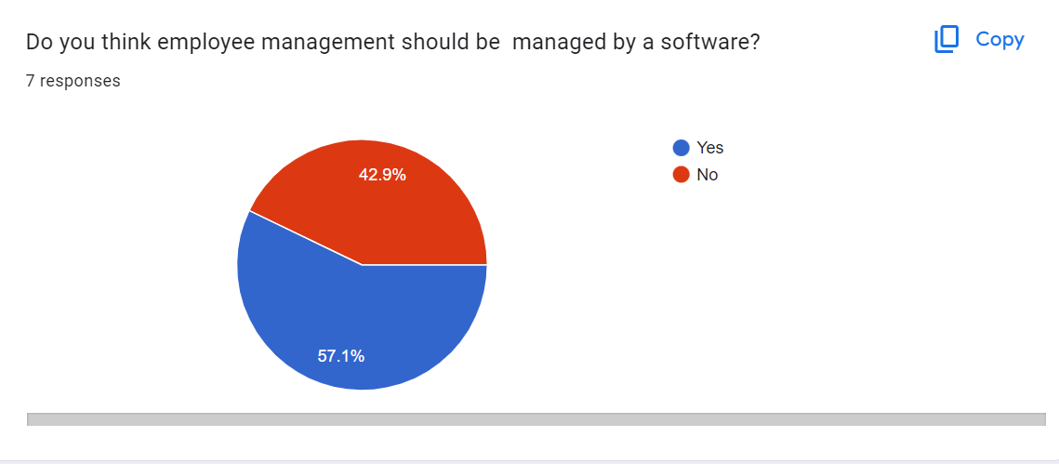
Figure 2:chart highlighting employees view on employee management being done by a software
The pie chart below shows how many people have interacted with an Employee management system before.
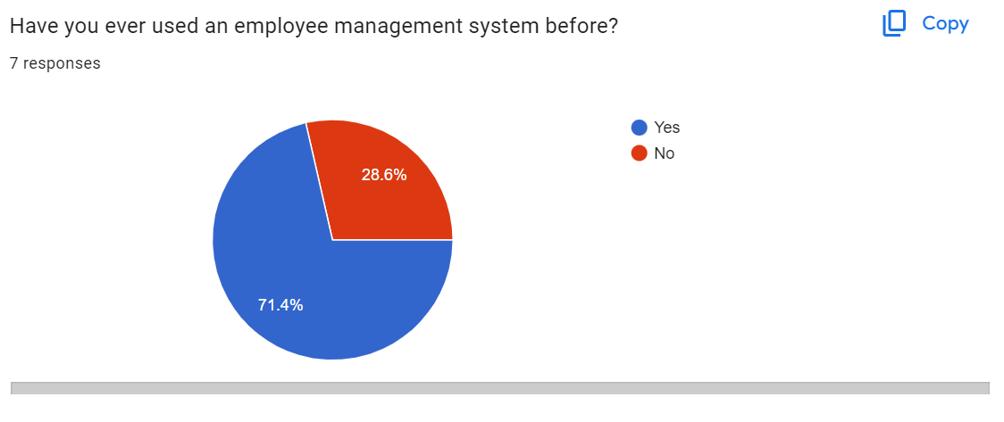
Figure 3: chart highlighting how many people have interacted with an employee management system

3.9 Ethical consideration.
There are several ethical considerations that were taken into account while developing an advanced employee management system during the data gathering phase. These include:
Informed consent: Employees were informed about the purpose of the data collection and how their data will be used. They were given the option to opt-out or withdraw their participation at any time (Arifin, 2018).
Anonymity and confidentiality: Employees were assured that their responses will be kept anonymous and confidential. This meant that their personal identifying information was kept separate from their responses and should not share with anyone outside the research team.
Data security: Measures were taken to ensure that the data is securely stored and protected from unauthorized access or breaches(Roberts, 2015)..
Data ownership: Employees were informed about their data ownership and how it will be used. This included informing employees whether their data will be used for commercial purposes or shared with third-party vendors (Arifin, 2018).
Avoiding harm: My data collection methods were designed to minimize any potential harm to employees. For example, if sensitive information was being collected, measures were taken to ensure that employees were not negatively impacted by this information becoming known.
Fairness and equity: My data collection methods were designed to ensure that all employees were treated fairly and equitably. This means that the data collection methods were accessible to all employees, regardless of their job title, tenure, or other characteristics (Roberts, 2015).
Respect for privacy: I respected the right to privacy for all employees, and our data collection methods were designed to respect this right (Arifin, 2018).
By taking these ethical considerations into account during the data gathering phase, the advanced employee management system can be developed in a way that is respectful and fair to employees, while also producing high-quality data for analysis (Roberts, 2015).

CHAPTER 4: SYSTEM ANALYSIS AND DESIGN.

4.1 Introduction.
System analysis and design deals with planning the development of information system through understanding and specifying in detail what a system should do and how the components of the system should be implemented and work together. This chapter focuses on the analysis of the advanced employee management system in details. All functional and non -functional requirements are also discussed. System design is carried out according to the features and operations of the system which include the user interface, database schema, code and other documentations. Design ensures that the system will be user friendly and users are able to interact with it.

4.2 Requirements Analysis.
A requirement is simply a high-level abstract statement of a service that a system should provide on a system. These include the functional and Non-functional requirements.

4.2.1 Functional Requirements.
The different given functional requirements define the capabilities and functions the system will perform successfully.
- To display employee records within the database at any given time.
- To prevent unauthorized access to the system.
- To enable employees, apply for leaves.
- Enable admin to assign projects and assess them.
- Enable admin to register new employees.

4.2.2 Non-functional requirements.
The non-functional requirements define or describe attributes such as security, reliability, maintainability, scalability and usability that the system will have.
These will include;
- The system includes all available safeguards from website attacks.
- The system should be available for use 24 hours per day ,365 days per year without failing.
- The system should be able to work on any web browser.
- Personal Information is protected in compliance with the required safeguarding guidelines.

4.3 System Analysis.
System analysis refers the process of collecting and interpreting facts, identifying the problems and decomposition of a system into its components.
Analysis specifies what the system should be able to execute or do at any given moment.

Use case Diagram.

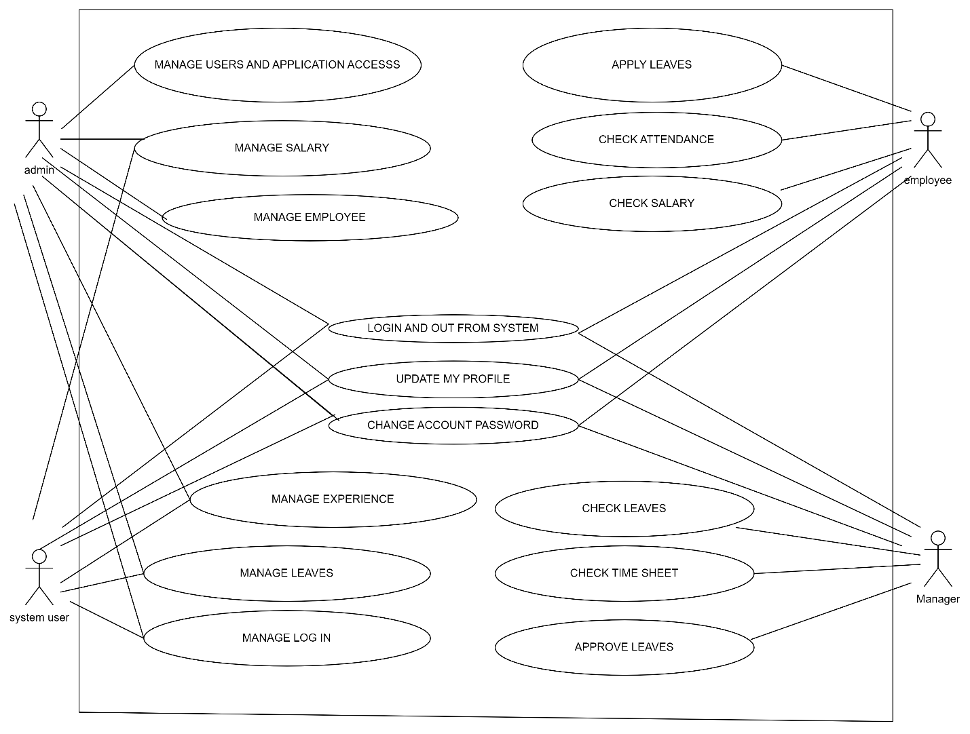
Figure 4: usecase diagram
A use case diagram is a visual representation of the interactions between actors (users) and the system in a particular project. In the case of an Employee Management System, it typically involves various actors like employees, managers, and administrators interacting with the system to perform specific tasks. Here's a description of the use case diagram for an Employee Management System:
- Actor Descriptions:
- Employee: Represents regular employees who can access their own information, request leaves, and update their details.
- Manager: Represents managers who have additional responsibilities like managing employee information, approving leave requests, and generating reports.
- Administrator: Represents system administrators who have overall control over the Employee Management System, including user management and system configurations.
- Use Case Descriptions:
- Login: All actors will interact with the system through the login use case, which enables them to access their respective functionalities upon successful authentication.
- View Employee Profile: Employees and managers can view their own or their subordinates' employee profiles, respectively, to access and update their personal details.
- Update Employee Details: Both employees and managers can update employee information, such as contact details or emergency contact information.
- Request Leave: Employees can submit leave requests through this use case, and managers can access and approve/reject those requests.
- Generate Reports: Managers and administrators can generate various reports, such as employee attendance, leave history, or performance reports.
- Manage Employees: Managers and administrators can add new employees, terminate employees, or update employee roles and permissions.
- Manage User Accounts: Administrators have the ability to create new user accounts, reset passwords, and manage user access to the system.
- Configure System Settings: Administrators can configure various system settings, such as leave policies, working hours, and access controls.
- Associations:
- Employee to Manager: The "View Employee Profile" and "Update Employee Details" use cases are associated with the Employee and Manager actors, respectively. Employees can view and edit their profiles, while managers can view and edit their subordinates' profiles.
- Employee to Administrator: The "Request Leave" use case is associated with the Employee actor, who can request leave to be approved by the manager or administrator.
- Manager to Administrator: The "Manage Employees," "Manage User Accounts," and "Configure System Settings" use cases are associated with the Manager and Administrator actors, with administrators having overall control.

Sequence Diagram.
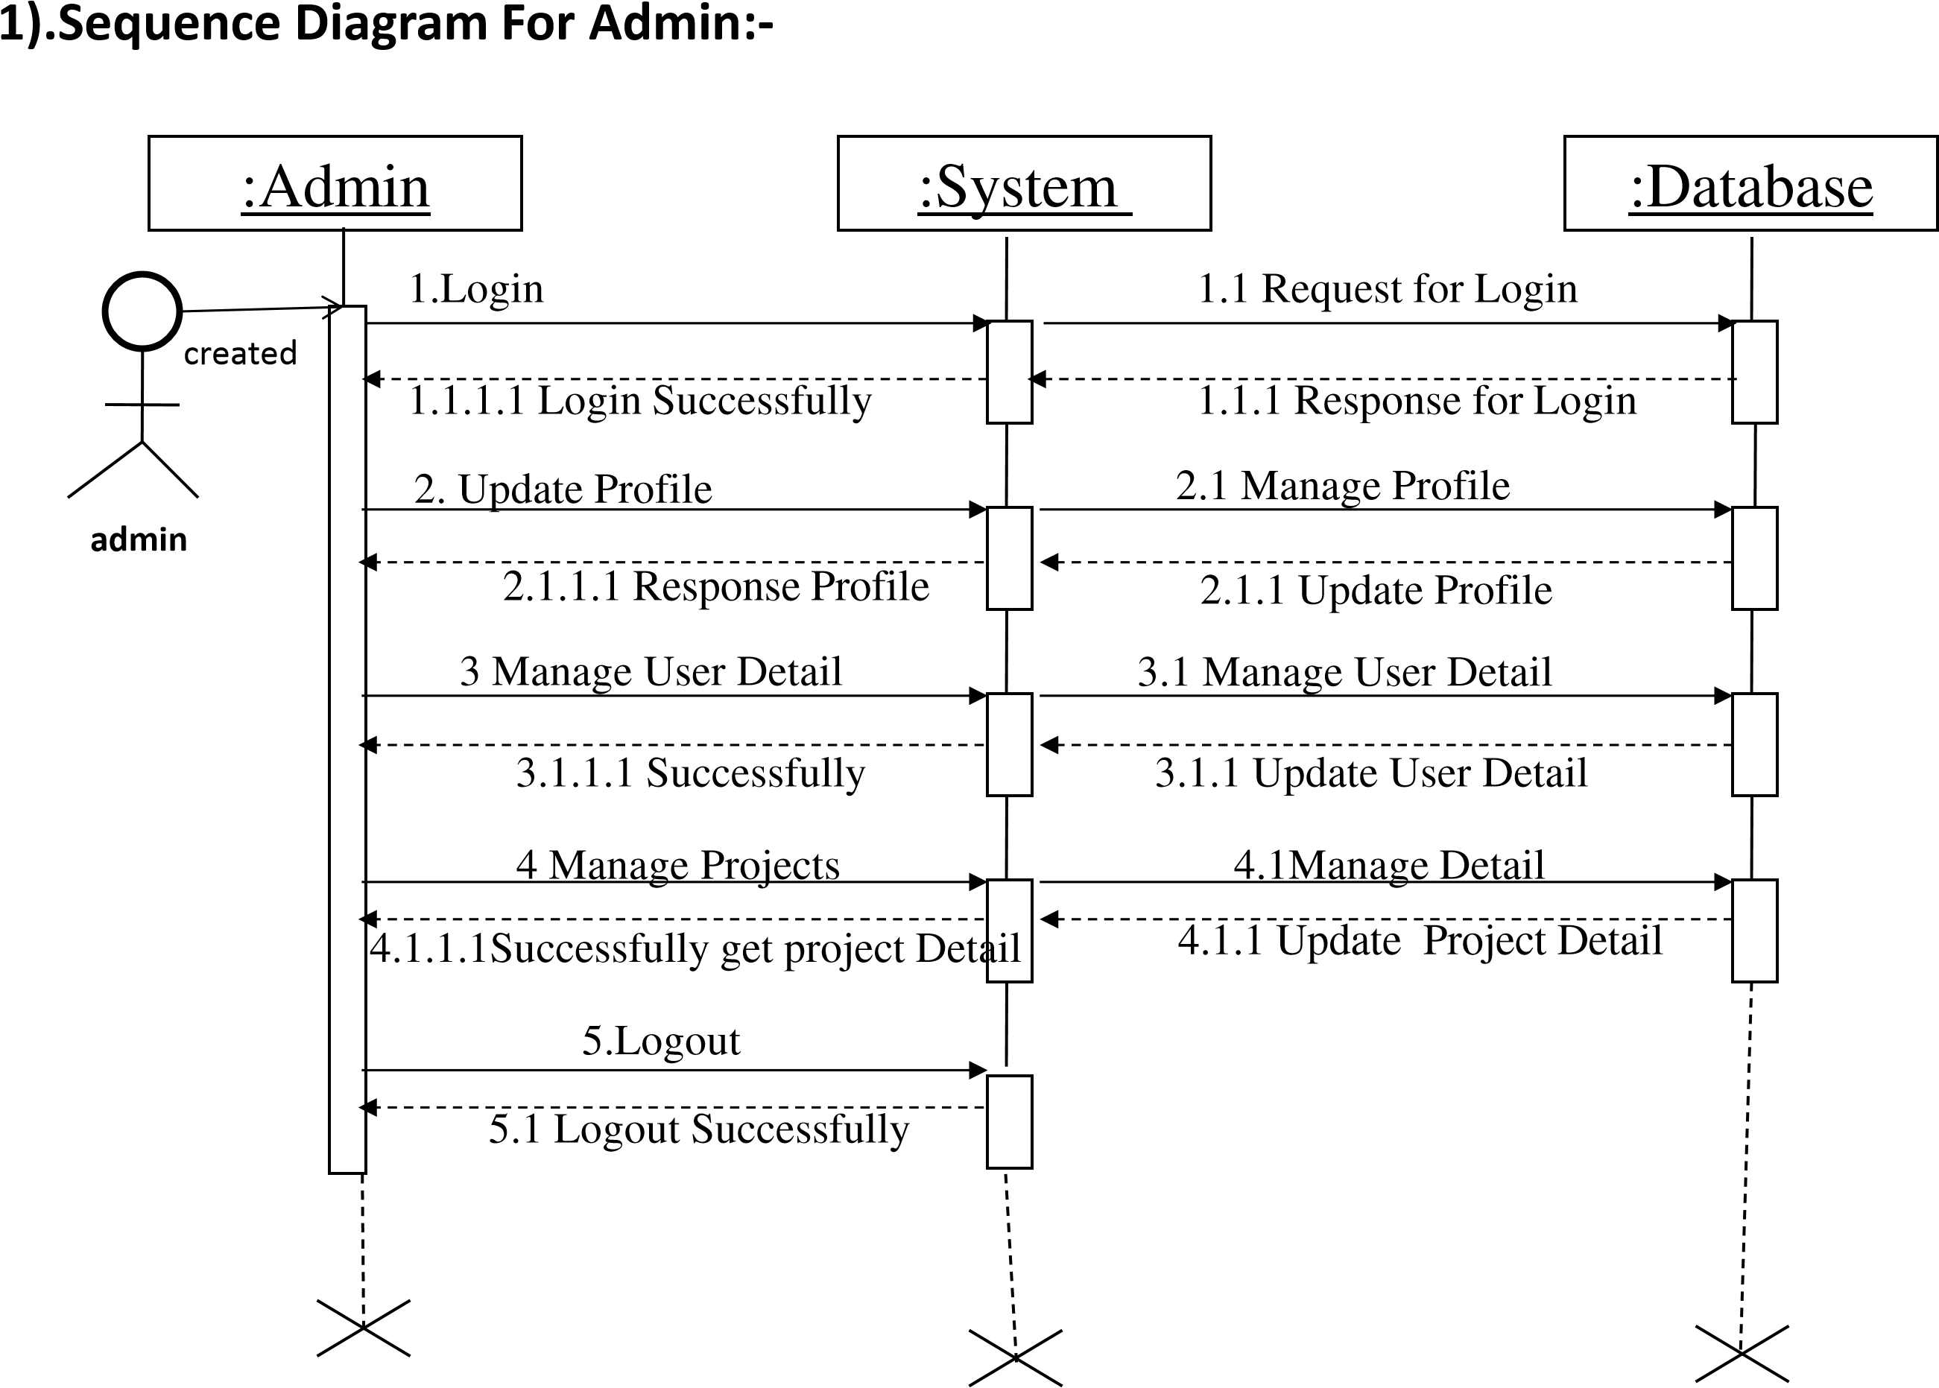
Figure 5: sequence diagram

E-R Diagram.
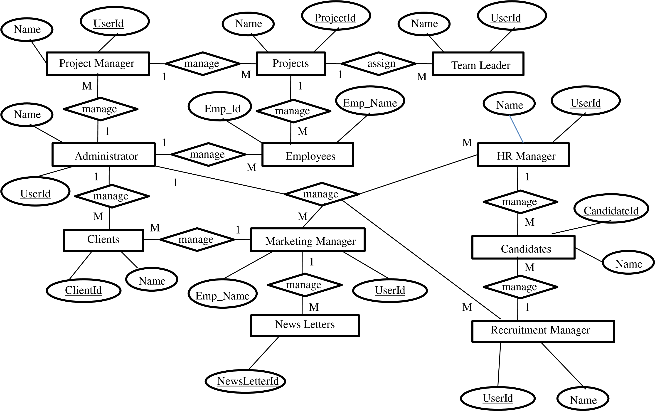
Figure: 6E-R diagram

System activity diagram
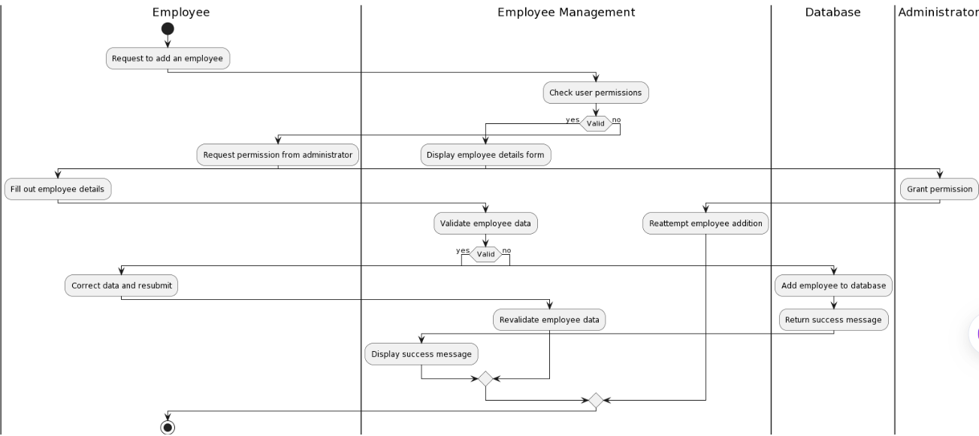
Figure 7: activity diagram

Class Diagram
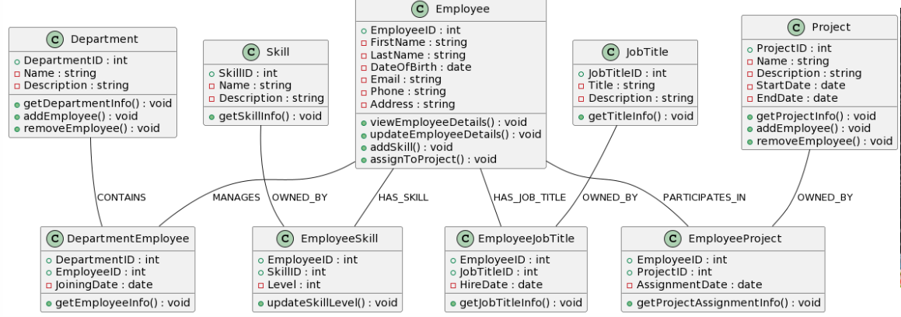
Figure 8: class diagram

CHAPTER 5: TESTING AND RESULTS.

5.1 INTRODUCTION
Software testing is done to demonstrate to the developer and customer that the software meets its requirements as well as to discover faults or any malfunctions in the software.
There exists various forms or kinds of testing using test cases to test the various aspects of the system.
These are;
- Unit testing.
- System testing.
- Integration testing.
- Acceptance testing.

5.2. TEST CASE.
The test cases of the system are as below;

5.2.1; Test case 1
Purpose; Admin to login the system
Pre-requisites.
- User Account: Users should have a valid and active user account within the employee management system. The system administrator or HR department typically creates these accounts for employees.
- Username/Employee ID: To log in, employees usually need to provide their unique username or employee ID, which is assigned to them when their account is created.
- Password: A secure and confidential password associated with the user account is required for authentication. Passwords should be strong and kept private by each employee.
- Procedure;
Open the Employee Management System: Open your web browser and enter the URL or navigate to the website of the employee management system. This is typically provided by your employer or IT department.
- Enter Username/Employee ID: On the login page, you will see a field to enter your username or employee ID. Type in the unique identifier that was assigned to you by the system administrator.
- Provide Password: Below the username field, you will find the password field. Enter the secure and confidential password associated with your account. Make sure to use the correct capitalization and any special characters requir
- Click "Login": Once you have entered your credentials and completed any additional authentication steps, click the "Login" or "Sign In" button to proceed.
- Successful Login: If your credentials are correct, you will be granted access to the employee management system dashboard or home page. Here, you can view and manage your personal information, work-related details, and other relevant features depending on your access level.
Admin homepage after log in.
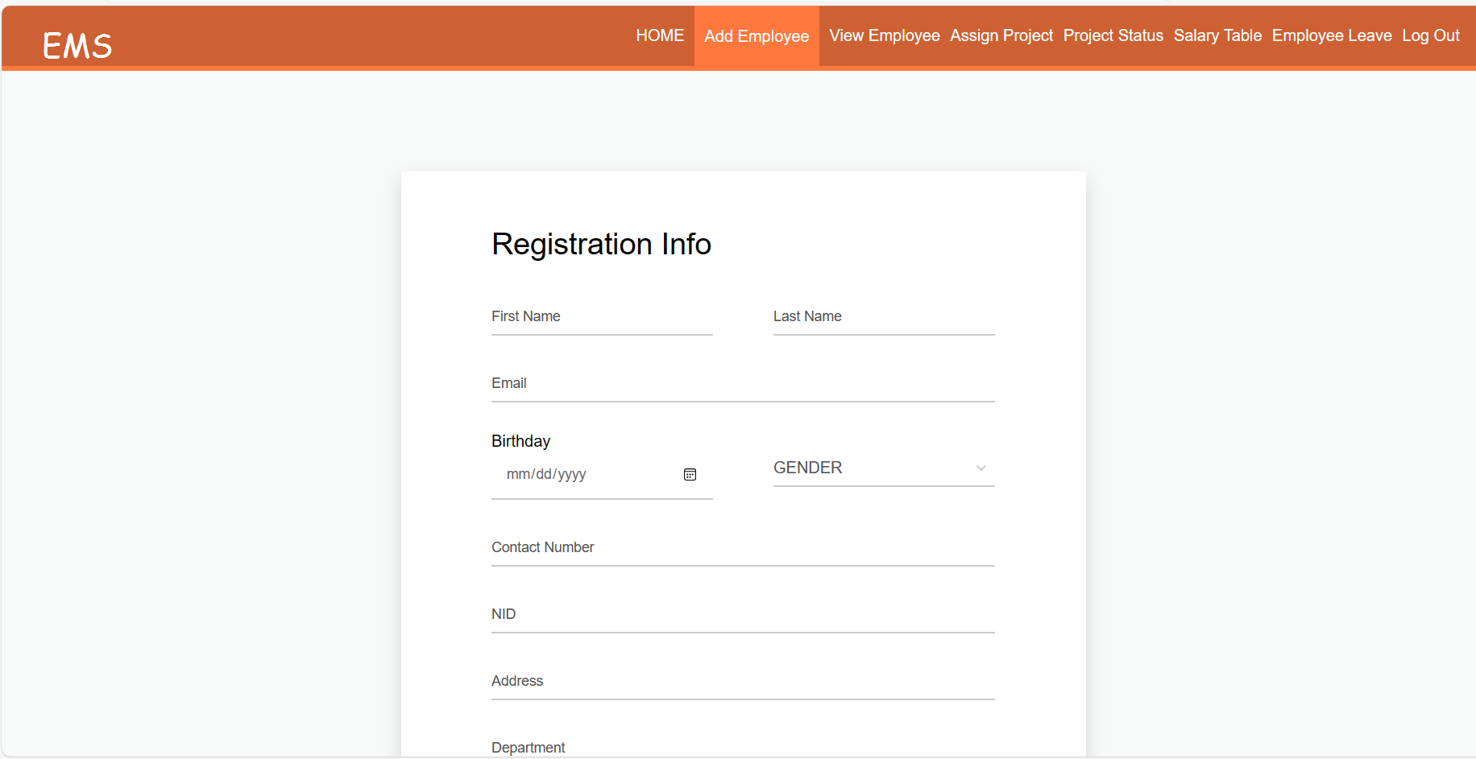
Figure 9: successful admin log in
- Unsuccessful Login: If your credentials are incorrect, you will receive an error message. Double-check your username and password and try again. Some systems may have a limited number of login attempts before temporarily locking the account for security purposes.
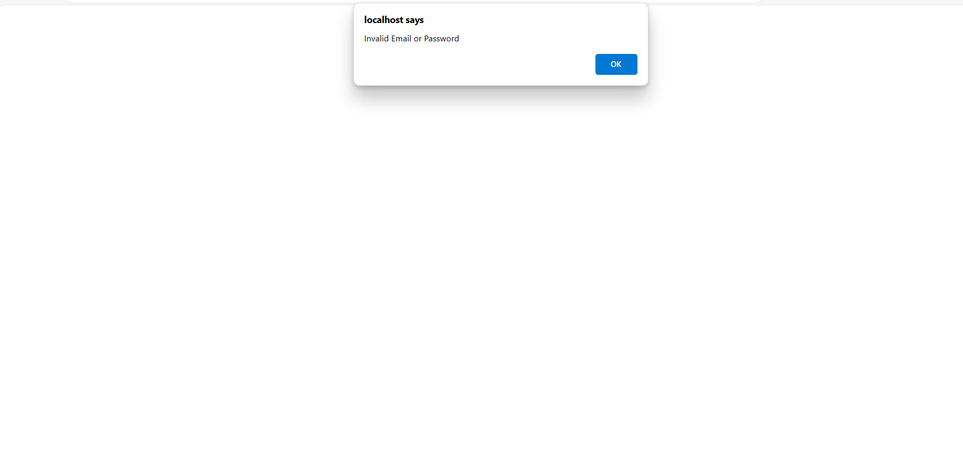
Figure 10: unsuccessful admin login
- Logout (After Usage): When you're finished using the employee management system, always remember to log out. This prevents unauthorized access to your account if someone else uses the same device.
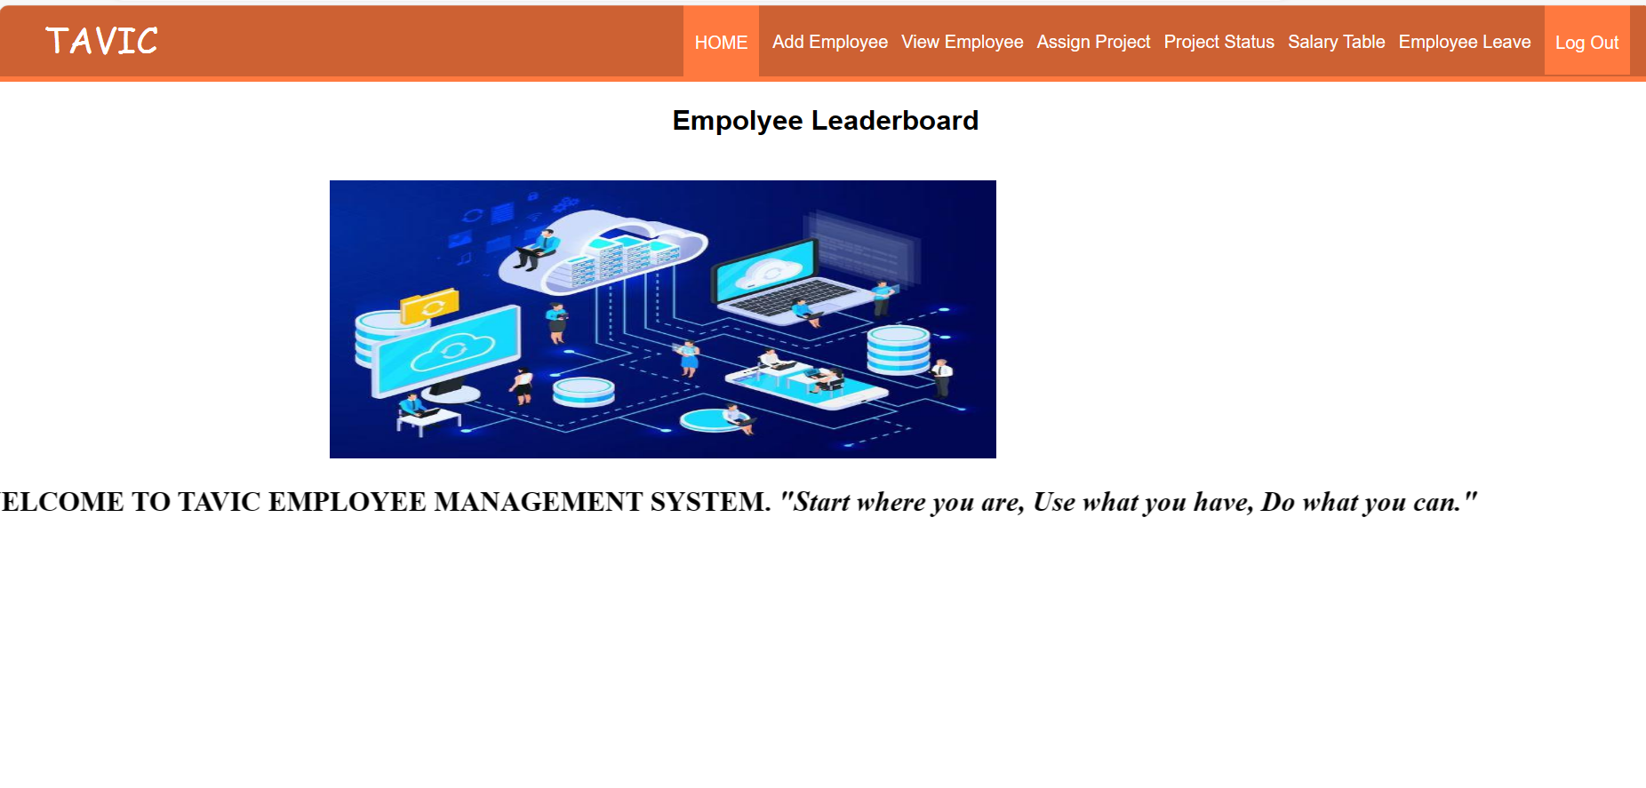
Figure 11: logout

5.2.2 Test case 2.
Data entry case: Verify that the software can accept and store data accurately and that it can handle various data types such as numbers, text and dates. Test cases could include:
- Entering an employee’s basic information (name, date of birth and gender)and verify that it appears correctly in the system.
- Entering a specific project assigned to a specific employee.
- Entering an employee’s contact information and verifying that it is correctly stored.

5.2.3 Test case 3.
Assign project Test case; Verify that the admin can successfully assigns projects to employees
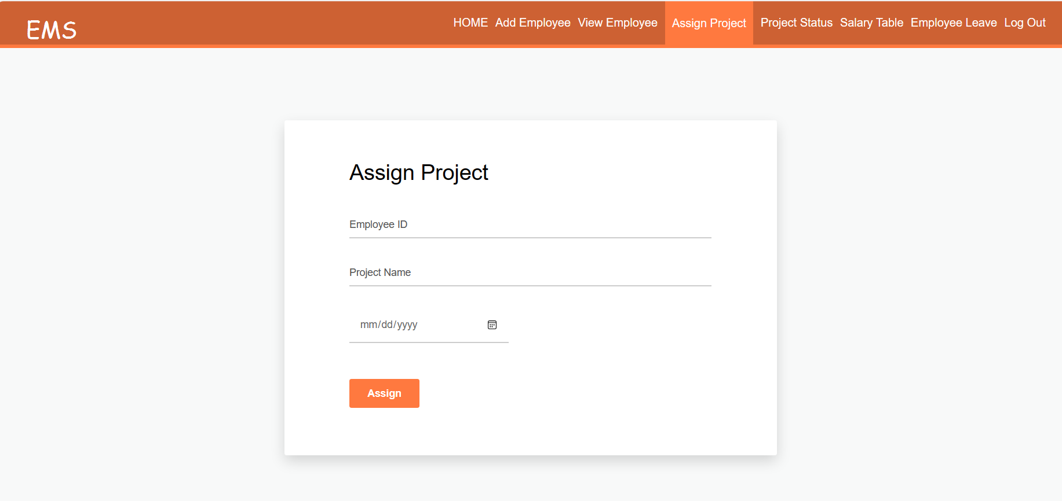
Figure 13: screenshot indicating hoe admin can allocate projects

5.2.4Test case 4
User Interface Test Case: Verify that the software has a user-friendly interface that is easy to navigate and use. Test case could include
- Navigating through various menus and screens and verifying that they are organized logically and are easy to find.
- Verifying that the font sizes and colors are appropriate and do not cause any readability issues.
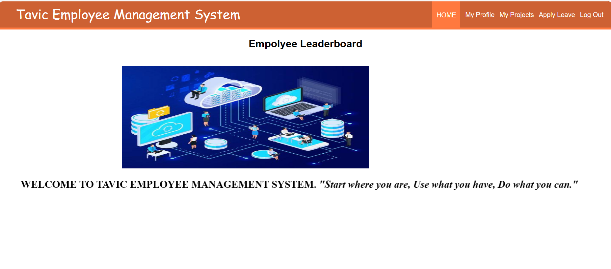
Figure 14: screenshot to indicate employee page with navigate buttons

5.3 Sample Results.

5.3.1 Sample result 1: Successful admin login.
Figure 15: screenshot for admin successful login

5.3.2 Sample result for successful leave application.
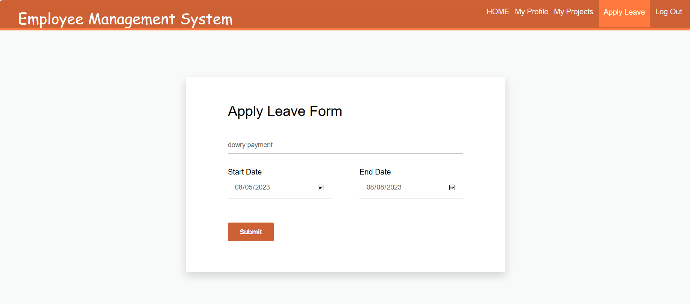
Figure 16: successful leave application
Test cases are important to ensure that the Employee management system software is free of errors, bugs and performs well in terms of usability, functionality and security. By testing the software thoroughly, the stakeholders can have confidence in its reliability and effectiveness.

CHAPTER 6: IMPLEMENTATION AND DEPLOYMENT.
6.1 DATA CONVERSION.
Data conversion in the context of implementing and developing an employee management system refers to the process of transforming and migrating data from existing sources to the new system. It involves converting data from different formats, structures, and systems into a unified and compatible format that can be seamlessly integrated into the new system. Here's an overview of the data conversion process for an employee management system:
- Data Assessment:
  - Identify existing data sources: Determine where the employee-related data is currently stored, such as spreadsheets, databases, or legacy systems.
  - Understand data quality: Assess the quality and consistency of the data to identify any inconsistencies, errors, or missing information.
  - Define data requirements: Determine what data needs to be converted and which data can be discarded or archived.
- Data Mapping and Transformation:
  - Create a data mapping plan: Map the data elements from the old system to the corresponding fields in the new employee management system.
  - Data cleansing: Cleanse and standardize the data to ensure uniformity and accuracy.
  - Data transformation: Convert data from the existing formats to the format required by the new system. This may include reformatting dates, updating codes, or adjusting data types.
- Data Extraction:
  - Extract data from the existing sources: Retrieve the relevant data from spreadsheets, databases, or other systems.
  - Data filtering: Filter out any data that is not required for the new system, reducing unnecessary clutter.
- Data Load and Validation:
  - Load data into the new system: Populate the employee management system with the converted data.
  - Data validation: Perform data validation checks to ensure that the data meets the defined criteria and is accurate.
- Data Migration:
  - Plan the migration process: Decide on the timing and strategy for data migration to minimize disruption to the organization's operations.
  - Execute the migration: Perform the actual migration of data from the old system to the new system.
- Data Integration:
  - Integrate with other systems: If the employee management system needs to communicate with other systems like payroll or attendance, ensure data integration between them is properly set up.
- Testing and Validation:
  - Conduct data validation testing: Verify the accuracy and completeness of the migrated data through testing scenarios and validation checks.
  - Address data discrepancies: If any issues are identified during testing, address and resolve them before the system goes live.
- Data Archiving:
  - Archive old data: Once the data has been successfully migrated and validated, consider archiving the old data for historical reference.
- Data Security and Privacy:
  - Ensure data security: Implement appropriate security measures to protect sensitive employee data from unauthorized access.

6.3 SYSTEM SPECIFICATION.

6.3.1 Hardware requirements.
The hardware requirements for an employee management system will depend on various factors such as the scale of the organization, the number of employees, the complexity of the system, and the specific functionalities required. However, here are some general hardware requirements that are typically needed for a basic employee management system:
- Server:
  - A dedicated server is essential to host the employee management system. The server should have sufficient processing power, memory, and storage to handle the system's database and application requirements.
- Processor (CPU):
  - A multi-core processor is recommended to ensure smooth performance, especially when handling multiple concurrent user requests.
- Memory (RAM):
  - Sufficient RAM is crucial for the system's performance. The amount of RAM required will depend on the complexity of the application and the expected number of users. At least 8GB of RAM is generally recommended for a small to medium-sized organization.
- Storage (Hard Disk or SSD):
  - Adequate storage space is needed to store the employee data, application files, and any backups. An SSD (Solid State Drive) is preferable for faster data access and improved system responsiveness.
- Network Interface:
  - A reliable network interface is essential for communication between the server and the users. A high-speed Ethernet connection is recommended to ensure fast data transfer.
- Backup Solution:
  - Implement a reliable backup solution to regularly back up the employee management system's data and configurations to prevent data loss in case of hardware failures or other issues.
- Firewall and Security Hardware:
  - Install a firewall and other security hardware to protect the server from unauthorized access and cyber threats.
- Load Balancer (Optional):
  - If the organization anticipates a large number of users accessing the system simultaneously, a load balancer may be necessary to distribute the incoming traffic evenly across multiple servers and prevent overload.
- Redundancy and Failover Mechanism (Optional):
  - For enhanced reliability, consider implementing redundancy and failover mechanisms. Redundant power supplies, RAID configurations, and redundant servers can help maintain system availability even in case of hardware failures.
- Workstations:
  - The workstations used by employees to access the employee management system should meet the minimum requirements specified by the system's software. They should have a modern web browser and an internet connection for accessing the system.
The hardware requirements can vary significantly based on the specific employee management system being implemented. Before finalizing hardware choices, I noted it’s very crucial and important to acquire precise hardware recommendations based on the system's requirements and expected usage.

6.3.2 Software requirements.
The software requirements for an employee management system are essential components needed to run and operate the system effectively. These requirements encompass both the operating system and other software components necessary for the system to function correctly. Below are the general software requirements for an employee management system:
- Operating System:
  - The choice of operating system will depend on the system's architecture and the preferences of the organization. Commonly used operating systems for hosting the employee management system include:
    - Windows Server.
    - Linux distributions.
- Web Server:
  - A web server is required to host and serve the web application of the employee management system. Commonly used web servers include:
    - Apache HTTP Server.
    - Nginx.
    - Microsoft Internet Information Services (IIS).
I worked with wamp server in my employee management system project.
- Database Management System (DBMS):
  - A DBMS is necessary to store and manage the employee-related data. The choice of DBMS will depend on factors such as scalability, data volume, and the organization's expertise. Commonly used DBMS options include:
    - MySQL.
    - PostgreSQL.
    - Microsoft SQL Server.
    - Oracle Database.
In my project case I worked with MySQL which conformed with my database system requirements.
- Programming Languages and Frameworks:
  - The employee management system will likely be developed using specific programming languages and frameworks. Some common choices include:
    - PHP.
    - HTML, CSS, JAVASCRIPT.
    - Python with Django or Flask frameworks
    - .NET with ASP.NET framework.
My project predominantly used PHP.
- Client-Side Technologies:
  - The front-end of the employee management system will require client-side technologies to create a user-friendly interface. Commonly used client-side technologies include:
    - HTML5
    - CSS3
    - JavaScript with libraries and frameworks like React, Angular, or Vue.js
I applied some CSS on my system design .
- Security Software:
  - Security software is vital to safeguard the employee management system and its data. Some critical security components include:
    - SSL/TLS certificates for secure communication (HTTPS)
    - Firewalls to protect against unauthorized access
    - Antivirus and anti-malware software to prevent and detect threats
- Integration Software (Optional): If the employee management system needs to integrate with other applications like payroll systems or attendance tracking software, integration software or APIs (Application Programming Interfaces) may be required.
- Email and Notification Services (Optional):
  - If the system needs to send notifications or reminders to employees or managers, email and notification services may be integrated into the system.
Specific software requirements can vary based on the technology stack chosen for the development of the employee management system and any additional functionalities needed. The system's software requirements were determined during the initial planning and design phase of the project, and the software components will be kept up-to-date to ensure security and performance.

6.4 SUPPORT AND TRAINING.
Support and training are crucial aspects of implementing an employee management system successfully. They ensure that users can effectively use the system, resolve any issues that may arise, and optimize the system's potential. Here's a breakdown of support and training considerations for my employee management system:
1. User Documentation:
- Prepare comprehensive user documentation that includes step-by-step guides, FAQs, and troubleshooting tips. This documentation should cover all aspects of the system, from basic functionalities to more advanced features.
2. Training Sessions:
- Conduct training sessions for different user groups, such as employees, managers, and administrators. These sessions can be in-person or conducted virtually, depending on the organization's setup and preferences.
3. Online Tutorials and Videos:
- Create online tutorials and video guides that users can access at their convenience. This allows users to revisit training materials whenever needed and aids in onboarding new employees.
4. Help Desk and Support Channels:
- Set up a help desk or support system where users can report issues, seek assistance, or ask questions. This support can be provided through email, phone, or a dedicated support portal.
5. Regular System Updates:
- Keep the system up-to-date with the latest bug fixes, security patches, and enhancements. Regular updates ensure that the system remains stable and secure.
6. User Feedback and Improvement:
- Encourage users to provide feedback on the system's usability and functionality. Use this feedback to make continuous improvements and address any pain points.
7. On-Site Support (if applicable):
- For larger organizations or complex implementations, consider offering on-site support during the initial stages of the system's deployment.
8. System Administrators Training:
- Train designated system administrators to manage and configure the system effectively. They should be well-versed in user management, security settings, and system configurations.
9. Data Backup and Recovery Training:
- Train administrators on proper data backup procedures and recovery protocols in case of data loss or system failures.
10. Training Materials in Multiple Formats:
- Ensure training materials are available in different formats, such as written guides, videos, and interactive demos, to cater to various learning styles.
11. Ongoing Support and Maintenance:
- Provide ongoing support and maintenance services to address any issues that arise after the system's deployment. This may include periodic health checks and performance tuning.
12. Vendor Support:
- If the employee management system is a third-party solution, ensure that the vendor provides adequate support and is responsive to any support requests.
The success of an employee management system heavily relies on how well users can utilize its features. By providing comprehensive support and training, organizations can maximize the benefits of the system, improve user adoption, and enhance overall efficiency in managing employees and their data.

6.5 SYSTEMS DEPLOYMENT.

System deployment for an employee management system project involves the process of making the system accessible to end-users and ensuring its smooth integration into the organization's infrastructure. Here are the key steps involved in deploying an employee management system:
- System Readiness Assessment:
  - Ensure that the employee management system is thoroughly tested and meets all the functional and non-functional requirements specified in the project scope. Address any outstanding issues or bugs before proceeding with deployment.
- Infrastructure Setup:
  - Set up the necessary hardware and software infrastructure to host the employee management system. This may involve configuring servers, databases, web servers, and network components.
- Data Migration:
  - If the employee management system is replacing an existing system, migrate the relevant data from the old system to the new system. Ensure data integrity and accuracy during the migration process.
- User Account Setup:
  - Create user accounts and assign appropriate roles and permissions to employees, managers, and administrators who will be using the system.
- Training and User Onboarding:
  - Conduct training sessions for end-users to familiarize them with the new system. Provide guidance on how to perform common tasks, access information, and utilize the system effectively.
- Pilot Testing (Optional):
  - Consider running a pilot deployment with a small group of users to identify any issues or areas for improvement before rolling out the system to the entire organization.
- Communication and Change Management:
  - Communicate the deployment plan and changes to all employees to ensure they are aware of the upcoming transition and its benefits. Address any concerns and encourage buy-in from stakeholders.
- Deployment Strategy:
  - Decide on the deployment strategy based on the organization's size, structure, and workforce. Options include:
    - Phased Deployment: Roll out the system in stages, starting with specific departments or teams and gradually expanding.
    - Big Bang Deployment: Implement the system organization-wide at once.
- Quality Assurance:
  - Conduct final quality assurance checks to ensure that the system is functioning as expected and is ready for full-scale deployment.
- Backup and Disaster Recovery:
  - Implement robust backup and disaster recovery mechanisms to safeguard the system's data in case of unexpected incidents.
- Go-Live and Monitoring:
  - Execute the deployment plan and make the system accessible to all authorized users. Monitor the system closely during the initial period to identify and address any issues promptly.
- Post-Deployment Support:
  - Provide post-deployment support to assist users with any questions or problems they encounter as they start using the system.
- User Feedback and Continuous Improvement:
  - Encourage users to provide feedback on their experiences with the system and use this feedback for continuous improvement and optimization.
- Security Measures:
  - Implement necessary security measures, such as access controls, encryption, and authentication, to protect sensitive employee data.
- Compliance Considerations:
  - Ensure that the employee management system complies with relevant data protection and privacy regulations, especially if personal data is being processed.
By following a well-planned deployment strategy and providing comprehensive support, organizations can ensure a successful transition to the new employee management system and effectively manage their workforce data and processes.

CHAPTER 7: CONCLUSION AND DEPLOYMENT.

7.1 DISCUSSION.
This discussion sets out to discuss or put in writing what I have achieved throughout the implementation of the project from the beginning to the end.
This discussion highlights the benefits and significance of implementing an employee management system:

Summary of Achievements.
In this project, I have successfully designed, developed, and implemented an employee management system to streamline the organization's HR processes. The system offers a centralized platform for managing employee data, attendance, leaves, and performance, improving overall efficiency and reducing manual administrative tasks.
Some of the achievements include but are not limited to:

1. Centralized Employee Data: An employee management system provides a centralized repository for all employee-related information, including personal details, contact information, job roles, and performance records. This single source of truth ensures data accuracy, eliminates duplication, and enables easy access to information.
2. Efficient Leave Management: The system simplifies leave management by allowing employees to submit leave requests electronically and providing managers with a clear overview of team availability. Automated leave calculations and approvals reduce manual intervention and minimize scheduling conflicts.
3. Attendance Tracking and Time Management: The system facilitates accurate attendance tracking, whether through biometric systems, time clock entries, or mobile applications. This data enables organizations to monitor employee work hours, analyze attendance patterns, and optimize workforce planning.
4. Performance Evaluation and Appraisals: With the employee management system, managers can conduct performance evaluations and appraisals based on predefined metrics. This standardized approach ensures fairness and consistency in performance assessments, leading to better talent development and career growth opportunities.
5. Streamlined Recruitment and Onboarding: The system streamlines the recruitment process, allowing HR teams to manage job postings, applications, and candidate evaluations efficiently. Furthermore, it simplifies the onboarding process for new employees, ensuring a smooth transition into the organization.
6. Enhanced Reporting and Decision-Making: By generating comprehensive reports and analytics on HR metrics, the system empowers management to make data-driven decisions. Insights into employee performance, turnover rates, and absenteeism support strategic workforce planning and resource allocation.
7. Increased Employee Engagement: The system's self-service features empower employees to update their profiles, access pay stubs, and apply for leaves independently. This autonomy fosters a sense of ownership and engagement among employees.
8. Improved Compliance and Data Security: Employee management systems help organizations comply with labor regulations and data protection laws. Access controls and encryption mechanisms ensure data security and confidentiality.
9. Scalability and Adaptability: Modern employee management systems are designed to scale with an organization's growth. They are often customizable to meet specific business needs and can integrate with other HR software and systems.
10. Time and Cost Savings: By automating repetitive HR tasks and reducing manual paperwork, the system saves time for HR personnel and reduces administrative costs. The streamlined processes also lead to increased operational efficiency.

7.2 RECOMMENDATIONS.
For future development and use of an employee management system, it's essential to keep the system relevant, efficient, and capable of meeting evolving organizational needs. Here are some recommendations to consider for future development:
- Regular Updates and Maintenance: Schedule regular updates and maintenance to ensure the system remains secure, stable, and up-to-date with the latest technologies and industry standards. Address bugs, vulnerabilities, and compatibility issues promptly.
- User Feedback and Engagement: Encourage users to provide feedback on their experience with the system regularly. Actively engage with employees, managers, and administrators to understand their pain points and preferences, and incorporate their suggestions into system improvements.
- Mobile Accessibility: Consider developing a mobile application or optimizing the system for mobile devices. Mobile accessibility allows users to access the employee management system on the go, promoting flexibility and productivity.
- Integration with Additional Systems: Explore opportunities for integrating the employee management system with other organizational systems, such as payroll software, performance management tools, or learning management systems. Seamless integration improves data flow and enhances overall efficiency.
- Advanced Reporting and Analytics: Enhance the system's reporting and analytics capabilities to provide deeper insights into HR metrics, employee performance, and workforce trends. Advanced reporting enables data-driven decision-making and strategic planning.
- AI and Automation: Integrate artificial intelligence (AI) and automation features to optimize HR processes further. AI-driven chatbots, for instance, can provide real-time support to employees and managers, freeing up HR personnel for more strategic tasks.
- Enhanced Security Measures: Continuously improve the system's security measures to protect sensitive employee data from evolving cyber threats. Implement multi-factor authentication, encryption, and regular security audits.
- Scalability and Flexibility: Design the system with scalability in mind to accommodate organizational growth. Ensure the system can adapt to changes in the workforce size, structure, and business requirements.
- Employee Self-Service Features: Expand the employee self-service features, allowing employees to update their personal information, view pay stubs, and access relevant HR documents without HR intervention.
- Compliance Updates: Stay up-to-date with changes in labor laws, data protection regulations, and industry best practices. Ensure the system remains compliant with all relevant regulations.
- Advanced Training and Onboarding Modules: Enhance the training and onboarding modules to offer a personalized learning experience for employees and provide comprehensive resources to support their professional growth.

By implementing these recommendations, we can keep the employee management system relevant and effective thus empowering the organization with a modern, user-friendly, and adaptable HR solution that contributes to long-term success. Continuously seek opportunities for improvement, adapt to changing needs, and leverage technology advancements to make the most of the system's capabilities.

7.3 LIMITATIONS.
An employee management system offers numerous benefits; it may also have certain limitations or challenges that should be considered during its development and implementation. Here are some common limitations of an employee management system project:
- Initial Setup and Implementation Cost: The initial setup and implementation of an employee management system can require significant financial investment, especially for custom solutions or integration with existing systems.
- Data Migration Complexity: Migrating data from legacy systems to the new employee management system can be complex and time-consuming, potentially leading to data integrity issues if not managed carefully.
- Integration Challenges: Integrating the employee management system with other HR or enterprise software may present technical challenges, particularly if the systems use different data formats or APIs.
- User Resistance and Adoption: Some employees and managers may resist using the new system, especially if they are accustomed to existing workflows. Overcoming resistance and ensuring full user adoption can be a challenge.
- Training and Onboarding Time: Training employees, managers, and administrators on how to use the new system effectively may require substantial time and effort, leading to a temporary decrease in productivity during the transition period.
- System Downtime and Technical Issues: During the deployment phase or system updates, there is a risk of temporary system downtime or technical issues that may impact day-to-day operations.
- Data Security Concerns: Storing sensitive employee data in a centralized system raises concerns about data security and potential breaches if the system is not adequately protected.
- Customization and Flexibility: Off-the-shelf employee management systems may not fully align with the organization's unique HR processes, requiring customization or adjustments to fit specific needs.
- Accessibility and Connectivity: Employees working remotely or in areas with limited internet connectivity may face challenges accessing the system, affecting their ability to perform certain tasks.
- Scalability Limitations: As the organization grows, the employee management system may face scalability limitations, potentially requiring upgrades or enhancements to accommodate a larger workforce.
- Regulatory Compliance: Ensuring that the system complies with all relevant data protection and privacy regulations can be a complex task, requiring ongoing monitoring and updates.
- User Support and Maintenance: Providing ongoing support and maintenance for the system is essential but can be resource-intensive, especially for organizations with limited IT resources.

While these limitations exist, they can often be addressed through careful planning, stakeholder engagement, and proactive management. Understanding and preparing for potential challenges can lead to a successful employee management system implementation and a smoother transition for the organization and its workforce.

7.4 CONCLUSION.
In conclusion, the development and implementation of my employee management system project mark a transformative milestone in the organization's Human Resource (HR) practices and operational efficiency. This comprehensive system has been designed with a clear focus on streamlining HR processes, optimizing workforce management, and empowering both employees and managers alike.
Throughout the project, I worked diligently to address the diverse challenges faced by HR departments, ensuring that the system caters to the unique needs of the organization. By defining clear objectives and conducting thorough requirements gathering, I laid the foundation for a robust and adaptable solution that aligns seamlessly with the organization's HR workflows.
The employee management system's key functionalities, including centralized employee data, efficient leave management, attendance tracking, and performance evaluation, have elevated HR operations to a new level of accuracy and effectiveness. HR personnel now have more time to focus on strategic tasks, such as talent development and employee engagement, fostering a more positive work environment.
During the deployment phase, I carefully managed data migration, integration with existing systems, and user onboarding to ensure a smooth transition. The system's user-friendly interface and comprehensive training resources facilitated high user adoption and minimized disruption during the transition period.
The project's success was driven not only by my technical expertise of our team but also by the collaboration and involvement of key stakeholders. Input from HR personnel, managers, and employees proved invaluable in shaping the system's features and ensuring it addresses the real-life challenges faced daily.
Looking ahead, I recognize that the journey does not end here. The employee management system will continue to evolve and grow with the organization. Regular updates, ongoing support, and proactive maintenance are essential to address emerging needs and ensure the system remains efficient, secure, and compliant with evolving regulations.
I extend my heartfelt appreciation to my team members, stakeholders, and employees who played a vital role in the success of this project. Their dedication, feedback, and enthusiasm were instrumental in delivering a cutting-edge HR solution that enhances the organization's competitive advantage.
As I conclude this employee management system project, I stand proud of the positive impact it will have on the organization's HR practices and its workforce. With a modern, integrated, and user-centric system in place, the organization is poised to achieve new heights of productivity, employee satisfaction, and organizational success. I look forward to embracing the future of HR management and unlocking the full potential of our workforce.

REFERENCES.

Alagaraja, M., & Shuck, B. (2015). Exploring organizational alignment-employee engagement linkages and impact on individual performance: A conceptual model. Human Resource Development Review, 14(1), 17-37.
Alshamrani, A., & Bahattab, A. (2015). A comparison between three SDLC models waterfall model, spiral model, and Incremental/Iterative model. International Journal of Computer Science Issues (IJCSI), 12(1), 106.
Anderson, R., & Williams, S. (2021). "Scalability Challenges in Employee Database Systems." Proceedings of the International Conference on Software Engineering (ICSE), 235-245.
Andrei, B. A., Casu-Pop, A. C., Gheorghe, S. C., & Boiangiu, C. A. (2019). A study on using waterfall and agile methods in software project management. Journal of Information Systems & Operations Management, 125-135.
Arifin, S. R. M. (2018). Ethical considerations in qualitative study. International journal of care scholars, 1(2), 30-33.
Asiamah, N., Mensah, H., & Oteng-Abayie, E. F. (2017). General, target, and accessible population: Demystifying the concepts for effective sampling. The qualitative report, 22(6), 1607-1621.
Brown, M. (2018). "Security and Data Privacy in Human Resource Information Systems." Information Security Journal, 27(4), 212-227.
Cletus, H. E., Mahmood, N. A., Umar, A., & Ibrahim, A. D. (2018). Prospects and challenges of workplace diversity in modern day organizations: A critical review. HOLISTICA–Journal of Business and Public Administration, 9(2), 35-52.
Cozmiuc, D. C., & Petrisor, I. I. (2021). The siemens digitalization strategy in a value-based management framework. In Managerial Issues in Digital Transformation of Global Modern Corporations (pp. 183-209). IGI Global.
Fardowsa, A. (2022). Strategies Employed by Safaricom Kenya Limited to Enhance Service Delivery (Doctoral dissertation, University of Nairobi).
Feng, Y., Duives, D., Daamen, W., & Hoogendoorn, S. (2021). Data collection methods for studying pedestrian behaviour: A systematic review. Building and Environment, 187, 107329.
Gobachew, A. M., Kitaw, D., Berhan, E., & Haasis, H. D. (2021). ABC/XYZ Analysis for Kanban System Implementation in Pharmaceutical Supply Chain: A Case of Ethiopian Pharmaceutical Supply Agency. International Journal of Information Systems and Supply Chain Management (IJISSCM), 14(3), 63-78.
Gupta, P., & Patel, R. (2022). "Implementing Employee Self-Service Portals for Enhanced Productivity." Journal of Information Technology Management, 37(1), 88-104.
Gurl, E. (2017). SWOT analysis: A theoretical review.
Harrison, L., & Davis, E. (2017). "Effective Integration of HR Analytics in Employee Management Systems." International Journal of Human Resource Management, 28(9), 1298-1315.
Jamali, D. R., El Dirani, A. M., & Harwood, I. A. (2015). Exploring human resource management roles in corporate social responsibility: The CSR‐HRM co‐creation model. Business Ethics: A European Review, 24(2), 125-143.
Johnson, A. (2019). "Designing User-Centric Employee Management Systems." Journal of Human-Computer Interaction, 42(2), 189-204.
Luchiri, C. (2011). Adoption of human resource business partnership model and performance of Safaricom Limited (Doctoral dissertation, University of Nairobi, Kenya).
Men, L. R. (2015). The internal communication role of the chief executive officer: Communication channels, style, and effectiveness. Public Relations Review, 41(4), 461-471.
Otzen, T., & Manterola, C. (2017). Sampling techniques on a population study. Int. J. Morphol, 35(1), 227-232.
Pang, K., & Lu, C. S. (2018). Organizational motivation, employee job satisfaction and organizational performance: An empirical study of container shipping companies in Taiwan. Maritime Business Review, 3(1), 36-52.
Roberts, L. D. (2015). Ethical issues in conducting qualitative research in online communities. Qualitative Research in Psychology, 12(3), 314-325.
Robinson, C., & White, S. (2019). "Agile Development Methodologies in HR Software Projects." Proceedings of the Annual Conference on Software Engineering (ACSE), 75-82.
Shihab, H. A., Rogers, M. F., Gough, J., Mort, M., Cooper, D. N., Day, I. N., ... & Campbell, C. (2015). An integrative approach to predicting the functional effects of non-coding and coding sequence variation. Bioinformatics, 31(10), 1536-1543.
Sileyew, K. J. (2019). Research design and methodology. Cyberspace, 1-12.
Simaanya, M. (2015). Employee Management System (Doctoral dissertation).
Singh, P., Fartyal, H., Zubair, K. A. A., & Laddha, A. (2019). Employee management system. International Research Journal of Engineering and Technology (IRJET), 6.
Smith, J. (2020). "Modern Trends in HR Management." HR Tech Magazine, 15(3), 45-57.
Teoli, D., Sanvictores, T., & An, J. (2019). SWOT analysis.
Tursunbayeva, A. (2019). Human resource technology disruptions and their implications for human resources management in healthcare organizations. BMC health services research, 19(1), 1-8.
Varma, A., Budhwar, P. S., & DeNisi, A. (Eds.). (2023). Performance management systems: A global perspective. Taylor & Francis.
Weissgerber, T. L., Milic, N. M., Winham, S. J., & Garovic, V. D. (2015). Beyond bar and line graphs: time for a new data presentation paradigm. PLoS biology, 13(4), e1002128.
Younis, H., Sundarakani, B., & Alsharairi, M. (2022). Applications of artificial intelligence and machine learning within supply chains: systematic review and future research directions. Journal of Modelling in Management, 17(3), 916-940.

APPENDICES

APPENDIX I:HARDWARE AND SOFTWARE REQUIREMENTS
Hardware Components: An effective Employee Management System relies on robust hardware infrastructure. It typically involves a dedicated server with ample processing power and storage capacity to host the application and database. Workstations used by HR personnel and managers should be equipped with sufficient processing capabilities for seamless interaction with the system. A dependable network infrastructure, including routers and switches, ensures smooth communication between users and the server. Furthermore, mobile device support is essential to enable on-the-go access to the EMS, providing flexibility for employees and managers.
Software Components: The software components of an EMS encompass several critical elements. An operating system compatible with the EMS software, such as Windows Server or Linux, is vital. A reliable Database Management System (DBMS), like MySQL or PostgreSQL, is required to securely store and manage employee data. The EMS application itself, featuring modules for employee information, attendance tracking, payroll processing, and more, forms the core of the system. Security software, backup and recovery tools, authentication mechanisms, and access control systems protect sensitive data and maintain system integrity. Additionally, reporting and analytics tools empower HR and management to derive meaningful insights from the data, while integration tools facilitate connections with other systems. Regular updates and patch management protocols are vital for security and functionality maintenance.

APPENDIX II: QUESTIONNAIRE

SECTION A: PERSONAL INFORMATION (TICK WHERE APPROPRIATE)
- Name in full (optional)………………………………………………………
- Your Sex:
(a) Male [ ] (b) female [ ].
- Which position do you occupy on the organization?
(a) Management staff [ ] (b) Non-management staff [ ]
- Age bracket (years)
20– 29 ( ) 30 – 39 ( )
- – 49 ( ) 50 and above ( )

- Please tick the highest level of your education (academic)
PhD ( ) Diploma ( ) Certificate ( )

Masters ( ) Degree ( ) Secondary ( )
- Please state your professional qualification if any
………………………………………………………………………………………………….………………………………………………………………………………………………….

- How long have you served in your position stated in question 3 above?
1– 5 year ( ) 5 – 10 years ( )
10 – 15 years ( ) 15 years and above ( )
- Have you ever used an employee system before
Yes ( ) No ( )
- Do you consider digitization services
Yes ( ) No ( )

- Have you ever encountered challenge from using employee management system?
Yes ( ) No ( )
- Do you think employee management systems should be managed by software?
Yes ( ) No ( )
- If Yes which specifications should be in the system
…………………………………………………………………………………………….………………………………………………………………………………………………….
- If no recommend that you would like to be done
…………………………………………………………………………………………….………………………………………………………………………………………………….
- How do you maintain employee’s records in your firm?
…………………………………………………………………………………………….………………………………………………………………………………………………….

APPENDIX III: WORK PLAN

ACTIVITY  2024 | JAN | FEB | MAR | APR
Introduction
Literature review
Project development
Project presentation
Data collection
Data analysis
Final report write-up and presentation

APPENDIX IV:BUDGET
Item | Cost
Base study | 3000
Investigation | 2000
Title, objectives, literature review | 3000
System design | 5000
Establish methodology | 4000
Feasibility study | 4000
System Investigation | 2000
System Analysis | 6000
System Design | 3000
System development | 4500
Prepare proposal | 3000
System Implementation | 9000
Prepare documentation | 4000
Total | 52500.

