PAPER NAME AUTHOR

MY RESEARCH WINNIE AKACH revised ( Winnie Akatch 1) (2).docx

WORD COUNT 16972 Words | CHARACTER COUNT 98527 Characters
PAGE COUNT 74 Pages | FILE SIZE  614.6KB
SUBMISSION DATE  Sep 2, 2023 1:54 PM GMT+3 | REPORT DATE  Sep 2, 2023 1:55 PM GMT+3
13
% Overall Similarity
The combined total of all matches, including overlapping sources, for each database.
10% Internet database 0% Publications database

12% Submitted Works database
oid:2945:172244469
Similarity Report ID:

Excluded from Similarity Report
Crossref databaseCrossref Posted Content database
Bibliographic materialQuoted material
Cited material
Summary

5

FACTORS AFFECTING LOGISTICS MANAGEMENT IN
MANUFACTURING COMPANIES IN RWANDA: A CASE STUDY OF KIGALI CEMENT COMPANY LIMITED.

BY

WINNIE ADHIAMBO AKACH

1

A RESEARCH PROJECT SUBMITTED IN PARTIAL
FULFILLMENT OF THE REQUIREMENT FOR THE AWARD OF DIPLOMA IN SUPPLY CHAIN MANAGEMENT TO THE MANAGEMENT UNIVERSITY OF AFRICA.

AUGUST 2023

DECLARATION
The subject examination research is my own work and not acquainted with another research work.
1
This report or some of its section should not be reproduced without my full authority and consent or that of The Management University of Africa.

STUDENT: WINNIE ADHIAMBO AKACH
ADMISSION NUMBER: DSM/14/00101/2022
SIGNATURE: ……………………………………………

DATE: 31st September 2023

7
I declare that this exploratory work has been prepared under my supervision and I certify that it meets the requirements to be presented in the procedure for granting a professional title.

SUPERVISOR: RUTH KIILU
SIGNATURE: …………………………….

7
DATE: ……………………………………….

DEDICATION
I wish to dedicate this work to my parents for their support, commitment and relentless help
30 they have accorded me throughout this journey. I also wish to devote this to my able lecturers for the mentorship and encouragement they have given me since the beginning of this course. My wish and prayer is long life and good health to everyone. Without your support and words of encouragement, I never would not have reached up to this aspect.

ACKNOWLEDGEMENT
I might want to communicate my extraordinary and sincere appreciation to God the Father for
29 granting life, the opportunity to undertake this course and guiding me through up to this point. I also express my gratitude and acknowledgement to Mrs. Ruth Kiilu for her guidance and encouragement and also the management of Kigali Cement Company Ltd for giving me the permission to tour and interact with various staff and departments towards this research project and for also providing a friendly environment. I am highly indebted to the management of Kigali Cement Company Ltd for the opportunity to carry out my academic research study in their association and for providing a conducive and positive environment.

ABSTRACT
The review looked to lay out factors influencing coordinated operations of the executives in
36 assembling organizations in Rwanda; a contextual investigation of CIMERWA Plc. The specific areas of the review were data innovation progression, stock control, lead time, the board style and money on coordinated factors the executives in assembling organizations in Rwanda. The review will be important to the administration of CIMERWA Plc, and a variety of specialists.
The review took on a clear examination plan. The objective populace for the review was 200
48
workers from which sample size of 60 respondents was selected. The instruments of information assortment were surveys. The survey involved both unassuming and shut-off questions. The gathered information was divided into subjective and quantitative segments techniques was presented by utilization of figures and numbers.
It was discovered that 89% of the sampled population revealed that data innovation headway influenced operations the executives in assembling organizations in Rwanda while just 11% dissented, stock control by 96% while just 4% deviated, lead time by 93% while just 7% deviated, the board style by 85% while just 15% differ and fund by 91% while just 9%
The administration ought to have their frameworks robotized. The administration ought to embrace data innovation to upgrade productivity, adequacy and straightforwardness. As to stock control the review suggests that merchant oversaw stock frameworks ought to be taken on to empower produces to decrease or avoid stock prompting better execution. Concerning lead time the review suggests that the association ought to set up compelling strategy systems, procedures, for example, EOQ and request and supply gauging in order to diminish lead time levels, it ought to likewise set task execution measures to be seen to be noticed to guarantee that lead time is negligibly tame. As to the board style the review suggests the administration ought to guarantee that all individuals inside the association are resolved to changes initiated inside the acquirement capability. With respect to back the review prescribes to help the obtainment division by distributing more assets. It is additionally suggested that satisfactory asset be apportioned and the asset as often as possible audited to fit with the changing climate to make the acquisition execution more compelling and productive.

CHAPTER BY CHAPTER

9

DECLARATION: ………………………………………………………………………... II
DEDICATION: …………………………………………………………………………... III ACKNOWLEDGEMENT: ……………………………………………………………….IV
ABSTRACT: …………………………………………………………………………….....V
TABLE OF CONTENTS: ……………………………………………………………….. .VI
Rundown OF TABLES: …………………………………………………………………...VIII
Rundown OF FIGURES: ……………………………………………………………….....IX
Functional Meaning OF TERMS: ………………………………………………………. ..X
Rundown OF Contractions/ACRONYMS: ………………………………………………………..XI
Chapter One

1.1 Introduction to the Study……………………………………………………………………1

1.2 Background of the Study……………………………………………………………………1

1.3 Statement of the Problem……………………………………………………………………4

1.4 Objectives of the Study……………………………………………………………………...5

1.5 Research Questions………………………………………………………………………….5

1.6 Significance of the Study……………………………………………………………………6

1.7 Limitation of the Study……………………………………………………………………...6

1.8 Scope of the Study…………………………………………………………………………..7
₄₄
Chapter Two

Literature Review
2.1 Introduction to the Study……………………………………………………………………8
3
2.2 Audit of Theoretical Writing ……………………………………………………………8

2.3 Critical Review…………………………………………………………………………..…15

2.4 Summary……………………………………………………………………………………22

2.5 Conceptual Framework……………………………………………………………………..26

CHAPTER THREE

RESEARCH DESIGN AND METHODOLOGY
3.1 Introduction ........................................................................................................ 32
3.2 Research Design ................................................................................................. 32
3.3 Target Population ............................................................................................... 32
3.4 Sample Design .................................................................................................... 33 3.5 Data Collection Instruments and Procedures Used ............................................ 33
3
3.6 Data Analysis Methods…………………………………………………………34

CHAPTER FOUR
DATA ANALYSIS, PRESENTATION AND INTERPRETATION OF FINDINGS
4.1 Introduction…………………………………………………………………..35
4.2 Presentations of Findings .................................................................................... 35
4.3 Summary of Data Analysis .................................................................................. 50

CHAPTER FIVE
SUMMARY OF FINDINGS, CONCLUSIONS AND RECOMMENDATIONS
5.1 Introduction……………………………………………………………………..52
12
5.2 Summary of Findings…………………………………………………………...52
5.3 Conclusions……………………………………………………………………..53
5.4 Recommendations………………………………………………………………54
5.5 Suggestions for Further Studies………………………………………………...55

REFERENCES…………………………………………………………………….56

APPENDICES
Appendix - I Letter of Introduction
Appendix – II Questionnaire

Rundown OF TABLES
Table 3. 1 Target Population ………………………………………………..32 Table 3. 2 Sample Size………………………………………………………33
Table 4. 1 Response Rate……………………………………………………35
Table 4. 2 Gender……………………………………………………………36 Table 4. 3 Levels of Management…………………………………………...37
15
3
40
Table 4. 4 Number of Long periods of Service……………………………...38 Table 4. 5 Highest Degree of Education…………………………………….9 Table 4. 6 Effect of IT Advancement……………………………………….
1
Table 4. 7 Rating the impact of IT Advancement…………………………...41
Table 4. 8 Effect of Stock Control…………………………………………..42
25
Table 4. 9 Rating of Stock Control………………………………………….43
Table 4. 10 Impact of Lead Time…………………………………………….44
Table 4. 11 Rating of Lead Time……………………………………………..45
Table 4. 12 Impact of The executives Style…………………………………..46
3Table 4. 13 Rating of The executives Style…………………………………...47
Table 4. 14 Impact of Finance………………………………………………...48
Table 4. 15 Rating the impact of Finance……………………………………..49

Rundown OF FIGURES
Figure 1. 1 ..................................................................................................... CIMERWA Plc 4
Figure 2. 1 ......................................................................................... Conceptual Framework 28
Figure 4. 1 ....................................................................................................... Response Rate 35
Figure 4. 2 .................................................................................................... Gender Analysis 36
Figure 4. 3 .......................................................................................... Levels of Management 37
56
Figure 4. 4 .................................................................... Numbers of Long periods of Service 38
2
Figure 4. 5 ................................................................................ Highest Degree of Education 39
Figure 4. 6 ..................................................................................... Effect of IT Advancement 40
Figure 4. 7 .................................................................................... Rating of IT Advancement 41
3
Figure 4. 8 ......................................................................................... Effect of Stock Control 42
Figure 4. 9 ........................................................................................ Rating of Stock Control 43
Figure 4. 10 Impact of Lead Time……………………………………………………………44
Figure 4. 11 Rating of Lead Time…………………………………………………………….45
14
Figure 4. 12 Impact of The executives Style………………………………………………….46
Figure 4. 13 Rating of The executives Style…………………………………………………..47
Figure 4. 14 Impact of Finance………………………………………………………………..48
Figure 4. 15 Rating the impact of Finance…………………………………………………….49
Functional Meaning OF TERMS

Finance-It alludes to any cash that is utilized to support the activity of a business.

Data Innovation Advancement-Is the age of data or the disclosure of information that progresses the comprehension of innovation.

22
Stock Control - It shows the level of raw materials and finished goods held in an organization and tracking the same to ensure replenishment to avoid interruption of operations and meet customer’s demands.

Lead Time-The measures the time or duration between placement of order and the actual delivery of goods or products in a procurement process.

Planned operations Management-Is the coordination of interrelated activities and strategies that involves planning, control md monitoring in a operation system.

The executives Style-The way that a chief plans, puts together, simply decides, designates, and deals with their staff.

RUNDOWN OF SHORTENED FORMS/ABBREVIATIONS
CEO Chief Executive Officer
EDI Electronic Data Interchange
EOQ Economic Order Quantity
ERP Enterprise Resource Planning
FIFO First in First Out
ICT Information Communication Technology
JIT Just in Time
IT Information Technology
MIS Management Information System
MRP Material Requirement Planning
MTTR Longer Mean Time to Repair
PPD Public Procurement Directorate
PPOA Public Procurement and Oversight Authority
SCM Supply Chain Management
SOP Standard Operating Procedure
STDs Standard Tender Documents
US United States
59

Chapter 1 Prologue to the Review

1.1 Introduction
This section presents the factors influencing planned operations the executives in assembling organizations in Rwanda; it factors the foundation of the review, explanation of the problem, its goals, its questions and its importance, impediments of the review.

1.1 Background of the Review
As per Keller (2014) coordinated factors is defined as the planning, organization, and control of all movements throughout the material flow, from raw materials to their final uses and opposite progressions of the manufactured item, with the goal of meeting the needs of the client and other interested parties while minimizing costs, tying up capital, and having a minimal negative impact on the environment. Strategies are also defined as actions related to obtaining the appropriate product or service in the right standard, in the equitable quality, in the correct place, wonderfully, delivering to the right client, and doing all at the right cost. In many instances, strategies are viewed from the perspective of a workable method for shipping, transferring products from one location to another, or delivering administration. The strength of the framework's plan, which inspires this kind of methods, determines the legitimacy of this activity. Usable responsibilities, which include organization, activity, and purchasing obligations as well as helpful obligations and an itemized plan, are included in strategy frameworks.

50
Coordinated operations refer to the process of organizing, carrying out, and managing the well -
40 organized, powerful stream and capacity of goods, benefits, and related data from the point of original to the point of usage to satisfy client needs. It contains the administration of unrefined substances stream to completed products through an association. Coordinated factors implies arranging and putting together exercises that guarantee that assets are set up so the cycle can be effectuated likewise in productive and powerful way. The fundamental elements of coordinated factors administrators include putting together and arranging of stock, buying, transportation and warehousing exercises (Graham, 2014).

Coordinated operations, recently saw as an old style capability, which includes ill-disposed connections among providers, clients and transportation suppliers, is arising as a key wellspring of upper hand and a main justification behind essential union connection among organizations and their coordinated operations suppliers. A calculated framework is comprised of an enormous number of partners. They incorporate the providers, makers, wholesalers or merchants and retailers who must be overseen decisively to convey eventual outcomes sufficiently, at the ideal time and quality at the perfect locations and at a sensible expense for the last purchasers. Planned operations methodology has three fundamental goals; cost decrease, capital decrease and administration improvement (Award, 2014).

Over the most recent twenty years, item stream has been significantly worked on because of better innovation in correspondence and transportation. Expanded assortment of products, globalization of showcasing and occasional varieties is among the significant difficulties of planned operations framework which prompts the need of creating viable coordinated factors procedures in the agrarian area. New horticultural items operations requires powerful, quick, touchy and solid strategies the board data organization and market interest data (Hisrich, 2017).

Coordinated factors includes the entirety of the information and material flows throughout an
28 organization. It covers everything from the invention of a outcome or service to be delivered to the management of obtaining raw materials, creation, storage of finished products, delivery to the clients, and after-deals administration. The extent of planned operations has changed since the rise of new advances and vital coalitions to contend on adaptability and responsiveness. The developing significance of coordinated operations emerges from organizations becoming globalized to get to new business sectors, acknowledge more noteworthy creation efficiencies, and tap mechanical abilities past their own geological lines. Right now, strategies activities incorporate buying, conveyance, the overseeing of inventories, bundling, assembling, and even client administrations (Honey, 2019).

31 The executive branch of acquisition is responsible for planning, carrying out, and managing the efficient, effective forward and turn-around stream and limit of products, benefits, and related information between the beginnings, point also, the characteristic of usage to satisfy the needs of
30 the client. Inbound and outbound transportation, armada exercises, warehousing, material handling, request fulfillment, coordinated factors network configuration, stock management, supply or request arranging, and the board of outsider planned operations organization are common strategies used by executives.

1.1.1 Profile CIMERWA Plc Company

The sole supplier of cement for civil and general building in Rwanda, mining unrefined components, delivering clinker concentrate, pressing and selling concrete CIMERWA Plc is a modern organization in Rwanda with a long and sound history as a serious financial backer. Combined in 1982 with a 50000 metric ton yearly capacity. It was run using a build-own-operatetransfer paradigm by the Chinese business CBMC. 53 workers perished and facility operations were interrupted during the 1994 genocide in Rwanda.
In 2006, CIMERWA was privatized under Rwanda Speculation Gathering. Possession moved to a few Rwanda based organizations. PPC Restricted procured 51% proprietorship in Cimerwa, for USD 69.4 million out of 20213. In 2015, the organization expected a new corporate distinguish to mirror the new proprietorship. The primary processing plant of the organization is situated in Muganza area in the town of Bugarama, in Rusizi Locale in the Western Territory of Rwanda.


CEO

Chief

Operating

Officer

Human

Resource

Manager

Credit

Controller

Manager

Chief

Accountant

Marketing

Manager

Merchandizing

Manager

Procurement
Manager

Human

Resource

Officers

Credit

Controller

Officers

Account

Clerks

Marketing

Officers

Merchandizing

Officers

Procurement

Officers

Figure

1.

1

Organizational

Structure

of

CIMERWA Plc
.

8

Source: CIMERWA Plc Company (2022)

1.2 Statement of the Issue
As per Joel (2014) around the world effective organizations are guiding devoted endeavors and more assets to coordinated factors the board and consequently in various assembling enterprises, the operations capability addresses the single biggest expense decrease opportunity placing as a primary concern that the right conveyance is reliably made on overall setting as required. Nonetheless, regardless of the endeavors to appropriately oversee planned operations division relentless difficulties incorporates, high above and organization costs, high faculty interest among others. A portion of these difficulties might be lethal to the degree of guaranteeing the associations security.
Coordinated factors the executives portrays all the strategies engaged with conveying an organization's items or administrations to the ideal locations, brilliantly, for the least expense. In the ceaseless work to understand these objectives, Strategic administration chose by a business assumes a fundamental part in this cycle. Jalenga (2015) led a concentrate on purchaser provider relationship and association execution where he figured out that there is an unmistakable connection between the two factors. Debras (2020) directed a concentrate on the impact of planned operations the board in associations. The analyst figured out that numerous associations have embraced different coordinated operations rehearses. None of these examinations zeroed
64 in on factors influencing planned operations management in manufacturing companies in
15 4
Rwanda. This is a knowledge gap that the study sought to fill by investigating the factors affecting logistics management in manufacturing companies in Rwanda.

1.2 Objectives of the Study

1.2.1 General Objective
The fundamental goal of the study was to determine factors influencing logistics management in manufacturing companies in Rwanda.
2

1.2.2 Specific Objectives
- To determine the impact of data innovation advancement on logistics management in manufacturing companies in Rwanda.
- To investigate the effect of inventory control on coordinated operations
20 the executives in assembling companies in Rwanda.
- To establish the effect of lead time on logistics management in manufacturing companies in Rwanda.
- To figure out the impact management style on logistics management in
20
manufacturing companies in Rwanda.
- To establish the impact of finance on logistics management in manufacturing companies in Rwanda.

1.3 Research Questions
- How does data innovation advancement influence logistics management in manufacturing companies in Rwanda?
- To what extent does inventory control influence logistics
management in manufacturing companies in Rwanda?
- How does lead time affect logistics management in manufacturing companies in Rwanda?
- To what extent does management style influence logistics management in manufacturing companies in Rwanda?
- How does finance affect logistics management in manufacturing companies in Rwanda?

1.4 Significance of the Review
1.4.1 Management of CIMERWA Plc Restricted
It is trusted that the review will help the administration of CIMERWA to have a comprehension of the elements influencing strategies the executives in assembling organizations in Rwanda. It will likewise assist the administration with knowing the most common way of arranging, executing, and controlling methodology for the proficient coordinated factors the executives.

1.4.2 Other Scientists
This exploration study will be vital especially for future scientists for it will give them satisfactory data and go about as a major hotspot for writing survey for their examination studies.

1.5 Limitation of the Review
1.5.1 Lack of Collaboration
Some responders were eager to fill out every request because they thought their chiefs would be able to access the information they would provide. This was resolved by presenting the group with a letter from Edge that demonstrated that my survey was intended to be used for instructional reasons.

1.5.2 Busy Plan for getting work done
The association plans were so close to such an extent that the specialist found it challenging to gather data. The representatives were caught up with doing their obligations as given by the association. The tight timetable of the representatives made it hard for the analyst to pose inquiries due to the restricted time. To beat this impediment the researcher used studies to assemble data. The polls were helpful and less tedious.

1.3.1 Inaccessibility
The researcher experienced challenges in accessing some of the premises in the company since some offices were not supposed to be accessed by the public. To overcome this challenge the researcher produced the introduction letter from RIM as a proof that the study was for academic purposes only and nobody was to be accused for any information provided.

1.4 Scope of the Study
The study sought to determine factors affecting logistics management in manufacturing companies in Kenya with specific reference to CIMERWA Plc. The target population was 200 employees from which a sample size of 60 respondents was selected. The study was undertaken around the month of May 2023 to August 2023.
15

CHAPTER TWO
LITERATURE
REVIEW

2.1 Introduction
This part covers theoretical writing survey, basic composing audit, outline and theoretical system.

2.1 Audit of Hypothetical Writing

2.1.1 Information Technology Advancement
Data innovation progression has been portrayed as the commonsense utilization of information particularly in a specific region; and a capacity given by the reasonable use of information. Innovation alludes to anything connected with registering, for example, organizing, equipment's, product and the web. This entails the safekeeping, processing, storing, and dispersal of spoken, graphical, written, and numerical data via a concoction of processing and broadcast communications based on tiny pieces of hardware (Cook, 2014).

A concentrate by Chandra (2014) states that viable strategies the board can be upgraded by the chiefs through acquaintances of current innovation with complete coordinated operations capabilities in an association. This incorporates having PCs and web in an association. New ideas like materials prerequisite preparation and without a moment to spare are being embraced for synchronized creation and decrease of loading costs. Rather than having couriers in an association the utilization of messages is consolidated to quick track processes and is practical.

According to a focus by Barrie (2020), innovation is seen as one of the key catalysts behind the rapid changes taking place in the world. Examining innovation and its goals reveals that it has permeated almost every aspect of our lives. Due to the acceptance of data innovation in both the home and workplace, many tasks are now completed electronically. Enhancements in data frameworks over ongoing years imply that criticism can be substantially more continuous and, now and again, can be practically moment, in this manner giving constant control capacities. There are different ways to deal with IT, yet the targets are constantly two folds: to empower the wide assortments of buying exchanges on which each organization depends and to arm leaders at each level with significant and noteworthy data in an anticipated, effectively open way (Bargey, 2014).

Innovative technological adoption might point to opportunities for brand-new products, upgrades to existing items, and modifications to production and marketing processes. The environment and performance of a corporation can change abruptly and dramatically as a result of a technology advancement. In the knowledge-based economy of today, a company's ability to further enhance its mechanical advancement capability is crucial to its existence. Numerous studies have shown that adopting mechanical improvements is the primary tool for efforts to keep their advantage. As a result, the evolution of operational improvements is a crucial factor and a technique for separating coordinated factors specialist coops. A few studies revealed that operations specialist co-ops needed to improve their management skills by consistently embracing new data or robotization technologies in order to fully satisfy the clients' growing needs. (Kerr, 2019).

2.1.2 According to a focus by Lathanair (2017), coordinated factors specialist co-ops should make use of new data innovations to improve their management capabilities in the internet-based business era. Martinich (2017) suggested that by applying new technologies, coordinated factors organizations could increase their exhibition. Nguti (2017) suggested that the coordinated operations sector should put more effort into managing strategy creation, which may be carried out through relationship, information, and innovation organizations. Adopting innovative coordinated elements developments could enable specialist businesses in planned operations to improve their management capabilities. However, the majority of research on the adoption and development of innovation focused on the assembly industry, but recently, more attention has been given to mechanical advancement in the assistance industry.
(Robbins, 2019).

2.1.3 As indicated by Sunil (2019) Mechanical advances don't go without a hitch and when they truly do recognize of buyers is as yet a benefit to getting a triumph Innovative change can likewise present danger to those organization progressively find they can't contend really with their more development rivals. Organizations are finding that old arrangements don't work with new issues. The business boundaries have changed innovation empowers the assistance to be quicker consequently consumer loyalty. Associations today are working in an extremely complicated, dynamic and cutthroat business climate. As indicated by Russell (2020) innovative advances don't go without a hitch and when they really do recognize of buyers is as yet a benefit to getting a triumph. Innovative change can likewise present danger to those organization bit by bit find they can't contend actually with their more development rivals. Organizations are finding that old arrangements don't work with new issues. The business boundaries have changed innovation empowers the assistance to be quicker. Associations today are working in an exceptionally mind boggling, dynamic and cutthroat business climate (Jaffee et al, 2016).Inventory Control

The act of controlling the quantities and timing of the goods that are requested and loaded to satisfy need as effectively and acceptably as might reasonably be expected is known as inventory control or stock control.
The items that have built up in inventories are suitable for use in fulfilling requests. A stock lowers seeking costs and creative arrangement charges while maintaining predictable creation rates and work levels that could be inferable from sporadic interest. For holding costs, it is important to keep in mind the following expenses: rent or ownership fees for stockrooms and other storage facilities; material maintenance and labor costs; local charges assessed against stock; and the cost of setting up a stock control system. (Nyagito et al 2017).

Inventory control must consider the following so as to ensure continuity between the
Capabilities: undertakings vital objectives, deals estimating, deals and tasks arranging creation and materials prerequisite preparation (MRP). Stock control gives data to supervisors to deal with their tasks. Stock control requires stock preparation. Stock alludes to more than the products available on the retail tasks, administration organizations or assembling office. It additionally addresses merchandise that should be on the way for appearance of new products at a similar second the last thing has been sold or utilized. This will assist with accomplishing the elevated degree of precision in the stockroom starting from the main in will be the first out (FIFO). The Financial Request Amount (EOQ) or base requests, relies on how much time great spends in shipment (Schultz, 2020).

Capacities: endeavors essential goals, bargains assessing, arrangements and undertakings organizing creation and materials essential readiness (MRP). Stock control gives information to bosses to manage their errands. Stock control requires stock arrangement. Stock implies more than the items accessible on the retail undertakings, organization associations or gathering office. It furthermore addresses stock that ought to be on the way for appearance of new items at a comparative second the last thing has been sold or used. This will help with achieving the raised level of accuracy in the stockroom beginning from the super in will be the first out (FIFO). The Monetary Solicitation Sum (EOQ) or base solicitations, depends on how long extraordinary spends in shipment (Schultz, 2020).

There are various stock levels at: The term "inadequate stock" refers to inventory that isn't enough to meet needs. The existence of this level indicates what is taking place. Exhaust container level; orders are placed using a quicker, more flexible source of supply the scandalous "unavailable" space is here. The capacity container is now completely empty.
In times of emergency, containers are provided using cradle stock or a maximum stock level. Any additional demands for the container are filled here using the hold or support stock, especially during times of high demand when new conveyances are delayed in arriving. At this stage, traditional routes are frequently used to order things as the stock arrives. How much danger is shown by how far it goes. In the unlikely event that a postponement takes place following this time, a stock out is unquestionable. (Water, 2020).

A PC program ought to be promptly including cautioning levels. The levels are to such an extent that assuming that there is a potential postponement, the handling ought to uncover this in time and the supervisor ought to make one of the accompanying moves. One ought to see that as 30% of the complete stock adds to 70% of the worth and these 30% are generally essential, taking everything into account. Understanding this peculiarity, stock, embraces the approach of specific control. In specific control, stock of high worth things is controlled on the grounds that they give most prominent returns. Moreover, not much care is assigned for the low-value items because the returns are low (Terry, 2019).

A study by Titus (2014) argues that stock control should be allocated to satisfy the
Commercial center's directives and support the organization's systems plan. Numerous shifts in market interest, new opportunities resulting from global sourcing of materials, and new assemblage technologies necessitate that numerous organizations modify their stock methodology and alter their stock administration procedures.
As per Peter (2014), in the present business climate organizations have come to depend on modernized Stock Administration Frameworks. Positively, many organizations depend on manual method for stock following. Indeed, it may be argued that for particular firms, such as those operating in the comfort sector, the acquisition of computerized stock global positioning frameworks may represent an unproductive allocation of financial resources. However, in the context of organizations working in industries pootrayed by the rapid turnover of raw materials and finished goods, automated global positioning systems have emerged as crucial components of corporate operations aimed at enhancing productivity and maintaining competitiveness.
As per Armstrong (2017), conventional store network arrangements, for example, (MRP) Materials Asset Arranging, stock control, normally centers on executing more quick and proficient frameworks to diminish the expense of conveying data between and across the stock connections in the SCM. Centers in advancing the all-out ventures of materials expenses furthermore, obligation regarding each stock. Streamlining infers giving a harmony of supply to fulfill the need at the very least complete expense. A stock strategy is a working structure or a Standard Working Technique (SOP) executing on stock model. Obviously, the stock model will depend on the choice of stock strategy brings about a stock diagram or a component of time. This figure depicts how the stock status shifts when some time has passed and obtainment interception takes place.
An inventory control management system refers to the integration of hardware and software, encompassing technological components, cycles and strategies, which facilitate the observing and upkeep of supplied items, including firm assets, raw materials, and finished goods, until they reach the end users. The inventory system incorporates several
53 forms of identification such as barcodes, labels, or asset tags. On the other hand, the inventory control management system is commonly referred to as the inventory control system. Inventory control systems refer to technological solutions that encompass several duties related to an organization's inventory management. These tasks include but are not limited to purchasing, shipping, warehouse storage rotation receiving, reordering, and tracking (Bogonko, 2017).

As indicated by Cook (2014) the generally speaking determined business goal ought to be stock control since it has a momentous limit on productivity. This is additionally clarified by Bikram (2019) who expresses that deeply grounded stock administration levels results by increasing serious capacity and portion of the overall industry of firms. Organizations can encounter high-positioning rivalry and elevated degree of monetary execution from accurately controlled inventories. This also ensures the enhancement of a firm and its success, as the quality of the product is intertwined with the quantity of products sold and ultimately the company's profitability (Cole, 2014).
A concentrate by David (2019) presented the lean creation rule which was related with decreased inventories. Their contention was that as an approach to decreasing stockpiling expenses, dealing with and squander, benefit improvement was acknowledged because of interest reserve funds and stock decrease as the primary justification behind that. Gan (2019) have assessed by writing, these reserve funds to be in the scope of 20 - 30 percent
19
(%) of benefit understood. Additionally, it emerged that in this competitive context, there was an increasing focus and recognition of the significance of inventory control. Proponents of the inventory control system contend that excessive inventory can adversely affect in the general net cash flow of a business. The primary expenses associated with maintaining inventory consist of capital costs, which encompass interest or opportunity costs, as well as physical costs such as insurance, spoiling and storage.

A few stock control frameworks have been found in order to handle the issue of overabundance stock. These stock control framework incorporate. Without a moment to spare (JIT) and Materials Prerequisites Arranging frameworks (MRP). Without a moment to spare is a mix of different activities to both decrease and destroy squander. It was first executed by Passage Organization then by Toyota Engine Enterprise (Japan) during the 1950s. JIT is used in the whole store network activity. The significant parts of JIT incorporate yet not restricted to imparting to providers and clients the item configuration, set-up seasons of machines decrease, having providers close by as single sources and keeping an exhaustive preparatory framework (Kadic, 2014).

Being that it is a stock methodology, its effect in a firm ought to be primarily on the profit from speculation which ought to go high in light of the stock decrease and some other expense corresponded to that. JIT likewise colossally affects the nature of the item and the association/request in which the item is delivered. The primary standard is, items ought to
19 possibly be created when a request for the thing is gotten by a firm. JIT process guarantees that there is likewise distribution center space and cost which is kept at a negligible. MRP framework works by recognizing the requirement for a thing being subject to the requirement for a stock thing. This is to truly intend that with the utilization of the promoting/deals gauge, they ought to be a connection between a finished result and the time span used to accomplish this item (Bogonko, 2017).

2.1.4 Lead Time

According to a study conducted by Lathanair (2017), lead time refers to the duration between the initiation of a request and afterwards receipt of the requested merchandise. It relies upon the idea of the item for instance. Whether it is specially made or on the other hand on the off chance that it is a from the rack item. Lead time additionally relies upon arranging and inventory network the board, strategies administrations and obviously distance to clients and providers.
Long lead time needn't bother with to be an issue in the event that conveyance is unsurprising and request is steady. However, in the event that there is vulnerability regarding future interest, extended lead time incurs significant costs, even if the consumer possesses precise knowledge of the merchandise's arrival schedule.

On the off chance that future interest has been misjudged, overabundance supply should be sold at a markdown. Besides, the more extended the lead time and the more assortments of the item
6 being referred to be available, the bigger stocks are required. It is likewise vital to see that intensity on lead time is definitely not an idea. At the point when a few firms can abbreviate lead time, others should continue to stay away from discipline concerning limited costs or to say the least rejection from the offering system. The last option can happen when a minimum amount of providers can convey without a moment to spare and the client tracks down it protected to decrease inbound inventories to two or three days or at times even several hours (Robbins, 2014).

A concentrate by Robert (2019), contends that lead time variety significantly affects parcel size and stock expenses. Besides, they demonstrate that a stock framework is more delicate to lead time variety than to request variety. Assortments in lead time can happen for bought things what’s more, for whose that are produced in house. A central point connected with these varieties is quality issues. Routinely, either prosperity stock or security lead time is used to pad the effect of this changeability. Regardless, bigger fluctuation requires expanded inventories. High lead time fluctuation is a significant justification behind a plant's feebleness to achieve stock goals and to cause longer typical throughout.

The variability of lead time is contingent upon the many tasks carried out within an office,
6 which are dependent on the equipment utilized and the decisions made. The presence of diverse orders is likewise a variable that contributes to fluctuations in lead time. Due of the lack of simultaneous order arrivals, pickers may experience prolonged periods of inactivity. This practice reduces the utilization of manual order selection and impacts the proficiency of the distribution center. Therefore, although the reduction in lead-time is achieved, the distribution center's efficiency will not reach 100 percent. According to Sunil (2019), it has been acknowledged that the level of preparedness inside a distribution center is a significant factor that contributes to the variability in lead time. Various factors that impact lead time include order placement, picking requests, organizing, packaging, and delivery (Graham, 2014).

Waiting time plays a significant influence in the variability of lead time. In this situation, ⁶ it is crucial to consider the normal delay time for a solitary server line when employing queuing theory, given that the help time and between appearance time between orders follow a normal
6 distribution. When a server is occupied and a customer's order arrives, it waits in a queue. After all preceding orders have been completed, the request is dellivered. In this instance, the FIFO (first in, first out) system is utilized. This consequently results in variable lead time (Hisrich, 2017).
Honey (2019) says that the optimal planned lead time for an item relies on how the demand changes, how well the resource used to make the item is used, and how much more it costs to hold this item than the final product it is used in. For the difference in holding costs and the change in demand, it stands to reason that if the value of one or both parameters goes up, so will the best scheduled lead time. This trait only applies to the utilization rate if there is a big enough difference between the holding costs of the item made by the resource with capacity and the end item. The main thing that determines the best expected wait time is how the holding costs are set up. Longer expected lead times can decrease safety stocks if the request or potentially use rate changes a lot, in any case this is as it were a good thing if the cost of workin-process doesn't go up too quickly.

In response to the demands of a highly competitive worldwide market, firms are increasingly prioritizing customer needs and actively seeking strategies to save costs, reduce lead times, enhance quality, and meet the ever-growing expectations of their clientele. Many of these closures have acknowledged tactics as a way to create financial and administrative advantages. However, the executives approach of "without a moment to spare" (JIT), which has long been
21 shown to be compelling in the assembling area in expanding, efficiency, quality and proficiency, lessening lead times, further developing correspondence and reducing expenses,
21 and reducing waste, could improve the chances for businesses to achieve lead time, costs and administration benefits through strategies. Furthermore, when compared to assembling, the capability of JIT has not been widely understood in operations. Similar to assembly, planned activities make use of techniques that improve the basic data sources needed to create the end product. Since business processes rather than individual items are the focus of JIT, the administration standards of JIT can be recreated and implemented in scheduled activities. In order to provide a preface for the use of JIT in the crucial areas of business coordination elements, it is decided to look into the potential effects of using JIT to oversee strategy activities (Gatheru, 2014).

Girman (2020) asserts that a critical concern in numerous organizations pertains to aligning the client's structure cycle, which denotes the duration the client is willing to wait for delivery, with the operations lead time, which represents the optimal time for the service provider to complete the cycle from getting the request for service to delivering the product. Failure to achieve this synchronization will lead to a delay in the lead time. The aforementioned gap is a particular challenge in the context of lengthier processes, as the end user is generally unwilling to endure extended waiting times only due to the increased duration of the process.
According to Award (2014), a study was conducted on the subject of operations management, specifically focusing on the coordination, training, and control of material flows and associated information within organizations, encompassing both public and private sectors. Its main goal, by and large, is to get the right materials to the perfect locations brilliantly, while upgrading a given exhibition measure (for instance limiting complete working expenses) and fulfilling a given arrangement of requirements. Planned operations is quite possibly of the main movement in current cultures. It is built on subsystems which thusly contain an assortment of interrelated parts. The connection between the subsystems and parts appears as coordination and trade of materials and data. The point of the framework is to supply clients effectively with their expected items. Every subsystem controls the size of the progression of materials through the framework by means of capacity, transportation and different phases of taking care of and esteem adding. The operations frameworks don't just comprise of streams of materials, parts and items which are handled and conveyed to clients, yet additionally incorporate store network streams of extra parts and return streams of inadequate and utilized items and bundling (Honey, 2019).
One of the most competitive factors among firms is lead time. Rapid communication ability affects goods, transactions, and subsequently income. Depending on what area of the company is involved, the definition of lead-time may change. Lead time begins when a client request is first received and ends when the client receives the item or
62 administration. The lead-time is located in the center of both. Lead time alludes to the
6 period of time between making furthermore getting a request. Lead time is defined as the amount of time between receiving a client's order and the client receiving the delivered item. Lead time fluctuation occurs when there is a delay between the request period and the delivery that is longer than usual. Thus, the term "lead time changeability" alludes to the variations in lead times that may occur for both bought and internally manufactured goods. Concerns about quality are a major factor in relation to these cultivars. Lead time or health stock are frequently employed to mitigate the impact of this variation. However, greater changeability necessitates larger inventories (Debras, 2020).
According to David (2019), the lead time variability may be significantly influenced by the
10 production dynamics and cost of inventory. Spitter adds that another element that may affect
10 lead time variability is waiting time. The amount of time that passes as people wait in line for machines is known as the waiting period. Long production lead times in manufacturing processes are caused by a variety of variables. One of the important factors is machine failure. Longer interim to fix (MTTR) will result in poorer machine accessibility when a machine malfunctions. Longer lead times for creation will follow therefore.
A concentrate by Award (2014) coordinated factors the executives manages the preparation and control of material streams and related data in associations, both in the general population and confidential areas. As a rule, mission is to get the right materials to the perfect locations brilliantly, while streamlining a given exhibition measure (for instance limiting complete working expenses) and fulfilling a given arrangement of limitations. Coordinated factors is perhaps of the main action in present day cultures. It is built on subsystems which thus contain an assortment of interrelated parts. The connection between the subsystems and parts appears as coordination and trade of materials and data. The point of the framework is to supply clients productively with their necessary items. Every subsystem controls the size of the progression of materials through the framework by means of capacity, transportation and different phases of taking care of and esteem adding. The coordinated operations frameworks don't just comprise of streams of materials, parts and items which are handled and disseminated to clients, yet in addition incorporate store network streams of extra parts and return streams of faulty and utilized items and bundling (Honey, 2019).

One of the crucially important factors that affects organizations is lead time. Rapid communication ability affects goods, transactions, and subsequently income. Depending on whatever area of the organization is involved, lead-time can signify different things. Lead time begins when a client request is first received and ends when the client receives the item or administration. The lead-time is located in the center of both. It refers to the period of time between making a request and receiving it. Is defined as the amount of time between receiving a client's order and the client receiving the delivered item. Lead time fluctuation occurs when the time interval between the requesting time and the conveyance differs from the expected time. Therefore, the term "lead time fluctuation" refers to the variations in lead times that may occur for items that are both purchased and internally manufactured. Concerns about quality are a major factor in relation to these cultivars. Usually, lead time or wellbeing stock are employed to mitigate the impact of this irregularity. However, greater changeability necessitates larger inventories (Debras, 2020).

Lead-time variation depends on each task that takes place in an office, and each task depends
6 on the tools used and the decisions made. The variety of orders is another factor that affects
6 lead time variation. Pickers may go for a long period of time without working because not all orders arrive at once. This reduces the need for request picking and affects the stockroom's effectiveness. As a result, even if the lead-time will be cut, the distribution center's competency won't be perfect. Chandra (2014) noted that lead-time changeability may be most significantly influenced by preparation in a stockroom.
According to Bargey (2014), the amount of the interest, the rate at which the asset on which the thing is built is used, and the difference between the holding costs of the thing and the final product it is used in, all affect how long the best scheduled lead season of a thing is. Because
10 interest rates vary and holding costs vary, it stands to reason that as the value of one or both
10 10 limits increases, the ideal prearranged lead time lengthens. If the holding cost difference between the items produced on the capacitated asset and the final items is sufficiently large, this trademark may hold for the usage rate. The holding cost structure plays a key role in ensuring the optimal scheduled lead time. If the variety demanded and the use rate are high,
10
health stocks can be reduced by longer planned lead times, but this is only beneficial on the off chance that the work-in-process costs don't rise too quickly.

Confronted with the difficulties of worldwide rivalry, associations are focusing more on the requirements of their customers and looking for ways of reducing expenses, lead times, work on quality, and satisfy the ever rising expectations for their customers. To achieve these goals, a large number of them have identified coordinated elements as a place to provide financial and administrative advantages. However, the executives' Without a Moment to Spare (JIT) approach, which has long been shown to be effective in the manufacturing sector in increasing quality, efficiency, and effectiveness, further developing communication and reducing expenses, decreasing lead times, and eliminating waste, could increase the likelihood that businesses will achieve cost, lead time, and service advantages through logistics (Armstrong, 2017).

2.1.5 Management Style
The board consists of organizing, prioritizing, and planning work efforts to
accomplish goals inside a business association. The precise method for achieving these objectives is through an administrative style. It includes the way they make straightforward decisions, organize and manage their work, and exercise authority. The board and procedural initiative will call for consistent examination of the executives of stock things to focus at a lean loaded material. The ward upon the styles and information on the stock organizers, the concentration and contribution of the board and the administration arrangements combined with the material administration framework (Michael, 2020).
Execution of production network the board activity in an association will increment being moved to outsider specialist co-ops on material required, subsequently guaranteeing that the ventures and cost of execution of production network the executives will be diminished. This will be a welcome pattern to give the organizations center around supervising and investigating both execution of production network and stock activity occasionally to guarantee legitimate controls are kept up with and process followed. Nonetheless, stock activity the board won't be heavily influenced by execution of production network the executives however it will rest with the outsider specialist co-ops. In this segment of the article one will expect to uncover not many of the basic regions and activity focuses with respect to tasks that can affect the production network of the assembling (Robins, 2014).
Programs for quality management have been established all around the world in both the for-profit and nonprofit sectors. Key components of quality management have been recognized as leadership and team building. From the standpoint of quality management, the focus of leadership is on the expression of a vision and the communication of values. These are comparable to the behaviors that the philosophy of transformative leadership recommends. Leadership is thus understood as a behavior that alters the motivation or abilities of others. Teams have been the main tool used to accomplish the necessary changes to the workforce needed to achieve organizational goals. Despite being widely used, quality management lacks a broadly recognized framework for evaluating improvement initiatives (Bargey, 2014).
Numerous academics have argued in the academic journals on logistics the significance of quality management approaches in achieving operational success and customer satisfaction. The Councilor Logistics Management (CLM) released two of the top papers on logistics quality management. Each one highlights techniques and procedures comparable to those mentioned above and makes the claim that they have an impact on the effectiveness of logistics and customer satisfaction. However, neither study made an effort to prove a causal link between quality management practices and logistical results (Barrie, 2020).
The essential goal is to decide if there are causal connections between quality administration elements and coordinated factors results, uncommonly strategies functional execution and client assistance. Toward this end, quality administration builds and a causal model in light of the Baldrige standards are created. The Baldrige rules were chosen over develop in light of 14 focuses because of the rising acknowledgment of the measures as the norm of greatness. Further, as far as anyone is concerned, no causal model in view of the Baldrige rules has been proposed or tried. Consequently, this exploration adds to broadening the hypothesis of value the board utilizing industry-acknowledged factors. The article's remaining sections are coordinated as follows: A brief overview of the Baldrige measures and the CLMsupported quality investigations is provided, followed by descriptions of how quality administration evolves and causative hypotheses. The research design, examination, and conclusions are then presented (Bikram, 2019).
Techniques and attributes of seen to find lasting success in the space of coordinated operations client worth and fulfillment were distinguished and utilized as the establishment for proposals and ideas on quality improvement. Alongside business technique (for example serious situating, administration, mission and objectives), these classes included what the creators alluded to as "The Method involved with Making Client Worth". The four classes were: client driven assistance system (for example needs/prerequisites, assumptions, administration methodology), senior administration responsibility (for example corporate perspectives and culture, process direction, cross useful coordination, provider/client connections), formal cycle for ceaseless improvement (e .g. examination apparatuses, benchmarking, estimation), and worker responsibility for (for example preparing, group approaches, prize and acknowledgment (Lethanair, 2017).

A concentrate by Kerr (2019) contended that while the ideas and bits of knowledge relating to the singular qualities of operations improvement are educational, a comprehension of the causal connections among them and among them and consumer loyalty is essential to the advancement of a genuine quality improvement 'process' for accomplishing consumer loyalty. The A.T. Kearney concentrate on made no endeavor, in any case, to decide causal connections between the techniques and qualities and client results. The Worldwide Planned operations Exploration Group at Michigan State College embraced a significant investigation of how a portion of the world's best-overseen organizations use strategies to accomplish cutthroat predominance. The goal of the review was 'to assist chiefs with taking advantage of strategies to draw in and hold chosen clients (Michael, 2020).
Many of the "world class propositions" and corollaries created by the study team suggest that the early 21st century will continue to be a relevant time for logistics quality management principles. For instance, it was predicted that world-class organizations would continually hone their visioning skills and competencies and keep a close eye on continuous development when it came to managing change. Strong supply chain ties, an increased focus on and relevance of measurement, and incentive and recognition systems were also anticipated. To ascertain if having a world-class reputation translates into higher performance, the research team used three different methods. First, correlation analysis was conducted to see if the perception of logistics performance in comparison to significant competitors was affected by world-class logistics techniques. Each responding company was given a score on a world-class logistics index, and the index scores and logistics performance indicators were associated. In order to ascertain if companies that benchmark believe their logistics departments perform better, the research also looked at respondents' level of benchmarking and reported performance perceptions. Third, to ascertain whether high level logistical performance will result in superior financial success for an organization, world class index scores were connected with publicly available financial information for a sub-sample of enterprises (Cole, 2014).
According to Gan (2019), the first two techniques' results supported the claim that enterprises that engage in world-class logistics practices obtain greater logistical performance. Less definitive findings were found regarding corporate financial performance. Quality control over the effectiveness of logistics. Although the study provided some empirical support for the correlation between high-caliber practices (including quality management components) and better logistics performance, causal links between specific management elements and customer satisfaction with logistics performance could not be established. Quality management must be developed in order to investigate such linkages (Graham, 2014).

2.1.6 Finance
Finance alludes to exercises associated with overseeing income in association or business climate. Organizations wherever should pick a hierarchical construction to utilize capital available to them; while adjusting the goals of corporate investors directors and different partners. Finance includes five fundamental related capabilities which incorporate raising money to help association activities and ventures, choosing best undertakings to put resources into dealing with the company's inside incomes and its blend of obligation and value dealing with the company's openness to gamble to keep up with ideal gamble - return compromise and thusly augment investors esteem. Business fund-raise either remotely from financial backers or loan bosses or inside by holding working incomes. Admittance to outside supporting impacts the type of business. Sole owners and organizations for example face restricted outside financing potential open doors when contrasted with organizations which approach. A few organizations choose to shape partnerships to upgrade their capital base (Award, 2014).
Associations can raise capital either by selling a possession interest or by acquiring from lenders. In business terms m a possession premium for instance, security, for example, stocks is called value and cash acquired from leasers is named to as obligation. At the point when enterprises offer protections to financial backers they raise capital in an essential market exchange. In such exchange cash streams from financial backers to firms then put away the cash to take advantage of speculation open doors, financial backers who hold a company's protections can exchange them with different financial backers. Such auxiliary market exchange exchanges (exchange between financial backers) create no money for the firm except for the presence of a functioning optional market makes the association's protections more appealing to financial backers. To stay away from insolvency which might open the association to mandatory twisting up or liquidation protection firm ought to investigate the different money sources and for those that are appropriate for their requirements (Gatheru, 2014).
According to the principles of effective financial management, the concept of monetary capability encompasses all aspects related to the management of an investment's financial resources. The scope of financial management encompasses various activities such as exercise planning and gauging, which involve strategizing and determining how the project envisions the occurrence of events. Additionally, it involves money and depository management, ensuring that the project receives its due payments and fulfills its financial obligations. Tax planning, filling, and reporting are also crucial aspects, as they involve meeting the project's tax obligations to the government. Risk management is another important facet, aimed at safeguarding the organization from unforeseen adverse events. External and internal management reporting provides transparency and visibility into the enterprise for relevant stakeholders. These activities collectively contribute to effective financial management (Cole, 2014).
The financial capacity is extensive in its range. The financial capacity, as a result of a valid initiative, provides the necessary resources that the leader requires to execute the project. The monetary capacity necessitates logical prerequisites due to the extensive scope of financial capabilities and the diverse range of business processes employed by enterprises in contemporary times. The two predominant viewpoints on the investment in the financial realm are the balance sheet and the income statement. A financial statement is a snapshot of a company's financial status at a specific moment in time, generally at the conclusion of an accounting period. A monetary record encompasses the financial resources, liabilities, and equity or shareholder value. A financial statement known as an income statement, or profit and loss (P&L) statement, provides a summary of a company's financial performance, indicating its profit or loss over a specific period, such as a monthly, quarterly, or annual basis. The pay explanation encompasses all earnings and expenses incurred throughout the specified time frame (Michael, 2020).
According to Robert's (2019) study, it is argued that the majority of enterprises will be required to examine the evolution of their financial statements, including their balance sheets and profit and loss statements. This type of study is characterized by its clarity. The present study on time-series analysis is expected to consistently exhibit a monthly increase in profits. The analysis of profit and loss statements will mostly include conducting thorough investigations to identify the origins of revenue and expenses. Which aspects of the project include the generation and utilization of financial resources? What are the contrasting characteristics of sub-part associations within an enterprise in terms of their development and consumption of economic resources? What is the impact of reality on prearranged or planned situations? It is evident that scientific requirements play a critical and extensive job in the management of undertakings. In general, numerous financial organizations allocate 80% of their effort to the management aspect, while just 20% of their attention is directed on the critical data requirement. When contemplating the concept of money, many individuals naturally associate it with bookkeeping and laborious administrative procedures, only secondarily considering its role in proactive planning. Consequently, the financial sector is often perceived as a hindrance to progress and innovation, rather than a catalyst for transformative change and advancements. In order to ensure the financial capacity of both individuals and groups. The augmentation of value in both preparation and the board can be perceived through the recognition of their crucial responsibilities as sources of information for decision making and company management. According to Russell (2020), the finance department can enhance its utility inside the business by developing a comprehensive understanding of the significance of effective communication, information management, and the organization's cost profile and strategic viewpoint.

The money capability is with the end goal that the money official leads the center capability in the cause as master, business chief and provider of data. Their associates who as often as possible ask them for their recommendation and partners who much of the time ask them for their recommendation,' regard them. They partake in the unfit help of the legal administrators. Or on the other hand at times staff considers the money Office to be hindrances to jobs. Financial plan supervisors grumble of getting, data that is late and of no utilization to them. Legal administrators don't draw in when money is on the plan. The money capability representing things to come will move to a greater amount of an association administration center. This implies: Answering difficulties, not staying away from issues: vital comprehension of associations and in - profundity information on who its partners (Sunil, 2019).
Capital lack is a significant limit to any business. Individuals who adventure into SSE don't have adequate capital or assets to support their business. Be that as it may, absence of admittance to credit offices is all around demonstrated as the vital issue to SSEs. This factor exerts an influence on the decision-making process on innovation by imposing limitations on the range of options that can be considered. Many small-scale enterprises may employ inadequate technology due to financial constraints, as it may be the only option within their means. In certain situations, even when finance is obtainable, the owner or manager may desire autonomy in decision-making due to the lending terms that may necessitate the purchasing of substantial, durable equipment that can serve as collateral for the loan. The lack of a well-developed capital market in Rwanda necessitates that entrepreneurs rely on self-funding or borrowing from friends and family, hence affecting the many ways in which credits are obtained. This has resulted in their reliance on substantial shortterm financial resources (Gan, 2019).

According to David (2019), supervisors must possess accurate, relevant, and timely information in order to make informed decisions, particularly with regards to financial data pertaining to a company's operations. An inadequate bookkeeping system is crucial in determining the failure of small-scale projects. Owners or managers of little and medium – sized endeavors (SSEs) may have the belief that they possess a reduced need for financial information due to their personal involvement in day-to-day operations. However, this perception is misguided and lacks a comprehensive understanding of the situation. Rarely do SSE entrepreneurs or directors possess expertise in bookkeeping, nor is it advisable for them to aspire to or attempt to acquire such skills. Regardless, it is imperative for all individuals to possess a comprehensive understanding of the accounting system, encompassing the ability to generate and interpret financial statements. This knowledge is crucial in order to discern the most suitable accounting methods for their respective firms. Small enterprise entrepreneurs frequently overlook the significance of assessing their business success. In numerous instances, the reason behind this phenomenon may be attributed to the owner's lack of sufficient knowledge and expertise required for the evaluation of a financial statement (Barrie, 2020).
A concentrate by Bargey (2014) brings up that numerous business visionaries would like to stay away from the subject fiscal summary for example when the point is presented they answer, "I will have a bookkeeper, I don't have to grasp that part of business". This is awful disposition, regardless of how the little the business legitimate monetary administration is basic to its prosperity. It is fundamental that the proprietor or the administrator have full comprehension of the monetary angle to design the fate of the business. Numerous SSEs come up short on the grounds that the proprietor or administrator doesn't have adequate data about this. This has restricted numerous SSEs from getting to these crucial administrations.

Microcredit tasks offer credits that convey higher loan costs than business banks loaning to prime clients. This mirrors the greater expenses of controlling a portfolio comprised of many little credits of modest quantities. What's more microcredit clients frequently pay various secret exchanges costs for instance going to a progression of customary gatherings or gathering instructional courses that are conditions for getting to credit frequently expects borrowers to close their ventures during these times, fashioning pay and frequently forever losing clients to contenders. At the point when documentation necessity are exorbitant extra exchange costs are forced on borrowers particularly the individuals who don't grasp the structures and can't peruse the fine prints of a credit contract.
Borrowers willingly volunteer to counsel nearby educated copyist to interpret these reports Such secret exchanges costs as well as charge paid to neighborhood authorities to approve advance applications, can be higher than the interest paid on the credit (Bogonko, 2017).

2.2 Critical Review
A concentrate by Bargey (2014) brings up that numerous business visionaries would like to stay away from the subject fiscal summary for example when the point is presented they answer, "I will have a bookkeeper, I don't have to grasp that part of business". This is awful disposition, regardless of how the little the business legitimate monetary administration is basic to its prosperity. It is fundamental that the proprietor or the administrator have full comprehension of the monetary angle to design the fate of the business. Numerous SSEs come up short on the grounds that the proprietor or administrator doesn't have adequate data about this. This has restricted numerous SSEs from getting to these crucial administrations.

Microcredit tasks offer credits that convey higher loan costs than business banks loaning to prime clients. This mirrors the greater expenses of controlling a portfolio comprised of many little credits of modest quantities. What's more microcredit clients frequently pay various secret exchanges costs for instance going to a progression of customary gatherings or gathering instructional courses that are conditions for getting to credit frequently expects borrowers to close their ventures during these times, fashioning pay and frequently forever losing clients to contenders. At the point when documentation necessity are exorbitant extra exchange costs are forced on borrowers particularly the individuals who don't grasp the structures and can't peruse the fine prints of a credit contract. Borrowers willingly volunteer to counsel nearby educated copyist to interpret these reports Such secret exchanges costs as well as charge paid to neighborhood authorities to approve advance applications, can be higher than the interest paid on the credit (Bogonko, 2017).
According to Titus (2014), it is imperative to allocate inventory control in accordance with market demands and to align with the company's strategic plan. Numerous shifts in market demand, along with the global sourcing of materials and advancements in manufacturing technology, necessitate that numerous organizations modify their inventory approach and adapt their inventory management processes. While it is acknowledged that the aforementioned statement holds validity, noticing that is significant the author has not
61 provided a comprehensive analysis of the impact of inventory control on logistics management inside manufacturing enterprises in Rwanda. Consequently, the present studywas embraced with the point of addressing the existing research gaps in this area. According to Robert's (2019) focus, lead time variety has a large impact on parcel size and stock costs. Additionally, they show that a stock framework is more vulnerable to lead time variation than request variation. There can be differences in lead times between items that are purchased and those that are created in-house. Although this is true, the author hasn't explained what stock control means for executives' tactics in Rwandan assembling firms, thus the review was driven to fill in the holes left by the past experts.
The executives and procedural initiative will call for ceaseless investigation of the board of stock things to focus at a lean loaded material. The ward upon the styles and information on the stock organizers, the concentration and association of the board and the administration arrangements combined with the material administration framework (Michael, 2020). While this is valid the creator has not shown what the executives style means for coordinated operations the board in assembling organizations in Rwanda, and consequently the review was directed to fill in the holes left by the past specialists.

Businesses have the option to raise funds either through remote means, such as securing financial backing or leasing arrangements, or internally by utilizing operating cash flows. The form of business is influenced by the availability of external capital. Sole proprietors and partnerships, in comparison to organizations, encounter restricted external funding prospects. Certain organizations opt to establish corporations in order to bolster their capital foundation (Grant, 2014). While it is indeed accurate, the author has not provided evidence of the impact of financing on logistics management in manufacturing enterprises in Rwanda.
Consequently, this study was undertaken to address the deficiencies left by other researchers.

2.3 Summary
Innovation connects with the web in its endeavor to fulfill the administration objectives and coordinated operations processes viability. Innovation is an umbrella term which is an aggregate for all equipment's, product's and organization utilized in the organization acknowledged through its coordinated use in the different center and backing elements of an association as well likewise with outer colleague. It includes the turn of events, upkeep and utilization of PCs frameworks, programming's and organizations for the handling and conveyance of information.

Stock control oversees four distinct sorts of stock: natural substances, work underway, completed products and consumable. Coordinated factors the executives screens the advancement of the items through the stockroom which regularly includes actual distribution center framework, taking frameworks and correspondence between items stations.

47
Lead time is how much time between the circumstance of a solicitation and the receipts of the items mentioned. It relies upon the idea of the item for example whether it is specially made or on the other hand in the event that it is a from the rack item. Lead time additionally relies upon arranging and store network the board, operations administrations and obviously distance to clients and providers. Long lead time needn't bother with to be an issue in the event that conveyance is unsurprising and request is steady.

The executives and procedural initiative will call for nonstop investigation of the board of stock things to focus at a lean supplied material. The ward upon the styles and information on the stock organizers, the concentration and contribution of the executives and the administration approaches combined with the material administration framework.

The finance function provides the executive with the information necessary to manage the business. Given the breadth of the finance function and the diversity of business strategies employed by companies today, the financial function has analytic requirements.

33

2.4 Conceptual Framework
A conceptual framework is a visual representation that illustrates the relationships between independent variables and the dependent variable.

2
Figure 2. 1 Conceptual Framework

Independent Variables Dependent Variable


Source:

Author

(2022)

Finance

Management

Style

Lead

Time

Logistics
Management in

Companies in
Manufacturing

Rwanda

Inventory

Control

Information

Technology

Advancement

2.4.1 Information Innovation Headway

2.4.2 Data innovation headway has been portrayed as the pragmatic utilization of information particularly in a specific region; and a capacity given by the commonsense use of information. Powerful strategies the board can be improved by the supervisors through acquaintances of current innovation with complete coordinated operations capabilities in an association.

2.4.3 Inventory Control

2.4.4 Stock control is the method involved with dealing with the timing and the amounts of products to the arranged and supplied so the interest can be most sufficiently
32
and monetarily. Inventories are amassed wares ready to be utilized to meet the longing. A stock decreases requesting expenses and creation set up costs and keeps up with stable creation rates and work levels which could change on account of infrequent premium.

2.4.5 Lead Time
21
All of the tasks that happen in an office rely upon lead time variability, which in turn depends on the tools utilized and the choices made. Lead time variability is also influenced by variations in orders. Pickers could be inactive for a while because not all orders come at the same time. This reduces the use of order picking and has an impact on the effectiveness of logistics management.

2.4.6 Management Style
The board consists of organizing, planning, and concentrating efforts to accomplish goals within a corporate association. An administration style is a particular way that managers go about achieving these goals. It involves the way they make decisions, organize and plan their work, and exercise authority. The board and procedural initiative will require ongoing scrutiny of the stock thing executives in order to concentrate on a lean laden material.

2.4.9 Finance
Finance influences operations the executives in assembling organizations in Kenya. Finance alludes to exercises engaged with overseeing income in association or business climate. Organizations wherever should pick an authoritative construction to utilize capital available to them; while adjusting the goals of corporate investors directors and different partners. Finance includes five essential related capabilities which incorporate raising funding to help association activities and speculations, choosing best ventures to put resources into dealing with the company's inside incomes and its blend of obligation and value dealing with the company's openness to gamble to keep up with ideal gamble.

1
CHAPTER THREE

RESEARCH DESIGN AND METHODOLOGY

3.1 Introduction
This section managed research strategy and methods that was utilized in doing the review. It depicted the strategies that the analyst applied in completing the review. It nitty gritty the exploration configuration, target populace inspecting strategies instruments for information assortment and information investigation.

3.2 Research Design
According to Kothari (2014), research design is the plan and structure of investigation so
2 conceived as to obtain answers to research questions. The plan encompasses the comprehensive research program, outlining the investigator's intended actions from formulating the hypothesis to determining the theoretical and operational consequences, culminating in the last investigation of the information. The researcher employed a spellbinding exploration plan. The design was selected due to its focus on addressing inquiries pertaining to the identification of individuals, the nature of objects, the selection of options, the manner in which tasks are accomplished, the timing of events, and the quantification of quantities. A meticulously planned descriptive research was implemented to ensure a comprehensive depiction of the situation, with a focus on minimizing bias during data collecting and reducing errors in data interpretation.
24

3.3 Target Population
Mugenda and Mugenda (2009), defines target-populace as a comprehensive group for the
29 purpose of studying all individuals belonging to a genuine or theoretical arrangement of
1 individuals, occasions, or issues, for which a researcher intends to generalize the findings. The sample population for the study was derived from three tiers of the organization, including toplevel management, support workers, and middle-level administrations. The examination utilized target populace of 350 workers of CIMERWA Concrete Restricted.
24

Table 3. 1 Target Population

 | Category |  |  |  |  |  |  | Target Population |  |  | Percentage
 |  |  |  |  |  |  |  |  |  |  | (%)
High |  | Leve |  |  | l Administration |  | 15 |  |  |  |  |  | 1
Center |  |  | Level |  |  | Administration | 35 |  |  | 3
 | Support Staff |  |  |  |  |  | 300 |  |  | 96
 | Total |  |  |  |  |  | 350 |  |  |  |  | 100
34

Source: CIMERWA Plc (2023)

3.4 Sample Design
As per Keller (2014), examining is the cycle by which a moderately modest number of people, items or occasions is chosen and dissected to figure out something about the whole populace from
1 which was chosen. An example is a little extent of designated people picked using some exact structure. The scientist embraced delineated irregular inspecting on the grounds that it engaged hypothesis of a greater people with a safety buffer that is genuinely definite. An example size of 60 was chosen addressing 30% of the objective populace. The example size was as per the following:-

26

Table 3. 2 Sample Size

 | Category |  |  |  |  |  |  |  |  | Target Population |  |  | Sample Size |  |  |  | Percentage
 |  |  |  |  |  |  |  |  |  |  |  |  |  |  |  |  | (%)
High |  |  | Level Management |  |  |  |  |  | 15 |  |  |  |  | 1 |  | 1
Center |  |  |  | Level Management |  |  |  |  | 35 |  |  |  |  | 2 |  | 3
 | Support Staff |  |  |  |  |  |  |  | 300 |  |  | 57 |  |  |  |  |  | 9 | 6
 |  | Total |  |  |  |  |  |  | 350 |  |  | 60 |  |  |  |  |  | 100

Source: Author (2023)

3.5 Data Collection Procedures and Instruments Used
According to Kombo and Stomp (2009), a poll can be defined as a method used to elicit, record, and collect data. The researcher opted for a self-administered survey method for all participants
1 in the study due to its cost-effectiveness and ability to allow respondents to complete the questionnaire at their own convenience .A survey is printed structure containing a bunch of inquiries for social event data managed by the specialist or their partners, or self-regulated under oversight or unaided. The surveys were replied by every one of the singular respondents freely.

3.5.1 Legitimacy and Unwavering reality of Expolration Instruments
Legitimacy concerns pertain to the extent to which a thought accurately captures the intended
1 concept. The preliminary testing of the instrument enabled the researcher to ascertain the clarity and usability of the instrument. According to Mugenda & Mugenda (2009), the utilization of pretesting serves multiple purposes, including the identification of errors and the assessment of employee competency, prior to the commencement of data collecting by a research team.

3.5.2 Organization of Polls
In the study, surveys were used. They were sent out by hand and collected three days later. There
32
were both open-ended and closed-ended questions. Shut finished questions were utilized to make sure that the answers given are significant. The scientist explained the questions clearly so that it was clear how the answers were going to be analyzed. In simple questions, there was room for important clarifications from the answers, giving them a chance to say what they were thinking. This method was appealing to the focus group because it helped them sort things out and they didn't need a specialist because the poll was easy (Kombo and Stomp, 2009).

1

3.6 Data Analysis Methods
This describes both intuitive and quantitative examination in more detail. First, the information collected with different tools was changed to get the important information for the study. The changed information was coded so that it could be easily put into groups to help with sorting. The data was then looked into by figuring out different rates where possible. Zikmund (2020) contended that show of information was in type of tables and figures where it gave effective understanding of the discoveries. Subjective information was given in type of logical notes.
CHAPTER FOUR

INFORMATION EXAMINATION, SHOW AND TRANSLATION OF DISCOVERIES

4.1 Introduction
This part the specialist completes an examination of information utilizing both quantitative and subjective strategies. The examination interaction is finished based on the factors of the exploration targets. The assessment and comprehension of data is finished by the assistance of investigated apparatuses, for example, diagrams, pie outlines also, through judgment in light of discernments made.
2

4.2 Presentations of Findings

4.2.1 Response Rate
Table

4.

1

Response

Rate

Category

Frequenc
y

e
Percentag

)
%
(

Res
pondent

55

92

No
n

Respondent

5

8

Tota
l

60

10
0

Source:

Autho
r

(2023)

Figure

4.

1
Reaction

Rate


No
,

8
%

Yes,

92
%

Source: Author (2023)

1
4.2.2 From the examination in table 4.1 and figure 4.1 shows the reaction rate for the genuine portrayal of the populace. Out of 60 surveys circulated 55 were returned, that is 92% of the complete populace and 5 which is 8% were not returned. The reaction pace of 92% was viewed as huge enough to give a premise to dependable ends. It was deduced that there was great reaction rate.

3

4.2.3 Gender Analysis
Table

4.

2

Orientation
of

the

Respondents

y
Categor

y
Frequenc

Percentage

%
(
)

Male

31

56

Fem
al
e

24

44

Tota
l

55

0
10

Source:

r
Autho

(2023)

Figure

4.

2

Orientation
of
the
Respondents


Source:

Author

(2023)

of the respondents
Examination from table 4.2 and figure 4.2 shows that 56%

were male

No,

44
%

Yes,

56
%

1
while 44% were female. This infers that orientation portrayal was uniformly propositional and the perspectives under the review were illustrative of the two sexes, but male respondents were hardly more than their female associates. The discoveries uncovered that respondent's orientation is quite possibly of the main trademark in grasping their perspectives about subjects.
7
4.2.4 Levels of Management

Table 4. 3 Levels of
Management

Category

Frequenc
y

Percentag
e

(
%
)

High

Level

Management

15

2

Center

Level Management

35

3

Support

Staff

300

94

Tota
l

350

99

Source:

Autho
r

(2023)


Figure

4.

3

Levels of
Board

Source:

Author

(2023)

100

94

90

80

70

60

50

40

30

20

10

Top

Level

Center

Level

Category

Support

Staff

percentage

)
(
%

7

Table 4.3 and figure 4.3 demonstrate the reaction of the degrees of management which
1 filled the questionnaires. High level the executives’ respondent by 2%, center level
46 management by 4%, while the response of support staff being 94%. According to the study's findings, support staff made up the majority of the respondents. This
16 demonstrates that all organizational levels were fairly represented in the study. The results showed that respondents' positions inside an organization put them in a superior position to comprehend its dynamics and provide authoritative answers to research questions.
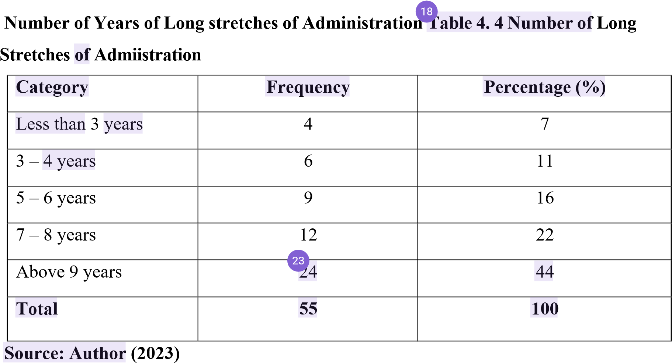

Figure 4. 4 Quantities of Long periods of Administration

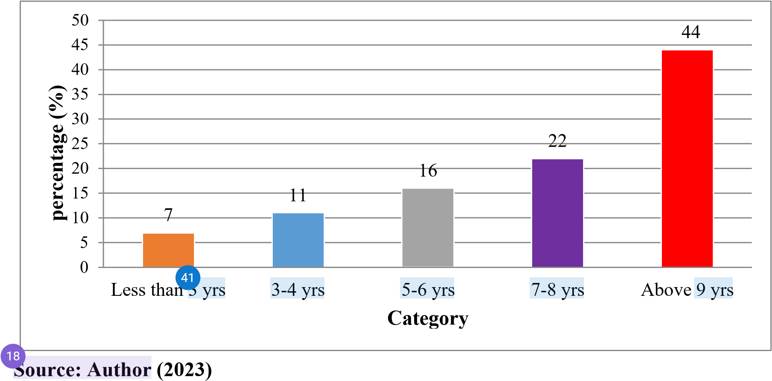

Table 4.4 and figure 4.4 demonstrates the examination of work insight. 7% had worked under 3 years, 11% had 3-4 years' insight, 16% had 5 - 6 years, 22% addressed those inside 7-8 years and 44% had over 9 years of involvement. These outcomes showed that a large portion of the
51 representatives had worked in the association for over 9 years. The review discoveries show that the respondents had worked in the association for term of time that places them in a superior situation to answer the polls. The discoveries uncovered that respondents who have worked in an association for long are in a superior situation to comprehend its elements what's more, answer research inquiries with power.
14
4.2.5 Most Elevated Level of

Schooing

Category

Frequency

Percentage

(
%
)

Endorsement

8

15

Confirmation

31

56

Undergraduate

12

22

Postgraduate

Degree

4

7

Total

55

100

Source:

Author

(2023)

2


Figure

4
.

5

Highest Level

of

Education

Source:

Author

(2023)

60

5
6

50

40

30

22

20

15

10

7

Certificate

Diploma

Undergraduate

degree

Category

Postgraduate

degree

percentage

(
)
%

1
4.2.6 Table 4.5 and figure 4.5 showed that 15% of the respondents had endorsement, 56% of respondents had certificate, 22% had college degree while 7% of respondents had
58 postgraduate certificate. This shows that the majority of respondents were knowledgeable and
63 well-versed in the association assumptions, as a result. This shows that the respondents' highest level of education was sufficient for them to respond to and understand the research questions. This demonstrates that the associations' activity requires expert information. The findings showed that a person's reaction is probably not fully determined by their degree of education, hence it is essential to understand the respondents' educational backgrounds

14
4.2.7 Information Technology Advancement

4.6 Whether information technology advancement affects logistics management in assembling companies in Rwanda

Class

Ocurrence

Percentage

)
%
(

Yes

49

89

No

6

11

Total

55

100

Source:

Author

(2023)

39
Figure 4.6 Whether information technology advancement affects Logistics management in assembling companies in Rwanda.


Source:

Author

(2023)

No,

11
%

Yes,

89
%

5

Table 4.6 and figure 4.6 shows the reaction on the impact of information technology advancement on logistics management in manufacturing companies in Rwanda. It was
22 determined that 89% of respondents indicated that the development of information technology has an impact on logistics management in Rwandan manufacturing enterprises, while 11% said
4 that there is no impact. Therefore, it can be stated that the development of information technology has a substantial impact on logistics management in Rwandan manufacturing enterprises.
Information Technology Advancement.

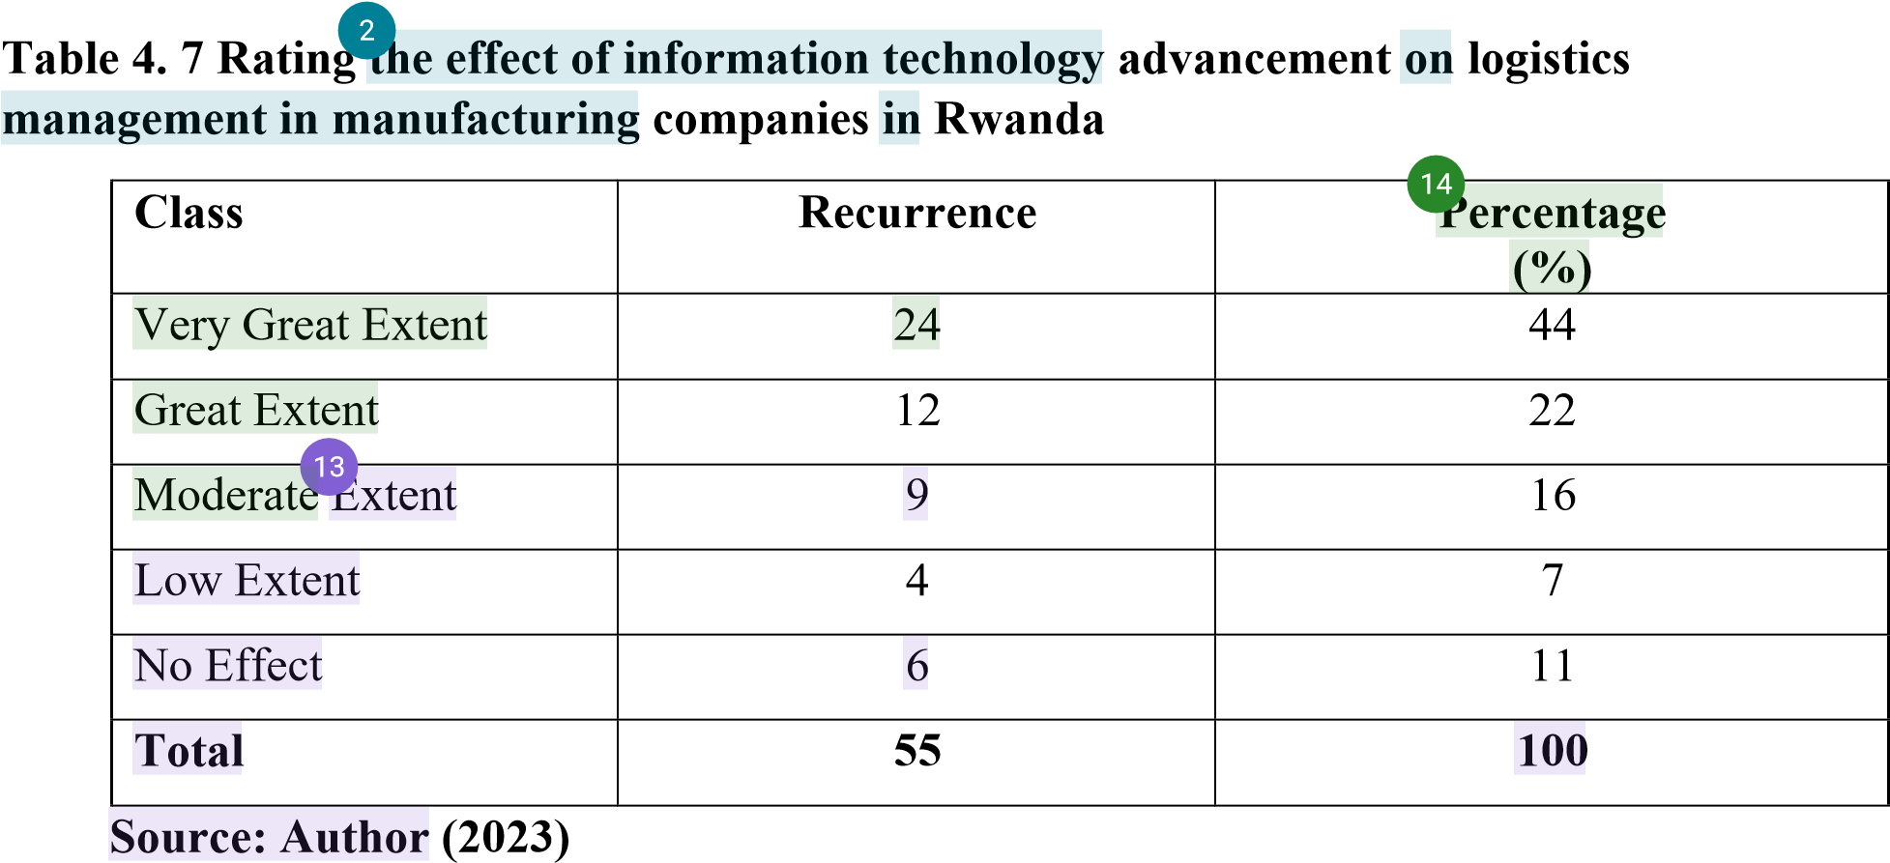

Figure 4. 7 Rating the effect of information technology advancement on logistics management in manufacturing companies in Rwanda

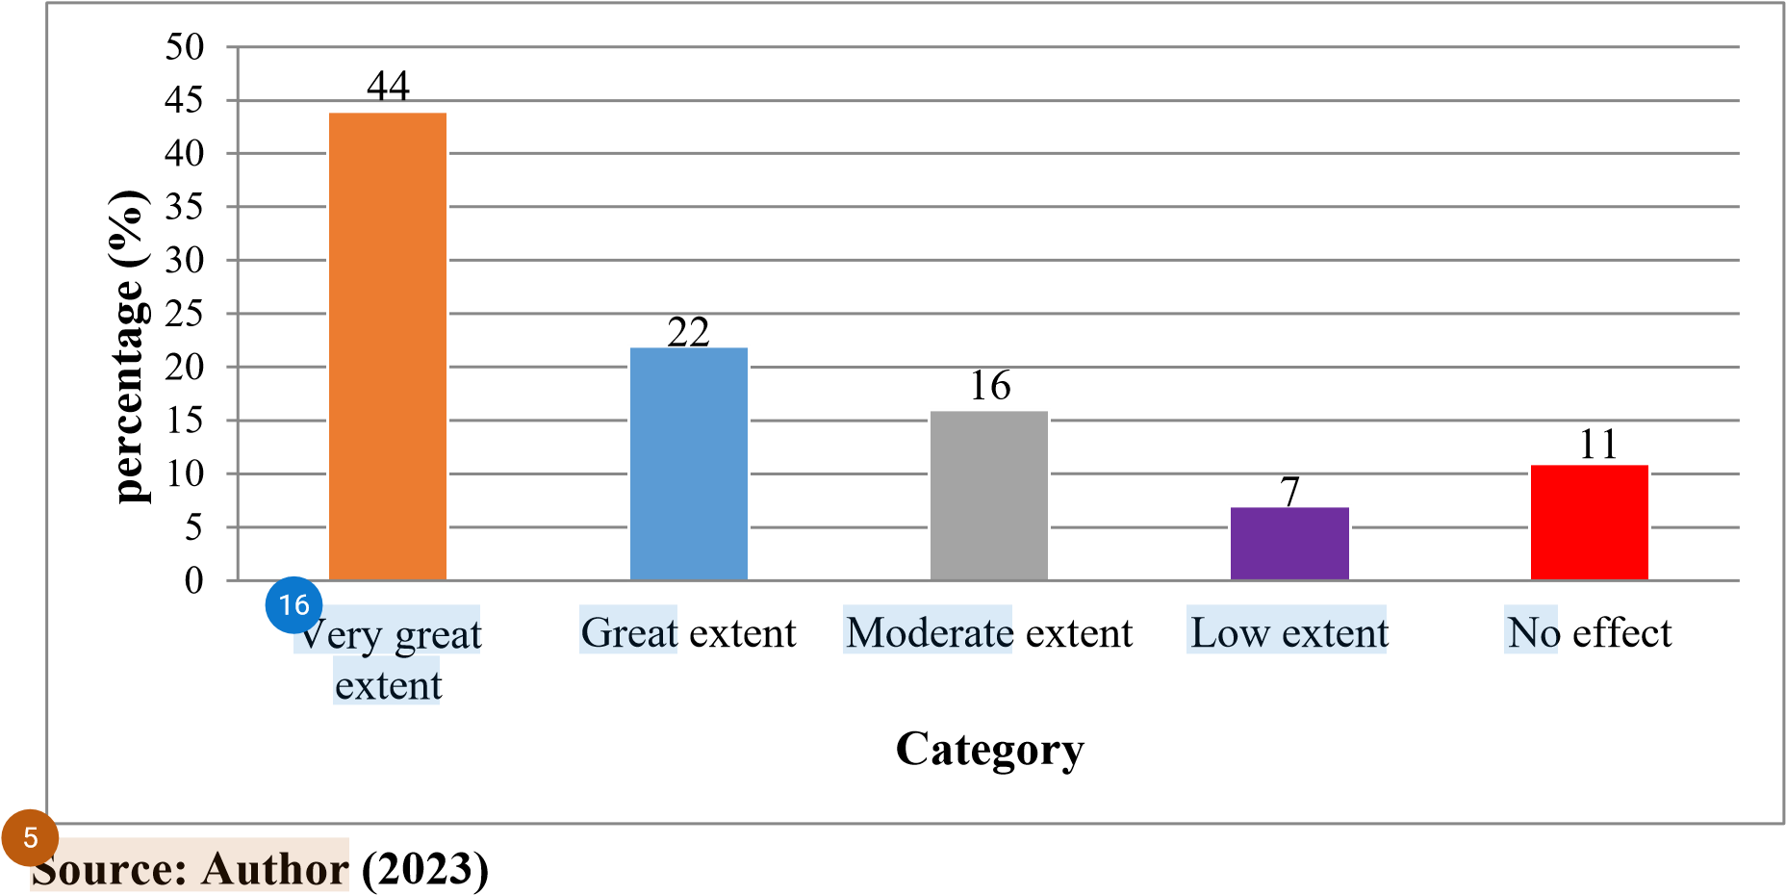

Table 4.7 and figure 4.7 show that the extent of which information technology advancement affects logistics management in manufacturing companies in Rwanda. Only 11% of respondents said it had no effect, compared to 44% who said it was very significant, 22% who said it was significant, 16% who said it was moderate, and 7% who said it was little. The vast majority of respondents claimed that Rwandan manufacturing enterprises' logistics management is significantly impacted by the development of information technology.

Inventory Control

Table 4. 8 Whether inventory control affects logistics management in manufacturing companies in Rwanda

Class

Reccurence

Percentage

)
%
(

Yes

53

96

No

2

4

Total

55

100

Source:

Author

(2023)

23

Figure 4. 8 Whether inventory control affects logistics management in manufacturing companies in Rwanda


Source:

Author

(2023)

No,

4
%

Yes,

96
%

3

From table 4.8 and figure 4.8, the review uncovered the impact of stock control on planned operations the executives in assembling organizations in Rwanda. It was laid out that 96% respondents said stock control influence coordinated operations the executives in assembling organizations in Rwanda while 4% said there is no impact. In view of this finding it very well may be derived that stock control is a key consider influencing coordinated factors the board fabricating organizations in Rwanda.

3
4.2.8 Inventory Control

Table 4. 9 Rating the effect of inventory control on logistics management in manufacturing companies in Rwanda
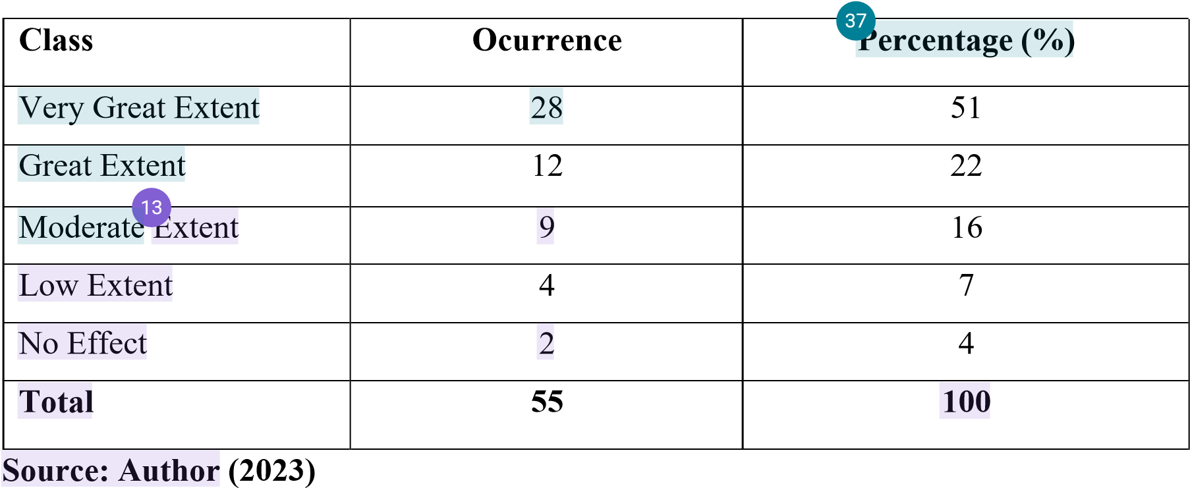

Figure 4. 9 Rating the effect of inventory control on logistics management in manufacturing companies in Rwanda



Source:

Author

(2023)

60

50

51

40

30

20

22

16

10

7

4

Very

great

Great

Moderate

Category

Low

No

effect

percentage

(
)
%

1
37

Table 4.9 and figure 4.9 indicates effect inventory control on logistics management in manufacturing companies in Rwanda. 51% of respondents said it had a very large impact, 22% said it had a big impact, 16% said it had a moderate impact, 7% said it had a small impact, and
22
4% said it had no impact. The majority of respondents believed that inventory control has a significant impact on logistics planning in Rwandan manufacturing enterprises.

Table 4. 10 Whether lead time affects logistics management in manufacturing companies in Rwanda

Category

Frequency

Percentage

)
%
(

Yes

51

93

No

4

7

Total

55

100

Source:

Author

(2023)

8

Figure 4. 10 Whether lead time affects Logistics management in manufacturing companies in Rwanda


No,

7
%

Yes,

93
%

Source: Author (2023)

42
4.2.9 From table 4.10 and figure 4.10, the review uncovered the impact of lead time on coordinated operations the executives in assembling organizations in Rwanda. It was laid out that 93% respondents said lead time influence planned operations the executives in assembling organizations in Rwanda while 7% said there is no impact. In light of this finding it tends to be derived that lead time is a key consider influencing planned operations the executives producing organizations in Rwanda.

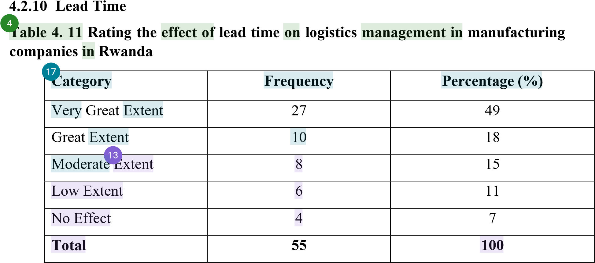

Source: Author (2023)

Figure 4. 11 Rating the effect of lead time on logistics management in manufacturing companies in Rwanda



Percentage

)
%
(

60

50

49

40

30

20

18

15

10

11

7

Very

great

Great

Moderate

Category

Low

No

effect

Source: Author (2023)

4.2.11 From table 4.11 and figure 4.11, lead time impact on planned operations the board in assembling organizations in Rwanda was referred to be exceptionally extraordinary degree by 49% respondents, 18% said the impact is extraordinary degree, 15% said the impact is moderate degree, 11% said it is low degree while just 7% it made no difference. Larger part of the respondents were of the assessment that lead time influences operations the executives in assembling organizations in Rwanda at an exceptionally extraordinary degree.

11
4.2.12 Management Style

Table 4.12 Whether management style affects logistics management in manufacturing companies in Rwanda

Category

Frequency

Percentage

(
)
%

Yes

47

85

No

8

15

Total

55

100

8

Source: Author (2023)

Figure 4.12 Whether management style affects Logistics management in manufacturing companies in Rwanda


Source:

Author

(2023)

No,

15
%

Yes,

85
%

5

Table 4.12 and figure 4.12 shows the response on the effect of management style on logistics
11 management in manufacturing companies in Rwanda. It was determined that while 15% of respondents indicated there is no influence, 85% of respondents claimed management style has an impact on logistics management in Rwandan manufacturing enterprises. Therefore, it can be inferred that management style has a substantial impact on logistics management in Rwandan manufacturing enterprises.

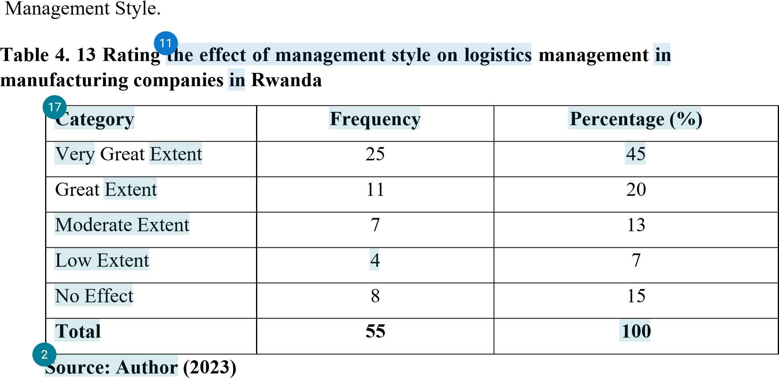

Figure 4. 13 Rating the effect of management style on logistics management in manufacturing companies in Rwanda



Source:

Author

(2023)

50

45

40

35

30

25

20

15

10

45

20

13

15

7

Very great

Great

Moderate

Category

Low

No

effect

percentage

%
)
(

38

Table 4.13 and figure 4.13 show that 45% of respondents said management style has a very large impact on logistics management in manufacturing companies in Rwanda, 20% said it has a great impact, 13%
45 said it has a moderate impact, 7% said it has a low impact, and only 15% said it has no impact. The majority of respondents said that management style had a significant impact on logistics management in Rwandan manufacturing enterprises.
8
4.2.13 Finance

Table 4. 14 Whether finance affects logistics management in manufacturing companies in Rwanda

 | Cate |  |  | gory |  |  | Frequency |  |  | Percentage (%)
 | Yes |  |  |  |  | 50 |  |  | 91
 | No |  |  |  |  | 5 |  |  | 9
 | Total |  |  |  |  | 55 |  |  |  |  | 100

Source: Author (2023)

Figure 4.14 Whether finance affects Logistics management in manufacturing companies in Rwanda

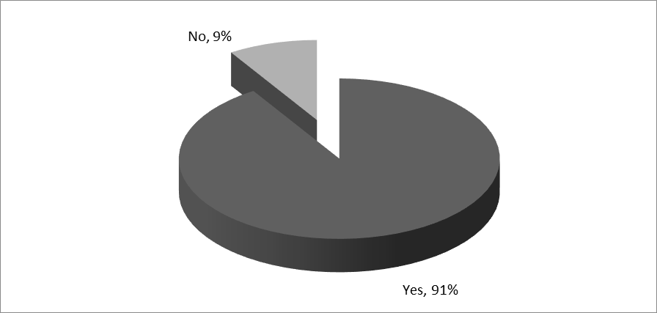

Source: Author (2023)
5
Table 4.14 and figure 4.14 shows the response on the effect of finance on logistics management in manufacturing companies in Rwanda. It was found that 91% of respondents claimed that finance has an impact on logistics management in Rwandan manufacturing enterprises, while 9% said that there is no impact. Therefore, it can be inferred that financing has a considerable impact on logistics management in Rwandan manufacturing enterprises.
4
4.2.14 Finance

Table 4. 15 Rating the effect of finance on logistics management in manufacturing companies in Rwanda

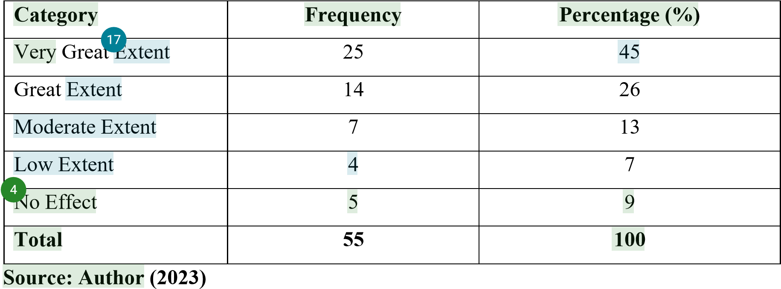

Figure 4. 15 Rating the effect of finance on logistics management in manufacturing companies in Rwanda

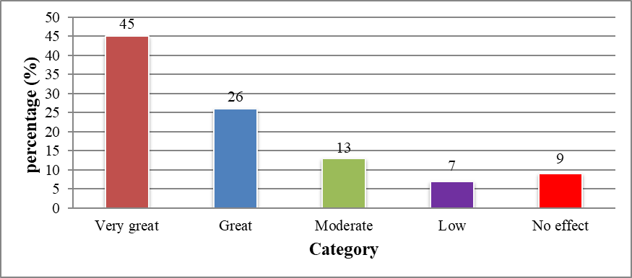
Source: Author (2023)
₃₅
Table 4.15 and figure 4.15 showed that 45% of respondents indicated that the impact of finance on logistics management in manufacturing companies in Rwanda is very great, 26% that it is great, 13% that it is moderate, 7% that it is low, and only 9% that it had no impact. Most of respondents believed that money has a significant impact on logistics management in Rwandan manufacturing enterprises.

4.2.15 Rundown of Information Examination 4.2.16 General Data
1
Out of 60 surveys dispersed 55 were returned, that is 92% of the absolute populace and 5 which is 8% were not returned. Orientation reaction shows that 56% of the respondents were male while 44% were female. High level administration respondent by 2%, center level administration by 4%, while the reaction of care staff being 94%. On instruction level, 15% of the respondents had endorsement, 56% of respondents had confirmation, and 22% had college degree while 7% of respondents had postgraduate certification. On work insight, 7% had worked for under 3 years, 11% had 3-4 years' insight, 16% had
4.2.17 5-6 years, 22% addressed those inside 7-8 years and 44% had over 9 years of
43 involvement. These outcomes demonstrated that the greater part of the representatives had worked in the association for over 9 years

4.2.18 Information Technology Advancement
The study revealed the effect of information technology advancement on logistics management in manufacturing companies in Rwanda. It was established that 89% of the respondents said that information technology advancement affects logistics management in manufacturing companies in Rwanda while 11% said that it has no effect on logistics management in manufacturing companies in Rwanda.

4.2.19 Inventory Control
The review uncovered the impact of stock control on coordinated factors the executives in assembling organizations in Rwanda. It was laid out that 96% of the respondents said that stock control influences strategies the board in assembling organizations in Rwanda while 4% said that it affects coordinated operations the executives in assembling organizations in Rwanda.

4.2.20 Lead Time
4
The study revealed the effect of lead time on logistics management in manufacturing companies in Rwanda. It was laid out that 93% of the respondents said that lead time affects logistics management in manufacturing companies in Rwanda while 7% said that it has no effect on logistics management in manufacturing companies in Rwanda.

4.2.21 Management Style
36
The review uncovered the impact of management style on logistics management in
4 manufacturing companies in Rwanda. It was established that 85% of the respondents said that management style affects logistics management in manufacturing companies in Rwanda while 15% said that it has no effect on logistics management in manufacturing companies in Rwanda.

4.2.22 Finance
The review uncovered the impact of money on planned operations the board in assembling organizations in Rwanda. It was laid out that 91% of the respondents said that money influences coordinated factors the board in assembling organizations in Rwanda while 9% said that it affects strategies the executives in assembling organizations in Rwanda.

CHAPTER FIVE OUTLINES OF DISCOVERIES, ND AND PROPOSALS
1

5.1 Introduction
This section gives a brief synopsis on the findings, responses to explore questions, end, proposals, and ideas for further investigation.

5.2 Rundown of Discoveries
5.2.1 How does information technology advancement affect logistics management in manufacturing companies in Rwanda?

5.2.2 How much does inventory control affect logistics management in manufacturing companies in Rwanda?
Stock control impact on coordinated operations the executives in assembling organizations in Rwanda was felt to be exceptionally extraordinary degree by 51% respondents, 22% said the impact is incredible degree, 16% said the impact is moderate degree, 7% said it is low, while just 4% said it makes no difference. From the review it was presumed that stock control meaningfully affected strategies the executives in assembling organizations in Rwanda at an extremely extraordinary degree.

5.2.3 How does lead time affect logistics management in manufacturing companies in Rwanda?
Lead time impact on planned operations the board in assembling organizations in Rwanda was felt to be extremely extraordinary degree by 49% respondents, 18% said the impact is incredible degree, 15% said the impact is moderate degree, 11% said it is low degree, though just 7% said it makes no difference. From the review it was reasoned that lead time affected operations the executives in assembling organizations in Rwanda at an exceptionally extraordinary degree.
5.2.4 To what degree does executive style influence operations the board assembling organizations in Rwanda?
11
45% of respondents said that the effect of management style on logistics management in manufacturing companies in Rwanda was very great, 20% said it was great, 13% said it
5 was middling, 7% said it was low, and 15% said it has no effect. From the study, it was clear that management style had a big impact on logistics management in Rwandan manufacturing businesses.

5.2.5 How funds influence coordinated factors the board in assembling organizations in Rwanda?
The impact of finance on logistics management in manufacturing enterprises in Rwanda
57 was perceived to be significant by 45% of the respondents. Additionally, 26% of the respondents indicated that the impact was of considerable extent, while 13% considered it to be of moderate extent. Furthermore, 7% of the respondents reported a low extent of impact, however just 9% stated that finance had no influence on logistics management. The study's findings indicate that financing significantly influences logistics management inside industrial enterprises in Rwanda.

5.3 Conclusions₄₉
A significant majority of the participants revealed that the advancement of information
27 technology has an impact on policy management within manufacturing companies in Rwanda. In view of the discoveries, the exploration has arrived at a conclusion that advancements in data
27 innovation have an impact on the management of integrated operations in manufacturing companies in Rwanda.

Bigger piece of the respondents uncovered that stock control influences coordinated factors the board in assembling organizations in Rwanda. In light of the discoveries, the review reached a resolution that stock control influences operations the executives in assembling organizations in Rwanda.

54
Greater part of the respondents uncovered that lead time influences strategies the board in assembling organizations in Rwanda. In light of the discoveries, the review reached a resolution that lead time influences coordinated operations the executives in assembling organizations in Rwanda.

52
The findings of the survey indicate that a significant proportion of the participants acknowledged the impact of financial factors on the management of logistics within the
60 industrial sector of Rwanda. The review's discoveries prompted the end that financing has an impact on logistics management within the manufacturing sector of Rwanda.

19

5.4 Recommendations

5.4.1 Information Technology Advancement
The administration ought to have their frameworks robotized. The administration ought to embrace data innovation to upgrade proficiency, adequacy and straightforwardness. The administration ought to likewise take on e-acquisition and electronic frameworks to oversee inside activities, for example, materials dealing with.

5.4.2 Inventory Control
The study proposes vendor managed inventory systems to help manufacturers reduce or eliminate inventory and improve performance. Manufacturing organizations should use vendor-managed inventory to avoid stock outs and boost efficiency. Re-planning skills
16
should be improved by top management to boost performance. The company's accounting and procurement teams should verify inventory numbers.
34

5.4.3 Lead Time
The study suggests that the organization set up effective policy frameworks and methods like EOQ and demand and supply forecasting to cut down on lead times. The organization
6 should also set task performance measures to be followed to make sure that lead times are kept to a minimum.

5.4.4 Management Style
The review prescribes the administration to ensure that all members within the organization are committed to changes instituted within the procurement function. Leaders should demonstrate support for the firm’s procurement officers to learn and emulate them.

5.4.5 Finance
The study proposes that more resources should be given to the buying department to help it. To make the buying process more effective and efficient, it suggests that enough resources be set aside and that these resources be reviewed often to keep up with changes in the environment.
16

5.5 Suggestions for Further Studies
Other than the study's aims, the study did not investigate all of the aspects influencing logistics management in Rwandan manufacturing enterprises. It is also recommended that additional study be conducted to determine other aspects affecting logistics management in Rwandan manufacturing enterprises other than those identified in this project, such as lead time, inventory control, and management style.

REFERENCES
Armstrong, G. (2017) Logistics Management and Strategy: Competing Through the Supply Chain, Prentice Hall, London
Bagonko, B. (2017), Principles of Managerial Finance, 11th Edition, British Library Catalogue Publishers, New Mexico, Mexico
Baker, D. (2014), Purchasing and Supply Chain Management 7th Edition Eindhoven
University of Government Policy the Netherlands Thomson learning, London UK
Bargey, P. (2014) Materials Management Tools and Techniques, Oxford University Press, New York
Barrie, G. (2020) Marketing and Introduction 4th Edition, Published by Harvard Business School Press New Jersey, U.S.A
Bikram, D. (2019) Procurement Principles and Management. Harlow: Pearson Education.
Chandra, L. (2014) Regulation and Regulatory Governance, 4th Ed. UN Paper on Regulation and Governance. Genève, Switzerland.
Cole, H. (2014) Strategic Operations Management, Second Edition, Butterworth, Heinemann, UK
David, D. (2019), Strategic Management 6th Edition Mc- Grew Hill New York City, U.S.A.
Debras, D. (2020) Information Technology 5th edition Jaico publishing house. New Delhi
Gan, K. (2019), Purchasing and Distribution Management, 7th Edition, Pearson Prentice Hall, London, UK
Gatheru, M. (2014), Our Problems Our Solutions, Institute of Economic Affairs 4th Editions Jaico Publishers Ampsher
Girman, S. (2020) Principles of Managerial Finance 11th Edition. British library catalogue publishers, Mexico
Graham, B. (2014) Business Financial Theory and Practice. 4th edition DP publishers New Mexico
Grant, J. (2014) Management Concepts and Strategies,3rd edition, Pvt ltd Publishers, Brussels Germany.
Gross, B. and Meridith F. (2019) Business, Marketing Prentice 6th edition by prentice hall publishers, San Francisco
Hisrich, M. (2017), Human Resource Management, (10th Edition) Thomson South
Western Publisher, Washington DC
Honey, C. (2019) Sales Management 3rd edition, publisher Taylor and Francis group Hampshire
Jaffee, S. and Morton J. (2015) Marketing Africa’s High Value Foods Cooperative
Experiences Kendal hunts publishing company, Hampshire
Jalenga, D. (2015) Marketing Management 2nd edition. Tata Mc Graw Hill Publishers, New Delhi India.
Joel, D. (2014), Purchasing Handbook: Standard Reference Book on Purchasing Policies, Practices, Procedures 3rd Edition Book Power Publishers Limited; USA
Kadic, C. (2017), Purchasing and Supply Chain Management, 7th Edition, Prentice Hall Publishers London UK
Keller, D. (2014) Economics 2nd edition, British Library Catalogue Publishers,
Atlanta’s
Kerr, (2019), Practice of Management, 7th Edition, Butterworth, Heinemann Jordan Hill, Oxford University. London.UK
Kombo and Tromp (2009). Proposal and thesis writing. An introduction. Pauline Publications Africa, Nairobi, Kenya
Kottler, B. (2014), Purchasing Handbook: Standard Reference Book on Purchasing
Policies, Practices, Procedures 3rd Edition Book Power Publishers Limited; USA
Kothari, C.R. (2014). Research Methodology: Methods and Techniques (2nd Ed.). Wishwa Prakshan. New Dhelhi: KK
Lathanair, M. (2017) Marketing Strategy 2nd edition DP publishers New Mexico

Marklas, S. (2015), Principle of Corporate Finance, 3rd Edition MC Graw hill publishers Hall, New York
Martin, T. (2020) Economics 2nd edition, British library catalogue publishers Atlanta’s
Martinich, L. (2017). Principles of Economics 4th Ed, Freeload Press: London, United Kingdom
Michael, E. (2020) Procurement Practice 3rd edition DP publishers New Mexico
Mugenda & Mugenda (2009) Research Methods-Quantitative &Qualitative, New Age Internal Publishers, Nairobi Kenya
Nguti, A. (2017) procurement 4th edition, Jomo Kenyatta Publishers Ltd. Nairobi
Nyagito and Ndirangu L (2017) Farmers Response To Reforms And Marketing Of
Maize2nd edition, Jaico publishing, New York
Robbins, K. (2014), ‘Power and Interdependence in Buyer Supplier Relationships, Merrill Publishing Company, Columbus, Ohio
Robert, R. (2019), Marketing Africans Value Foods Cooperative Experiences, 5th Edition,
Kendal Hunts Publishing Company, Hampshire
Sunil, C. (2019), Purchasing Handbook: Standard Reference Book on Purchasing
Policies, Practices, Procedures 3rd Edition Book Power Publishers Limited; USA
Russel, K. (2020) Business Financial Theory and Practice. Macdonald and Evans Limited
Saleemi, B. (2019): Personal Management, Jomo Kenyatta Publishers Ltd. Nairobi
Schultz, S. (2020) Management of Computer Software, Thomson South Western Publisher Washington Dc:
Taylor, F. (2020) Economics 2nd edition British library catalogue publishers Atlanta
Terry, B. (2019), Practice of Management 7th Edition Butterworth, Heinemann Jordan Hill, Oxford University, London, UK
Titus, F. (2014) Marketing Management 3rd edition DP publishers New Mexico
Peter, A. (2017) The Emerging Science of Relationships. (3rd Edition), Close relationships, New York
Water, C. (2020), Purchasing and Supply Chain Management, 4th Edition, Prentice Hall Publishers London UK
Zikmund, W. (2020). Business Research Methods. New York. McGraw-Hill Publishers

APPENDIX II QUESTIONNAIRE
1
Tick Where Appropriate and For Explanation, Please Be Brief

SECTION A: PERSONAL INFORMATION
- Gender
Male
Female

- Which is position in the management?
Top Level Management
Middle Level Management
Support Staff

- Years worked with the project
2
Less than 3 years
3-4 years 5-6 years 7-8 years
Above 9 years
- Highest Education level
Certificate Diploma
Undergraduates
Postgraduates

11

SECTION B: INFORMATION TECHNOLOGY ADVANCEMENT
2
5 Does information technology advancement affect logistics management in manufacturing companies in Rwanda?
Yes
No

- To what extent does information technology advancement affect logistics management in manufacturing companies in Rwanda?
Very Great Extent
Explain

35
Great Extent
Moderate Extent
Low Extent No Effect
………………………………………………………………………………………………
………………………………………………………………………………………………
………………………………………………………………………………

SECTION C: INVENTORY CONTROL
- Does inventory control affect logistics management in manufacturing companies in Rwanda?
2
Yes
No
Explain
………………………………………………………………………………………………
………………………………………………………………………………………………
………………………………………………………………………………

- To what extent does inventory control affect logistics management in manufacturing companies in Rwanda?
Very Great Extent
Great Extent
Moderate Extent
Low Extent
No Effect

34

SECTION D: LEAD TIME
2
- Does lead time affect logistics management in manufacturing companies in
Rwanda? Yes
No
Explain
………………………………………………………………………………………………
………………………………………………………………………………………………
………………………………………………………………………………

- To what extent does lead time affect logistics management in manufacturing companies in Rwanda?
Very Great Extent
Explain

11
Great Extent
Moderate Extent
Low Extent No Effect
………………………………………………………………………………………………
………………………………………………………………………………………………
………………………………………………………………………………

SECTION E: MANAGEMENT STYLE
2
- Does management style affect logistics management in manufacturing companies in Rwanda?
Yes
No

- To what extent does management style affect logistics management in manufacturing companies in Rwanda?
Very Great Extent
Explain

8
Great Extent
Moderate Extent
Low Extent No Effect
………………………………………………………………………………………………
………………………………………………………………………………………………
………………………………………………………………………………

SECTION F: FINANCE
- Does finance affect logistics management in manufacturing companies in 2
Rwanda? Yes
No
Explain
………………………………………………………………………………………………
………………………………………………………………………………………………
………………………………………………………………………………

- To what extent does finance affect logistics management in manufacturing companies in Rwanda?
Very Great Extent
Great Extent
Moderate Extent Low Extent
55
No Effect

Thank You for Your Cooperation

13% Overall Similarity
Top sources found in the following databases:
10
% Internet database
0
% Publications database
12
% Submitted Works database
TOP SOURCES
The sources with the highest number of matches within the submission. Overlapping sources will not be displayed.
1
repository.mua.ac.ke
2
%
Internet
2
core.ac.uk
1
%
Internet
3
zdocs.ro
%
1
Internet
4
Mesa State College on 2017-09-20
%
<1
Submitted works
5
Mesa State College on 2017-10-04
<1
%
Submitted works
6
Open Learning Group on 2019-05-24
<1
%
Submitted works
7
coursehero.com
<1
%
Internet
8
Saint Paul University on 2018-04-19
<1
%
Submitted works
9
Saint Paul University on 2017-04-19
<1
%
Submitted works

Midlands State University on 2022-12-20
10
Submitted works
Kiriri Women's University of Science and Technology on 2019-06-07  Submitted works | <1%
Kiriri Women's University of Science and Technology on 2019-11-27  Submitted works | <1%
University of Nairobi on 2016-11-04  Submitted works | <1%
Mesa State College on 2017-07-31  Submitted works | <1%
erepository.uonbi.ac.ke  Internet | <1%
ir-library.ku.ac.ke  Internet | <1%
Kenyatta University on 2020-11-12  Submitted works | <1%
Saint Paul University on 2016-11-30  Submitted works | <1%
researchnetwork.net  Internet | <1%
University of Rwanda on 2020-02-05  Submitted works | <1%
11
12
13
14
15
16
17
18
19
20

Midlands State University on 2023-06-29
21
Submitted works

The Hong Kong Polytechnic University on 2021-12-07
22
Submitted works
University of Northampton on 2012-01-23  Submitted works | <1%
Kiriri Women's University of Science and Technology on 2019-11-27  Submitted works | <1%
Bolton Institute of Higher Education on 2008-11-08  Submitted works | <1%
Saint Paul University on 2016-12-06  Submitted works | <1%
Eiffel Corporation on 2019-11-15  Submitted works | <1%
Saint Paul University on 2014-06-12  Submitted works | <1%
Mesa State College on 2017-08-02  Submitted works | <1%
University of Rwanda on 2019-06-21  Submitted works | <1%
dokumen.pub  Internet | <1%
proxdeveloper.com  Internet | <1%
23
24
25
26
27
28
29
30
31
32

scholar.mzumbe.ac.tz
33
Internet

Mesa State College on 2017-09-06
34
Submitted works
Pioneer International Univeristy on 2021-07-30  Submitted works | <1%
University of Rwanda on 2023-04-12  Submitted works | <1%
Saint Paul University on 2017-08-01  Submitted works | <1%
Saint Paul University on 2016-12-06  Submitted works | <1%
Saint Paul University on 2017-08-03  Submitted works | <1%
University of Rwanda on 2018-10-29  Submitted works | <1%
indiansilkhouseagencies.com  Internet | <1%
Saint Paul University on 2014-12-10  Submitted works | <1%
Saint Paul University on 2016-08-04  Submitted works | <1%
afribary.com  Internet | <1%
35
36
37
38
39
40
41
42
43
44

Intercollege on 2023-02-12
45
Submitted works

Midlands State University on 2022-12-11
46
Submitted works
Kiriri Women's University of Science and Technology on 2019-10-18  Submitted works | <1%
Mesa State College on 2017-09-25  Submitted works | <1%
Mesa State College on 2017-10-23  Submitted works | <1%
University of Bradford on 2022-09-04  Submitted works | <1%
ir.jkuat.ac.ke  Internet | <1%
sparc.tcd.ie  Internet | <1%
Ghana Telecom University College on 2012-10-03  Submitted works | <1%
Mesa State College on 2017-07-03  Submitted works | <1%
Mesa State College on 2017-07-28  Submitted works | <1%
Saint Paul University on 2017-07-30  Submitted works | <1%
47
48
49
50
51
52
53
54
55

56 erl.ucc.edu.gh:8080
57
Internet

ir.bowen.edu.ng:8080
58
Internet
researchspace.ukzn.ac.za  Internet | <1%
globalscientificjournal.com  Internet | <1%
CVC Nigeria Consortium on 2017-03-15  Submitted works | <1%
Midlands State University on 2015-10-18  Submitted works | <1%
Saint Paul University on 2014-04-17  Submitted works | <1%
59
60
61
62
63

University of Rwanda on 2019-05-22
64 <1%
Submitted works

